**Supporting information**

Additional data and figures; methods, materials and experimental details (including NMR spectra).

**Promise and challenge of β-lactone electrophiles to target Asp12 of mutant KRASG12D**

Balázs Budai1*, Andrea Vaupel1*, Callum J. Dickson2, Kim S. Beyer1, Daniel A. Guthy1, Nils Ostermann1, Lynn M. McGregor2, Ruben De Kanter1, Andreas Weiss1, Markus Linder1, Emine Sager1, Claudio Bomio-Confaglia1, Rupert Proctor1, Catherine Leblanc1, Jun Yuan2, Simona Cotesta1, Rainer Wilcken1, Aaron D. Danilack2, Francisco Garcia2, Phuong Rogemoser2, Malika Kazic-Legueux1, Zhang Ziyang3, Qinheng Zheng3, Kevan Shokat3, Saskia M. Brachmann1✉, Veronika Ehmke1✉

1 Novartis BioMedical Research, Basel, Switzerland

2 Novartis BioMedical Research, Cambridge, MA 02139, United States

3 Department of Cellular and Molecular Pharmacology and Howard Hughes Medical Institute, University of California San Francisco, San Francisco, CA 94158, United States

*These authors contributed equally

✉ Corresponding Authors: saskia.brachmann@novartis.com; veronika.ehmke@novartis.com

**Table of contents**

EXTENDED DATA AND FIGURES 5

NMR studies on specific Asp versus non-specific reactivity 5

Target occupancy MS studies (TO-MS assay) 11

Transition state energies and % covalent labelling for β-lactones series 13

MATERIALS AND METHODS 14

Quantum mechanical transition state calculations 14

Intact MS and kinetic data 15

Intrinsic chemical reactivity towards GSH 16

X-ray co-crystal structures 17

Cellular pERK assays 19

Target occupancy assay by Western blot 20

Peptide mapping studies on recombinant KRASG12D 21

iTrace proteome-wide reactivity profiling 22

PK study 23

PK/PD study 23

SYNTHETIC METHODS AND PROCEDURES 24

(3S,4R)-3-ethyl-3-methyl-4-(morpholine-4-carbonyl)oxetan-2-one 29

(4R)-4-(3-(7-(8-ethynyl-7-fluoro-3-hydroxynaphthalen-1-yl)-8-fluoro-2-(((2R,7aS)-2-fluorotetrahydro-1H-pyrrolizin-7a(5H)-yl)methoxy)pyrido[4,3-d]pyrimidin-4-yl)-3,8-diazabicyclo[3.2.1]octane-8-carbonyl)-3,3-dimethyloxetan-2-one 30

4-((1R,5S)-3-(7-(8-ethynyl-7-fluoro-3-hydroxynaphthalen-1-yl)-8-fluoro-2-(((2R,7aS)-2-fluorotetrahydro-1H-pyrrolizin-7a(5H)-yl)methoxy)pyrido[4,3-d]pyrimidin-4-yl)-3,8-diazabicyclo[3.2.1]octane-8-carbonyl)-3,3,4-trimethyloxetan-2-one 32

4-((1R,5S)-3-(7-(8-ethynyl-7-fluoro-3-hydroxynaphthalen-1-yl)-8-fluoro-2-(((2R,7aS)-2-fluorotetrahydro-1H-pyrrolizin-7a(5H)-yl)methoxy)pyrido[4,3-d]pyrimidin-4-yl)-3,8-diazabicyclo[3.2.1]octane-8-carbonyl)-3,3,4-trimethyloxetan-2-one 33

(3S,4R)-3-ethyl-4-((1R,5S)-3-(7-(8-ethynyl-7-fluoro-3-hydroxynaphthalen-1-yl)-8-fluoro-2-(((2R,7aS)-2-fluorotetrahydro-1H-pyrrolizin-7a(5H)-yl)methoxy)pyrido[4,3-d]pyrimidin-4-yl)-3,8-diazabicyclo[3.2.1]octane-8-carbonyl)-3-methyloxetan-2-one (3S, 4R)-4 37

(3R,4R)-3-ethyl-4-((1R,5S)-3-(7-(8-ethynyl-7-fluoro-3-hydroxynaphthalen-1-yl)-8-fluoro-2-(((2R,7aS)-2-fluorotetrahydro-1H-pyrrolizin-7a(5H)-yl)methoxy)pyrido[4,3-d]pyrimidin-4-yl)-3,8-diazabicyclo[3.2.1]octane-8-carbonyl)-3-methyloxetan-2-one (3R, 4R)-**3** 44

(3S,4R)-4-((1R,5S)-3-(7-(8-ethynyl-7-fluoro-3-hydroxynaphthalen-1-yl)-8-fluoro-2-(((2R,7aS)-2-fluorotetrahydro-1H-pyrrolizin-7a(5H)-yl)methoxy)pyrido[4,3-d]pyrimidin-4-yl)-3,8-diazabicyclo[3.2.1]octane-8-carbonyl)-3-methyl-3-propyloxetan-2-one (3S, 4R)-**5** 50

(3S,4R)-4-((1R,5S)-3-(7-(8-ethynyl-7-fluoro-3-hydroxynaphthalen-1-yl)-8-fluoro-2-(((2R,7aS)-2-fluorotetrahydro-1H-pyrrolizin-7a(5H)-yl)methoxy)pyrido[4,3-d]pyrimidin-4-yl)-3,8-diazabicyclo[3.2.1]octane-8-carbonyl)-3-isopropyl-3-methyloxetan-2-one (3S, 4R)-**6** ( 56

(3S,4R)-4-((1R,5S)-3-(7-(8-ethynyl-7-fluoro-3-hydroxynaphthalen-1-yl)-8-fluoro-2-(((2R,7aS)-2-fluorotetrahydro-1H-pyrrolizin-7a(5H)-yl)methoxy)pyrido[4,3-d]pyrimidin-4-yl)-3,8-diazabicyclo[3.2.1]octane-8-carbonyl)-3-isobutyl-3-methyloxetan-2-one

(3S,4R)-4-((1R,5S)-3-(7-(8-ethynyl-7-fluoro-3-hydroxynaphthalen-1-yl)-8-fluoro-2-(((2R,7aS)-2-fluorotetrahydro-1H-pyrrolizin-7a(5H)-yl)methoxy)pyrido[4,3-d]pyrimidin-4-yl)-3,8-diazabicyclo[3.2.1]octane-8-carbonyl)-3-methyl-3-((tetrahydro-2H-pyran-4-yl)methyl)oxetan-2-one (3S, 4R)-**8** 66

(3S,4R)-4-((1R,5S)-3-(7-(8-ethynyl-7-fluoro-3-hydroxynaphthalen-1-yl)-8-fluoro-2-(((2R,7aS)-2-fluorotetrahydro-1H-pyrrolizin-7a(5H)-yl)methoxy)pyrido[4,3-d]pyrimidin-4-yl)-3,8-diazabicyclo[3.2.1]octane-8-carbonyl)-3-methyl-3-(prop-1-en-2-yl)oxetan-2-one (3S, 4R)-**9** 73

(3S,4R)-3-cyclopropyl-4-((1R,5S)-3-(7-(8-ethynyl-7-fluoro-3-hydroxynaphthalen-1-yl)-8-fluoro-2-(((2R,7aS)-2-fluorotetrahydro-1H-pyrrolizin-7a(5H)-yl)methoxy)pyrido[4,3-d]pyrimidin-4-yl)-3,8-diazabicyclo[3.2.1]octane-8-carbonyl)-3-methyloxetan-2-one (3S, 4R)-**10** (S0-EE-N9KY) 79

(3S,4R)-3-cyclobutyl-4-((1R,5S)-3-(7-(8-ethynyl-7-fluoro-3-hydroxynaphthalen-1-yl)-8-fluoro-2-(((2R,7aS)-2-fluorotetrahydro-1H-pyrrolizin-7a(5H)-yl)methoxy)pyrido[4,3-d]pyrimidin-4-yl)-3,8-diazabicyclo[3.2.1]octane-8-carbonyl)-3-methyloxetan-2-one (3S,4R)-**11** 89

(3S,4R)-3-cyclopentyl-4-((1R,5S)-3-(7-(8-ethynyl-7-fluoro-3-hydroxynaphthalen-1-yl)-8-fluoro-2-(((2R,7aS)-2-fluorotetrahydro-1H-pyrrolizin-7a(5H)-yl)methoxy)pyrido[4,3-d]pyrimidin-4-yl)-3,8-diazabicyclo[3.2.1]octane-8-carbonyl)-3-methyloxetan-2-one 99

(3S,4R)-3-(cyclopent-1-en-1-yl)-4-((1R,5S)-3-(7-(8-ethynyl-7-fluoro-3-hydroxynaphthalen-1-yl)-8-fluoro-2-(((2R,7aS)-2-fluorotetrahydro-1H-pyrrolizin-7a(5H)-yl)methoxy)pyrido[4,3-d]pyrimidin-4-yl)-3,8-diazabicyclo[3.2.1]octane-8-carbonyl)-3-methyloxetan-2-one 108

(3S,4R)-4-((1R,5S)-3-(7-(8-ethynyl-7-fluoro-3-hydroxynaphthalen-1-yl)-8-fluoro-2-(((2R,7aS)-2-fluorotetrahydro-1H-pyrrolizin-7a(5H)-yl)methoxy)pyrido[4,3-d]pyrimidin-4-yl)-3,8-diazabicyclo[3.2.1]octane-8-carbonyl)-3-methyl-3-((R)-tetrahydrofuran-2-yl)oxetan-2-one 118

(3S,4R)-4-((1R,5S)-3-(7-(8-ethynyl-7-fluoro-3-hydroxynaphthalen-1-yl)-8-fluoro-2-(((2R,7aS)-2-fluorotetrahydro-1H-pyrrolizin-7a(5H)-yl)methoxy)pyrido[4,3-d]pyrimidin-4-yl)-3,8-diazabicyclo[3.2.1]octane-8-carbonyl)-3-methyl-3-((S)-tetrahydrofuran-2-yl)oxetan-2-one 118

(3S,4R)-3-(bicyclo[1.1.1]pentan-1-yl)-4-((1R,5S)-3-(7-(8-ethynyl-7-fluoro-3-hydroxynaphthalen-1-yl)-8-fluoro-2-(((2R,7aS)-2-fluorotetrahydro-1H-pyrrolizin-7a(5H)-yl)methoxy)pyrido[4,3-d]pyrimidin-4-yl)-3,8-diazabicyclo[3.2.1]octane-8-carbonyl)-3-methyloxetan-2-one 130

References 141

# EXTENDED DATA AND FIGURES

### NMR studies on specific Asp versus non-specific reactivity

The aim of this experiment was to investigate the reaction between L-Glutathione and a β-lactone tool compound (3*S*,4*R*)-**16** using NMR assays and determine regioselectivity of the reaction by identification of the formed isomer after the reaction.

L-Glutathione was obtained from a commercial supplier and used without further purification. RCN368 was synthesized, purified, and analyzed internally. Stock solutions of L-Glutathione and (3*S*,4*R*)-**16**, synthesis described below, were prepared in D2O and deuterated phosphate buffer at pH 7.4. To determine the accurate concentration of each solution, quantitative NMR (qNMR) was performed using an external reference in the same solvent. Maleic acid, with a known concentration, served as the reference, and the integration of its signal was used to determine the unknown concentration of the solutions using the ERETIC module of Bruker Topspin (qNMR with TOPSPIN). The concentration of each stock solution was determined by qNMR before mixing them together. Each sample was prepared by mixing 3 equivalents of L-Glutathione with 1 equivalent of (3*S*,4*R*)-**16** in D2O and phosphate buffer (pH 7.4) using a 3 mm NMR tube. The resulting clear solution was transferred into a 3 mm NMR sample tube and placed on a SampleJet sample changer prior to acquisition. 1H and 13C detected 1D and 2D NMR spectra of the sample were recorded at 298 K or 310 K using a Bruker 600 MHz AVANCE III HD spectrometer equipped with a 5 mm BBO H&F CryoProbe™ with a z-gradient system. All spectra were referenced to the internal solvent signal (1H: D2O = 4.79 ppm). The materials used included a stock solution of L-Glutathione at 4.1 mM and (3*S*,4*R*)-**16** with a concentration determined by qNMR at 2.3 mM. NMR assays were conducted to monitor the reaction progress and isomer formation. In D2O, the reaction showed no progress even after several days (Figure 1). However, in phosphate buffer (pH 7.4), the reaction initiated within minutes and proceeded slowly at 25°C. Heating the sample to 37°C accelerated the reaction. To determine the reaction kinetics, the tubes were immediately placed into the magnet. Initially, a 1D qNMR spectrum was measured, followed by automatic and continuous measurement of 80 proton spectra over several hours.

Upon reaction with GSH, compound (3*S*,4*R*)-**16** can form two different isomers (Figure SI-1).



***Figure SI-1:****The two possible isomers formed from the reaction between (3S,4R)-****16*** *and L-Glutathione.*

To determine which isomer has been formed, the following NMR experiments have been measured:

1. 1H-NMR: 1D 1H experiment with 30 degree pulse
2. 13C-NMR: 1D 13C experiment with 1H-broadband-decoupling
3. 2D: 1H,1H-COSY: Gradient selected 2D homonuclear shift correlation (Hurd (1990))
4. 2D: 1H,1H-ROESY: Phase sensitive experiment with 180x/180-x spin-lock including a purge pulse (Bax and Davis (1985), Hwang and Shaka (1992))
5. 2D: Single bond 1H,13C correlation (13C-DEPT-HSQC): HSQC experiment with multiplicity editing, 1H detection and z-gradient (Kay, Keifer and Saarinen 1992)
6. 2D: Long range 1H,13C correlation (13C-HMBC): HMBC experiment with 1H detection and z-gradient (Bax and Summers 1986).

Isomer identification was achieved through correlation in the HMBC spectrum with a carbon signal at 205 ppm, indicative of the thioester carbonyl. Additionally, LC-MS analysis of the NMR solution confirmed the formation of the thioester. The experiment successfully tracked the reaction, offering valuable insights into the reaction kinetics and isomer formation.



***Figure SI-2:*** *Proton NMR in D2O of the mixture of L-Glutathione with (3S,4R)-****16*** *(ratio 3 to 1). No reaction observed even after several days.*

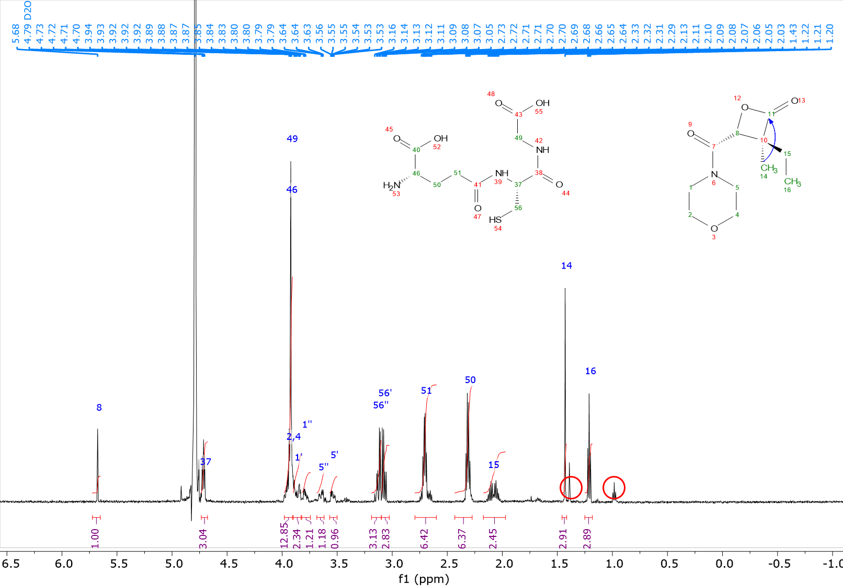

***Figure SI-3:*** *Proton NMR in phosphate buffer at pH 7.4 in D2O of the mixture of L-Glutathione with (3S,4R)-****16*** *(ratio 3 to 1). The reaction between the 2 components occurred within minutes. Signals of the newly formed compound are marked with red circles.*

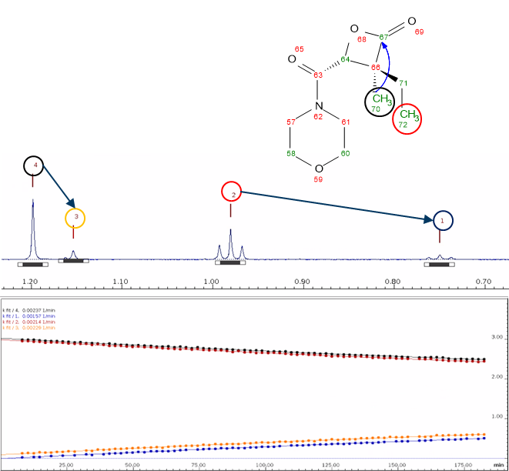

***Figure SI-4:****80 measured spectra were analyzed using the Dynamics Center module of TOPSPIN. The integration of various peaks was considered as follows: Peaks 4 and 2 for (3S,4R)-****16****, and peaks 3 and 1 for the newly formed compound, as illustrated in the figure. The scheme on the bottom represents the kinetics of the formation of the new compound and the disappearance of (3S,4R)-****16****.*

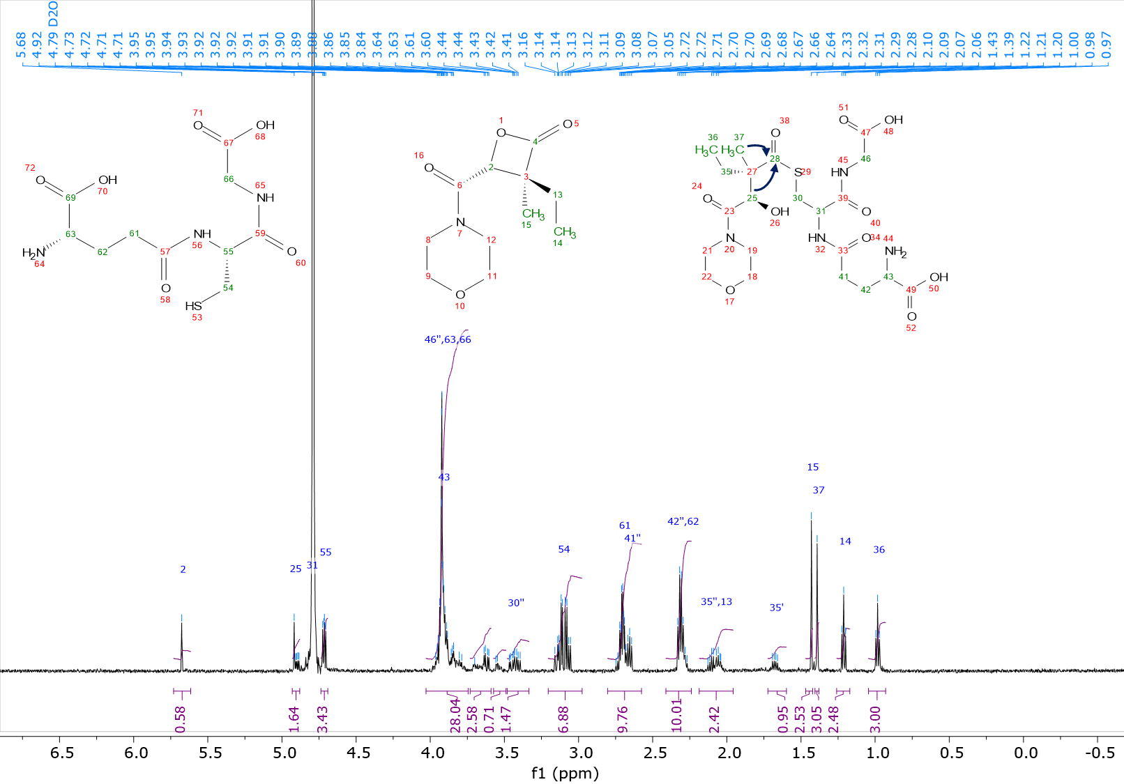

***Figure SI-5:****Assigned proton NMR spectrum used for the elucidation of the formed component.*

### Target occupancy MS studies (TO-MS assay)

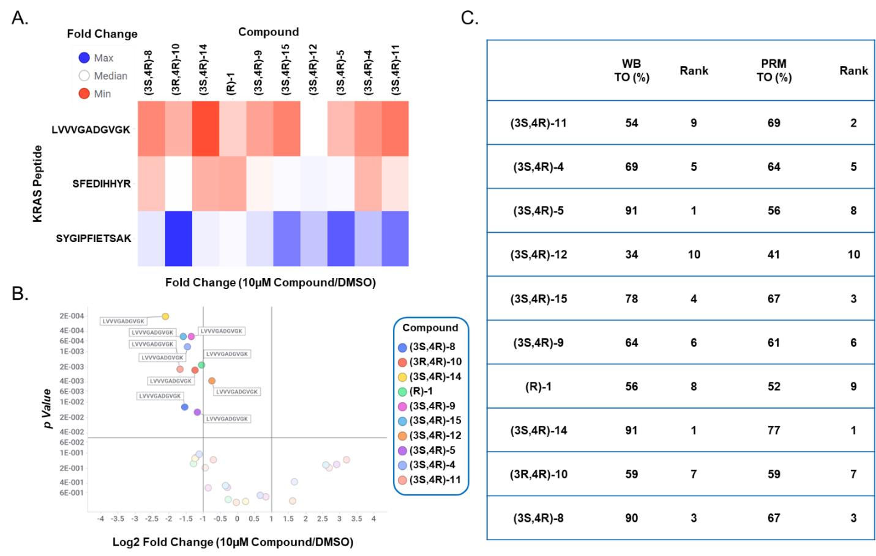

***Figure SI-6.*** *Application of a targeted mass spectrometry-based assay to characterize on-target engagement and site occupancy for covalent KRASG12D inhibitors in cells. In this parallel reaction monitoring (PRM) assay we isolate several target precursor ions, induce fragmentation, detect and quantify the fragment ions to yield absolute quantification of proteins and peptides. In this workflow, the assay monitors several KRASG12D peptides (LVVVGADGVGK, SFEDIHHYR, and SYGIPFIETSAK) within a complex proteome and monitors the loss of the G12D-containing peptide as a function of covalent compound treatment. Target occupancy is calculated by comparing the area under the curve (AUC) for KRASG12D inhibitor treated versus vehicle treated samples. (A) Heat map representing the fold change in peptide intensity for KRASG12D inhibitor treatment over vehicle control. (B) Volcano plot demonstrates target engagement with calculated fold change ratios between KRASG12D inhibitor treatment over vehicle control across triplicates samples generated and tested. (C) Target occupancy calculated from PRM analysis compared to target occupancy determined by Western Blot*.

#### Sample preparation for parallel reaction monitoring (PRM) studies

SW-1990 cells (ATCC, CRL-2172) were treated in triplicate with vehicle or 10 µM of the KRASG12D inhibitors for 2 hours at 37 °C in DMEM (Gibco) containing 10 % BSA and 1 % PennStrep. Following treatment, cells were harvested and prepped for digestion using the EasyPep MS Sample Prep Kit (Thermo) with slight modifications. Briefly, cells were lysed as per manufacturer’s instructions and 50 µg of whole cell lysate was reduced and alkylated for 10 minutes at room temperature. Next, samples were digested with 10 µg Trypsin/LysC for 1 hour at 37 °C. Finally, the digestion was quenched via acidification as specified by the manufacturer and cleaned using the provided peptide clean-up columns. The collection tubes were filled with 100 µL 10% formic acid to immediately acidify the eluants. The acidified eluants were concentrated to dryness and re-suspended in 200 µL mobile phase A (2% acetonitrile, 0.1% formic acid). Samples were then spiked in with a heavy KRAS WT and G12D synthetic peptide (LVVVGADGVGK, SFEDIHHYR, SYGIPFIETSAK) to 250/µL attomol.

#### Liquid chromatography – tandem mass spectrometry analysis

The digest was loaded directly onto a 25 cm Aurora Ultimate analytical column (IonOpticks) using an EasynLC 1200 (Thermo Fisher Scientific). Peptides were separated over a 55-minute gradient starting from 10% mobile phase A (2% acetonitrile, 0.1% formic acid) up to 55% mobile phase B (70% acetonitrile, 0.1% formic acid) at 300 nL/min. Peptides were analyzed by parallel reaction monitoring (PRM) mass spectrometry using a Thermo Orbitrap Fusion Lumos (Thermo Fisher Scientific) mass spectrometer with a targeted mass list for the KRAS WT (SFEDIHHYR: Light = 602.2812 m/z, z = 2; 401.8562 m/z, z = 3 and Heavy = 607.2848 m/z, z = 2; 405.1923 m/z, z = 3) and (SYGIPFIETSAK: Light = 656.8428 m/z, z = 2 and Heavy = 660.8499 m/z, z = 2) as well as G12D peptide (LVVVGADGVGK: Light = 507.3035 m/z, z = 2 and Heavy = 511.3106 m/z, z = 2). Precursor ions were fragmented at 32% CID collision energy and detected on an orbitrap at 30k resolution. Full mass scans were also collected on orbitrap at 120k resolution for XIC extraction. Data was analyzed using Skyline V21.2.0.425 (MacCoss Lab, University of Washington). Peptide quantification was performed by summing the peak areas corresponding to fragment ions and normalized against the heavy reference peptide. Percentage target occupancy was determined by comparison of average peptide AUC obtained from each compound-exposed sample with that of the vehicle control and multiplying the peak area ratios by the heavy spike (4 femtomole total). P-values were calculated for group comparison across multiple peptide conditions and bio-replicates using Benjamini-Hochberg procedures.

### Transition state energies and % covalent labelling for β-lactones series

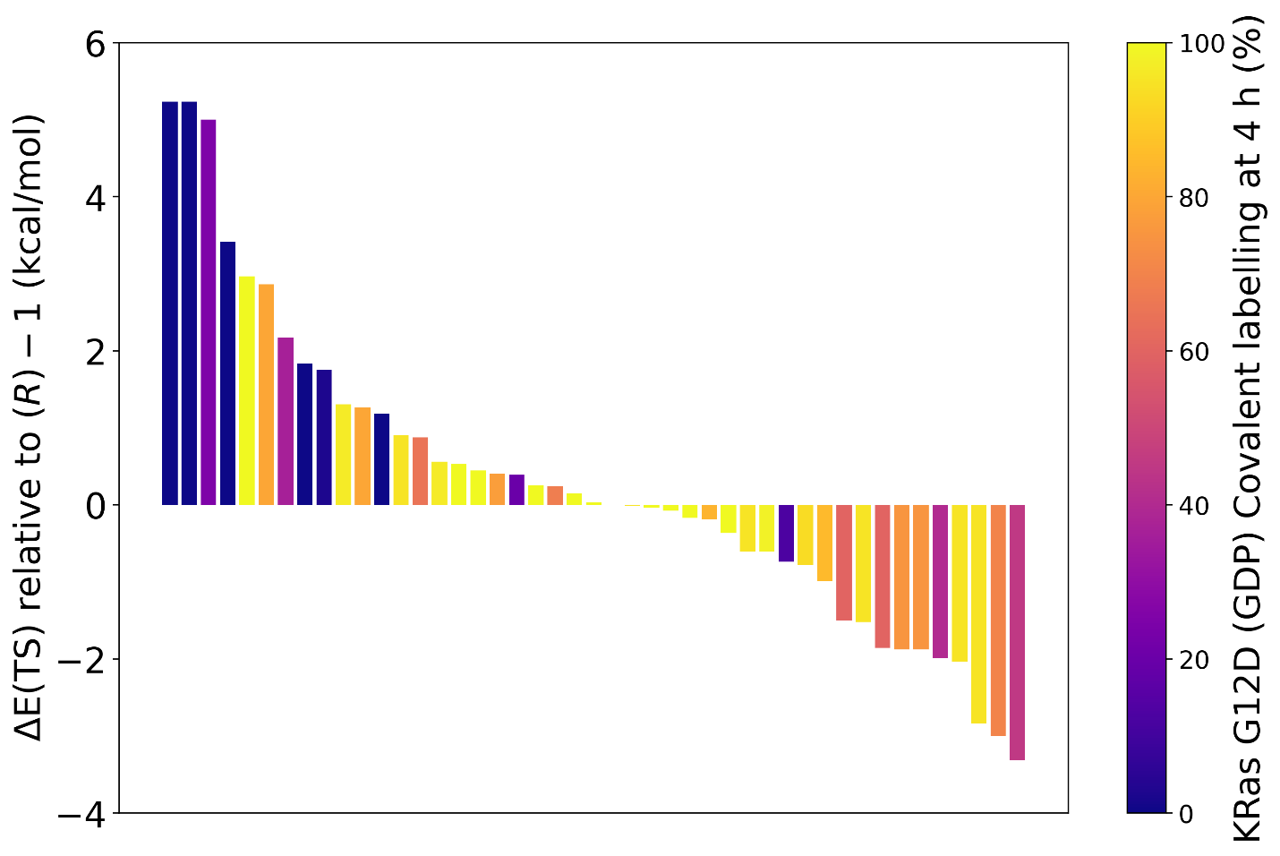***Figure SI-7.*** *Transition state energies (ΔETS) relative to the di-methyl (R)-****1*** *for 45 β-lactones which were selected for synthesis. The bar plot is colored by measured % covalent labelling of KRASG12D (GDP-bound) after 4 hours. Novel lactones with ΔETS within approximately ±1 kcal/mol of the reference compound typically maintained similar labelling reactivity.*

### SAR tables with standard deviations

#### Table SI-1.

#### Table SI-2.

# MATERIALS AND METHODS

### Quantum mechanical transition state calculations

All transition state energy calculations and dihedral scans were performed using Gaussian09 [Frisch et al] at the B3LYP/6-31g* level with application of an implicit solvent water environment via IEFPCM. We used the X-ray co-crystal structure of KRASWT (GDP-bound) - (*R*)-**1 to** obtain starting coordinates for the bridged amine with β-lactone warhead and the KRASG12D (GDP-bound) - (*RS*)‑G12Di‑1 X-ray co-crystal structure [Zheng et al] for coordinates of the Asp12 side‑chain. To aid minimization and retain the presumed bioactive conformation, constraints were applied: The bridged amine with β-lactone warhead was optimized with dihedral constraints on the dihedral determining rotation about the amide nitrogen-carbonyl bond and the dihedral determining rotation about the carbonyl-C4 bond. Separately, the Asp12 side-chain was optimized with a dihedral constraint on the χ2 rotation. Finally, a transition state scan was performed on the complex of bridged amine with β-lactone warhead and Asp12 side‑chain, with inspection of the vibrational modes confirming that the transition state had been identified (an imaginary frequency was found). In all cases, the reaction coordinate identified in the transition state was breaking of the C4-oxygen bond of the β‑lactone resulting in covalent attachment of Asp12 to C4 and conversion of the β‑lactone to a carboxylic acid. The transition state energy (sum of electronic potential energy and zero-point energy) is then reported as the energy of the optimized transition state minus the energy of the optimized bridged amine with β-lactone warhead, the energy of the optimized Asp12 side-chain and the energy of a single proton released during the SN2 nucleophilic attack. We determined the proton energy as the energy difference between a H3O+ hydronium ion and a water molecule.

In order to evaluate multiple β‑lactones under consideration for synthesis with novel substituents at the C3 position, a computational pipeline was constructed. First, novel β‑lactone coordinates were generated using the ConstrainedEmbed module of rdkit [RDKit], using the (*RS*)-G12Di-1 bridged amine with β-lactone as reference coordinates. This procedure was repeated 20 times using a different random seed to obtain a number of candidates for the reactant energy optimization. Each of these candidates were energy minimized with the XTB semi-empirical method [Bannwarth] using the same dihedral constraints as described previously. The atomic coordinates of the bridged amine with β-lactone ring were also frozen during the XTB optimization, ensuring only the C3 substituents are free to minimize. The lowest energy candidate was then used for DFT optimized of the novel β‑lactone in absence of the Asp12 side-chain. We used the same embedding and XTB minimization procedure to prepare transition state starting coordinates in complex with the Asp12 side‑chain.

Zheng [Strain-release alkylation of Asp12 enables mutant selective targeting of K-Ras-G12D | Nature Chemical Biology](https://www.nature.com/articles/s41589-024-01565-w)

Frisch [Gaussian 09 Citation | Gaussian.com](https://gaussian.com/g09citation/)

RDKit: Open-source cheminformatics; <http://www.rdkit.org>

Bannwarth [GFN2-xTB—An Accurate and Broadly Parametrized Self-Consistent Tight-Binding Quantum Chemical Method with Multipole Electrostatics and Density-Dependent Dispersion Contributions | Journal of Chemical Theory and Computation (acs.org)](https://pubs.acs.org/doi/10.1021/acs.jctc.8b01176)

### Intact MS and kinetic data

#### Protein production KRAS G12D

The cDNA encoding human KRAS G12D (1-169) fused to a cleavable poly-histidine tag (TEV protease) at the amino-terminal end were codon optimized and synthetized. The DNA fragments were inserted in a pET derived vector and point mutations were introduced by site-directed mutagenesis following standard protocols. Expression was performed overnight at 16 °C in *E. coli* BL21(DE3) strain transformed with the expression vector, after induction with IPTG. Cell pellets were resuspended in buffer A (20 mM Tris, 500 mM NaCl, 5 mM imidazole, 2 mM TCEP, 10% glycerol, pH 8.0) supplemented with Turbonuclease (Merck) and complete protease inhibitor tablets (Roche). The cells were lysed through a homogenizer (Avestin) at 800-1000 bar and the lysate was clarified by centrifugation at 40000 g for 40 min. The lysate was loaded onto a HisTrap HP column (Cytiva). The resin was washed with buffer A and bound protein was eluted with a linear gradient to buffer B (buffer A supplemented with 200 mM imidazole). To remove the poly-histidine tag, proteolytic cleavage by TEV protease was carried out over night during dialysis against buffer A. The protein solution was re-loaded onto a HisTrap column and the flow through containing the target protein was collected. Proteins were finally loaded onto a Superdex 75 size exclusion column (Cytiva) pre-equilibrated with SEC Buffer (20 mM HEPES pH 7.5, 150 mM NaCl, 5 mM MgCl2). To obtain protein fully loaded with GMPPNP, nucleotide exchange was performed by incubating the KRAS G12D protein during 1 hour at room temperature with a 24 molar excess of GMPPNP (Jena Bioscience) in presence of 25 mM EDTA. The mixture buffer was then exchanged using a PD-10 column (Cytiva) against nucleotide loading buffer (40 mM Tris pH 8.0, 200 mM (NH4)2SO4, 0.1 mM ZnCl2). A fresh 24 molar excess of nucleotide was again added. Ten units of Shrimp Alkaline Phosphatase (New England Biolabs) were added to the samples containing GMPPNP. After incubation for 1 hour at 4 ºC MgCl2 was added to a concentration of 30 mM. After nucleotide exchange the RAS proteins were further purified over a Superdex 200 size exclusion column (Cytiva) pre-equilibrated with final SEC buffer (20 mM HEPES, 150 mM NaCl, 5 mM MgCl2, 2 mM TCEP, pH 7.5). Nucleotide exchange was verified by ion-pairing chromatography [x].

[x] Eberth A, Ahmadian MR. In vitro GEF and GAP assays. Curr Protoc Cell Biol. 2009 Jun;Chapter 14:Unit 14.9. doi: 10.1002/0471143030.cb1409s43. PMID: 19499504.

#### Quantification of covalent modification by Intact MS

**Single time point.** Compounds were assessed for covalent binding by intact MS. Compounds were incubated at a final concentration of 10 µM with 1 µM KRAS G12D, fully loaded with GDP or GMPPNP in MS assay buffer (2 mM Tris pH 7.5, 150 mM NaCl, 10 mM MgCl2, 50 µM of the corresponding nucleotide, 1% DMSO) at room temperature. After 4 h, the sample was measured using a QToF Waters UPLC device (e.g. Acquity UPLC/Xevo G2-XS QTof MS(ESI)). For the LC method, an ultra-fast gradient was used, mostly for desalting. The retention range containing protein was deconvoluted using MassLynx software (Waters Inc) and % modification was derived from the spectra comparing the signal of modified and unmodified protein within that range.

**Kinetic MS to obtain apparent kinact/KI.** Serial dilutions of the test compounds (20 µM, 1:2 dilution steps) were prepared in 384-well plates and incubated with 1 µM KRAS G12D fully loaded with GDP or GMPPNP in 20 mM Tris pH 7.5, 150 mM NaCl, 10 mM MgCl2, 1% DMSO at room temperature. Reactions were quenched at different time points by addition of formic acid to 1%. As for single time point measurements, a QToF Waters UPLC device using an ultra-fast gradient in the LC method was used. For quantification the MaxEnt charge deconvolution algorithm of Genedata Expressionist was used to automate the processing of the data. Plotting the % modification obtained in intact MS vs. time allowed for extraction of kobs values for the different compound concentrations. In a second step, the obtained kobs values were plotted against the compound concentrations. Rate constants (i.e. kinact/KI) were derived from the initial linear part of the resulting curves. In parallel to the MS measurements, compound solubility was assessed by nephelometry and compound concentrations resulting in measurable turbidity were excluded from curve fitting.

### Intrinsic chemical reactivity towards GSH

To assess the intrinsic chemical reactivity toward GSH, compounds were incubated with a large excess of reduced GSH in 69 mM phosphate buffer pH 7.4 (assay buffer) at 37 °C, and the disappearance of the compounds was determined by LCMS-based quantification. A CTC PAL RTC instrument was used for sample preparation and for handling the transfer of aliquots to subsequent LCMS analysis. All assay solutions were kept at 37 °C throughout the duration of the assay. In the sample preparation step, the compounds were first diluted from a 10 mM DMSO solution into the assay buffer to a final concentration of 2 μM. In addition, 0.5 μM glyburide was present in the assay buffer and used as internal standard. After being mixed, this solution was then split into equal parts, and reduced GSH was added to one of the solutions to a final concentration of 5 mM. Of this GSH-containing sample, aliquots were taken after 10 min, 30 min, 1 h, 2 h, 4 h, 8 h, 16 h, and 24 h, while of the control sample (absence of GSH), aliquots were taken at 0, 8, 16, and 24 h. All aliquots were analyzed by LCMS immediately after their removal. Chromatography was performed with Accela system (ThermoFisher) using a Hypersil GOLD column (50 × 1 mm, 1.9 μM) and applying a 3 min method using solvents A (acetonitrile + 0.08% formic acid) and B (water + 0.08% formic acid) with a flow rate of 0.2 mL/min. The gradient started with 95% A/5% B and changed to 5% A/95% B between 0.1 and 0.6 min and then changed back to 95% A/5% B between 2.4 and 2.5 min of the method. A Q-Exactive Plus (ThermoFisher) mass spectrometer was used to perform full mass scans using heated electrospray ionization (HESI) and a mass range of 150–1200 *m*/*z*. Instrument parameters were set to sheath gas flow rate, 15; auxiliary gas flow rate, 10; sweep gas flow rate, 1; spray voltage, 3.60 kV; spray current, 16.70 µA; capillary temperature, 320 °C; S-lens RF level, 60; auxiliary gas heater temperature, 380 °C. Selected mass traces were analyzed and integrated with the Chromeleon software. The area derived for the parent compound was normalized against the area of glyburide. The normalized areas of the parent compound were plotted in a linearized fashion by determining the logarithmic value of the remaining percent of parent compound versus time, and the pseudo first-order rate constant *k* was obtained by calculating the slope of the linear regression curve. The half-life was then derived from the rate constant. In addition to the parent compound and the internal standard, the mass spectra were also scanned for the presence of the GSH adduct.

### X-ray co-crystal structures

All crystallization trials were performed using the sitting-drop vapour-diffusion method at room temperature. Equal volumes (0.2 µL) of protein-compound solution and reservoir solution were mixed and equilibrated against 80 mL reservoir solution. Compounds were added to the protein solution using a 100 mM DMSO stock solution. Cysteine residues of the KRASG12D protein used for co-crystallization of the covalent inhibitor complex were mutated to C51S, C80L and C118S. The KRAS protein constructs included residues 1-169 lacking the C-terminal hypervariable regions. Crystals grow typically within a few days.

Co-crystals of KRASWT – GDP in complex with (*R*)-**1** were obtained by mixing 0.2 mL protein-inhibitor solution containing 19.2 mg/ml KRASWT-GDP in 20 mM Hepes pH 7.5, 150 mM NaCl, 5 mM MgCl2 and 10 mM (*R*)-**1** with 0.2 mL reservoir solution (20% PEG 4000, 0.2 M (NH4)2SO4) and equilibrating against 80 mL reservoir solution.

Co-crystals of KRASG12D – GDP in complex with (3*R*,4*R*)-**3** or (3*S*,4*R*)-**8** were obtained by mixing 0.2 mL protein-inhibitor solution containing 19.4 mg/ml KRASG12D – GDP, 50 mM Hepes pH 7.5, 150 mM NaCl, 5 mM MgCl2 and 10 mM (3*R*,4*R*)-**3** or 10 mM (3*S*,4*R*)-**8** with 0.2 mL reservoir solution (30% PEG 1000, 0.2 M (NH4)2SO4 for (3*R*,4*R*)-**3** and 30% PEG 1000, 0.2 M NaH2PO4 for (3*S*,4*R*)-**8**) and equilibrating against 80 mL reservoir solution.

For data collection, crystals were flash cooled in liquid nitrogen. X-ray diffraction data were collected from single crystals at the Swiss Light Source, beamline X10SA equipped with an EIGER detector for the KRASWT-GDP-(*R*)-**1** and KRASG12D-GDP-(3*R*,4*R*)-**3** complexes and at the European Synchrotron Radiation Facility, beamline ID23-1 equipped with an EIGER detector for the KRASG12D-GDP-(3*S*,4*R*)-**8** complex. The diffraction data were processed and scaled with XDS/XSCALE1 and the autoPROC2 toolbox. The structures were solved by molecular replacement with PHASER3 using the coordinates of internally solved KRAS structures. The first internal KRAS structure was solved using the PDB code 4LRW as search model. The software programs COOT4 and BUSTER5 were used for iterative rounds of model building and structure refinement. Images were generated using the program PyMOL6.

1) Kabsch, W. (2010) XDS. Acta Crystallographica D, 66, 125-132.

2) Vonrhein C., Flensburg C., Keller P., Sharff A., Smart O., Paciorek W., Womack T., Bricogne G. Data processing and analysis with the autoPROC toolbox. Acta Crystallogr. 2011 D67, 293-302.

3) McCoy A.J., Grosse-Kunstleve R.W., Adams P.D., Winn M.D., Storoni L.C., Read R.J. Phaser crystallographic software. J. Appl. Crystallogr. 2007, 40, 658–674.

4) Emsley P. & Cowtan K. Coot: model-building tools for molecular graphics. Acta Crystallogr. 2004 D60, 2126–2132.

5) Bricogne G., Blanc E., Brandl M., Flensburg C., Keller P., Paciorek W., Roversi P., Sharff A., Smart O.S., Vonrhein C., Womack T.O. 2017. BUSTER version 2.11.8. Cambridge, United Kingdom: Global Phasing Ltd.

6) DeLano, W.L. The PyMOL Molecular Graphics System. DeLano Scientific LLC, San Carlos, CA, USA (2002); [http://www.pymol.org](http://www.pymol.org/).

|  |  |  |  |
| --- | --- | --- | --- |
|  | KRASWT-GDP-(*R*)-**1** | KRASG12D-GDP-(3*R*,4*R*)-**3** | KRASG12D-GDP-(3*S*,4*R*)-**8** |
| **Data collection** |  |  |  |
| Space group | *P*212121 | *P*212121 | *P*212121 |
| Cell dimensions |  |  |  |
| *a*, *b*, *c* (Å) | 40.4, 52.0, 89.7 | 40.4, 51.9, 90.4 | 40.2, 53.0, 89.8 |
| *a*, *b*, *g* (°) | 90, 90, 90 | 90, 90, 90 | 90, 90, 90 |
| Resolution (Å) | 1.31 (1.45-1.31) * | 1.55 (1.69-1.55) * | 1.20 (1.28-1.20) * |
| Rpim/*R*merge(%) | 2.6/7.6 (42.5/120) | 5.8/17.2 (50.2/145) | 3.5/10.1 (70.0/213) |
| *I*/s*I* | 11.3 (1.5) | 5.9 (1.5) | 10.1 (1.4) |
| Completeness (%) | 93.0 (58.3) | 94.3 (60.4) | 92.7 (50.2) |
| Redundancy | 9.8 (9.0) | 9.8 (9.2) | 10.1 (10.1) |
| CC(1/2) | 0.99 (0.69) | 0.99 (0.56) | 0.99 (0.55) |
|  |  |  |  |
| **Refinement** |  |  |  |
| Resolution (Å) | 24.02 - 1.31 | 45.21 - 1.55 | 24.01 - 1.30 |
| No. reflections | 34217 | 21979 | 46997 |
| *R*work/ *R*free | 19.7 / 21.9 | 18.5 / 21.3 | 19.7 / 20.8 |
| No. atoms |  |  |  |
| Protein | 1323 | 1310 | 1305 |
| Ligand/ion | 86 / 1 | 87 / 1 | 87 / 1 |
| Water | 203 | 185 | 211 |
| B-factors (Å2) | 18.3 | 21.9 | 17.2 |
| R.m.s deviations |  |  |  |
| Bond lengths (Å) | 0.012 | 0.010 | 0.013 |
| Bond angles (º) | 1.19 | 1.08 | 1.26 |

*\*Highest resolution shell is shown in parenthesis.*

### Cellular pERK assays

#### Compound dilution

Compound stock solutions were prepared in DMSO / H2O (90:10) by the compound hub at Novartis Pharma AG Basel. Compounds were tested with a 10-point serial dilution 1:3 with a starting concentration of 10 µM. The dilution plate was prepared with a BioMek i7.

#### Cells and cell culture conditions

The pancreatic line SW1990 (KRASG12D) was obtained from ATCC and maintained in RPMI-1640 (Gibco, 61870036) containing 10% FCS (FetalClone® II, US origin, HyClone™, SH30066.03HI) at 37 °C and 5% CO2 as specified by the provider. Cells were passaged by centrifuging in the respective culture media, and split into fresh media at a ratio of 1:10, twice per week.

| **Name** | **Disease** | **Supplier** | **Cat no.** |
| --- | --- | --- | --- |
| SW1990 | Pancreatic adenocarcinoma | ATCC | CRL-2172 |

#### Assessment of pERK1/2 levels in whole cell lysates by HTRF technology

The entire process was performed according to the manufacturer’s instructions and using buffers provided in the kit (#64AERPEH, PerkinElmer). SW1990 (KRASG12D) cells were plated in a 384-well plate (#784080, Greiner) at a density of 10’000 cells/well in 12 µL growth media without phenol red and incubated overnight at 37 ˚C, 95% CO2. The next day, cells were treated with the corresponding compounds using an ECHO acoustic dispenser with increasing concentrations of compound for 4 hours and then lysed using 4 µL lysis buffer per well. The plates were placed on a plate shaker for 30 min at 600 rpm at room temperature and finally 4 µL of antibody mix were added. The plates were then incubated overnight at room temperature in the dark without shaking. Finally, the plates were read using a PheraStar (HTRF optic module, lag time 60 µs, integration time 400 µs, 300 flashes).

#### Calculation and normalization

Percent of DMSO control in each sample was calculated using following equations:

$$Phospho ratio = \left(\frac{raw signal A}{raw signal B}\right)* 10000$$

Absolute qualified AC50 were analyzed with the standard Novartis in-house assay data analysis software (Helios software application, Novartis BioMedical Research, unpublished) using the methods described by H Gubler 2006, I Formenko 2006, DP Normolle 1993, JL Sebaugh 2011, C Kelly 1990, M Kahm 2010.

### Target occupancy assay by Western blot

#### Compound dilution

Compound 10 mM stock solution were prepared in DMSO / H2O (90:10) by the compound hub at Novartis Pharma AG Basel. Compounds were tested at 10 µM final concentration.

#### Cells and cell culture conditions

The pancreatic cell line SW1990 (KRASG12D) was obtained from ATCC and maintained in RPMI 1640 + GlutaMax (61870, Gibco) supplemented with 10% FBS (Corning 35-015-CV) and 1% penicillin–streptomycin (BioConcept #4-01F00-H), at 37 °C and 5% CO2 as specified by the provider. Cells were passaged by centrifuging in the respective culture media, and split into fresh media at a ratio of 1:10, twice per week.

| Name | Disease | Supplier | Cat no. |
| --- | --- | --- | --- |
| SW1990 | Pancreatic adenocarcinoma | ATCC | CRL-2172 |

#### Target occupancy Western blot

SW1990 cells were seeded into 6-well plates at a density of 0.5x106 cells per well in culture media and incubate overnight at 37 °C and 5% CO2. After the overnight incubation, cells were treated for 4 hours with compounds at final concentration of 10 µM. Cell lysis was performed in NP40/RIPA lysis buffer containing a protease inhibitor cocktail (Roche 11836153001). Protein concentration was measured using the Coomassie Plus Assay Kit (Thermo Scientific #XG346237). Samples were diluted to 15 µg protein per 10 µL with lysis buffer and 4x Lämmli sample buffer, then incubated at room temperature for 30 minutes. SDS-PAGE was conducted with MES buffer on Bis-Tris gels (Invitrogen). Proteins were transferred onto a nitrocellulose membrane (BioRad 170-4156) using a BioRad Trans Blot Turbo. Membranes were blocked for 1.5 hours at room temperature with 5% skim milk. The following Antibodies were used for Western Blot: KRAS G12D rabt mAb; CST#14429 and hGAPDH, rbt #80570-1-RR, Proteintech. Blots were incubated with primary antibody over night at 4 °C and treated with secondary antibody for 1 h at room temperature: LICOR IRDye 800CW Goat Anti-Rabbit IgG. The readout was performed using a Licor Odyssey M reader and analyzed with Empiria Studio Software. The reduction in Western Blot signal is associated with the covalent compound blocking the primary antibody epitope.

### Peptide mapping studies on recombinant KRASG12D

KRASG12D protein (1 µM, 50 µL) in 25 mM HEPES, 150 mM NaCl, pH 7.4 was treated with 10 µM of (*R*)-**1** at 23 °C for 2 h. Full labeled by *R*)-**1** is confirmed by intact MS as previously described. Samples were then buffer exchanged with 20 mM HEPES, pH 8 to remove excess *R*)-**1** prior to digestion. For pepsin digestion, treated samples were buffer exchanged with pH 5.5 buffer. Samples were then digested with 1.5 µg of pepsin for 5 minutes at 23 °C. Pepsin activity was quenched by addition of HALT protease cocktail (Thermo) to 1X final volume. For digestion with trypsin (Thermo) or GluC (Promega), samples were first reduced with 5 mM DTT for 30 minutes at 55 °C. After cooling to 23 °C, samples were alkylated with 20 mM iodoacetamide for 30 minutes in the dark. Samples were digested with 1.5 µg of trypsin for 2 h, 3 h, or 18 h at 37 °C. For GluC digestion, alkylated samples were buffer exchanged with pH 5.5 buffer and then digested with 1.5 µg GluC overnight at 37 °C.

Peptide mapping and quantitation were performed using reversed-phase separation coupled to an Orbitrap Q Exactive mass spectrometer. Samples (10 µL) were injected onto a reversed-phase (C18) (Agilent ZORBAX Extend-C18, 1.0 mm x 150 mm, 3.5 μm particle size) for separation and eluted over a 22 minutes gradient from 2% to 45% mobile phase B (Mobile Phase A = 0.1% formic acid in water, B = acetonitrile with 0.1% formic acid). The eluted peptides were then analyzed using data-dependent MS acquisition (DDA). Full MS Scan: 70,000 Resolution, AGC Target 1e5, m/z 325–1500 ddMS2 Settings; 35,000 resolution, AGC Target 1e5, max IT 75 ms, Isol window 2.0 m/z, NCE 25, Charge Exclusion >6, Min AGC Targe 5e4, and dynamic exclusion 5s. The resulting raw data files were processed and analyzed using Proteome Discoverer 2.4 (Thermo).

### iTrace proteome-wide reactivity profiling

Cysteine profiling proteomics was performed as previously described (JDQ443 Cancer Discovery). NCI-H358 cells were seed at 1x106 cells per 15 cm dish and cultured until confluent. Cells were then treated with DMSO, JDQ443 or Sotorasib at 10 μM for 6 hours in triplicate. Cells were washed and pelleted before resuspension in 50 mM HEPES pH 7.5, 150 mM NaCl, 1.5 mM MgCl2, 0.8% NP-40. Pellets were lysed by probe sonication (amplitude 10, 1s on/ 1s off, for 30s). Lysates were cleared by centrifugation at 1000 rpm for 5 minutes at 4 °C. Protein content of the resulting lysates were normalized, and 1 mg/sample was treated with biotin-PEG4-DADPS-C6-iodoacetamide at 100 μM for 1 hour at room temperature. Excess biotin probe was removed by cleanup through Zeba 7K MWCO columns. Lysates were denatured with 200 μL 8 M urea, reduced with 10 mM DTT for 15 minutes and alkylated with 55 mM iodoacetamide for 1 hour. The denatured, alkylated proteins were digested with 20 μg LysC/trypsin (Promega) for 2 hours at 37 °C. After dilution to 1 M urea, biotinylated peptides were enriched by incubating with 100 μL ultralink streptavidin agarose (Thermo) for 1 hour at room temperature with rotation. Beads were transferred to a 1.2 μm filter plate and washed 2x with 1 mL 5% MeOH and 2x with 1 mL 50 mM HEPES pH 8. Peptides were eluted by cleaving the DADPS linker with 300 μL 10% formic acid for 1 hour at room temperature. The eluted peptides were collected by centrifugation and concentrated by evaporation. The resulting concentrated peptides were resuspended in 40 μL 50 mM HEPES pH 8, 60 μL acetonitrile and 50 μL TMT label in acetonitrile (Thermo). TMT labeled samples were pooled and fractionated as previously described (17). The resulting fractions were combined in 24 fractions and concentrated by evaporation. Fractions were analyzed by nanoLC-MS/MS using an Easy-nLC 1000 high-performance liquid chromatography system (Thermo) interfaced with an Orbitrap Eclipse Tribrid Mass Spectrometer (Thermo). A Kasil-fritted trapping column (75 µm x 15 mm) packed with 5 μm ReproSil-Pur 120 C18-AQ, was used together with a fused silica spraying capillary pulled to a tip diameter of 8-10 μm using a P-2000 capillary puller (Sutter Instruments). The capillary tubing (75 µm I.D.) was packed with a 120 mm separation column comprised of 3 um ReproSil-Pur C18 AQ. Samples (10 µL) were injected onto the trapping column using 0.1% formic acid/2% acetonitrile in water at a flow rate of 2.5 µL/min. Trapped peptides were then introduced into the separation column and eluted at 300 nL/minute using a mobile phase A: 2% acetonitrile + 0.1% formic acid in water and a mobile phase B: 98% acetonitrile + 0.1% formic acid in water with over a gradient of 3-45% B over 90 min. MS1 scans were acquired from m/z 400-1600 at 100,000 mass resolution with a triggering intensity threshold of 400,000 ions. MS2 scans were acquired using 50,000 mass resolution, HCD with 38% collision and 0.7 Da isolation window. MS2 AGC target was 1.25e5 using an 86 ms maximum injection time. Raw files were processed using Proteome Discoverer 2.4. Data was searched against a reference human proteome including the KRASG12C mutant sequence using Mascot.

### PK study

Concentrations of (3*S*, 4*R*)-**11** in total blood were determined by liquid chromatography–tandem mass spectrometry (LC–MS/MS). After protein precipitation, supernatants were analyzed by LC–MS/MS with an internal standard and quantified by comparing to authentic standards. PK parameters were calculated by using a noncompartmental methods (Phoenix, Certara). LBF is rat liver blood flow, assumed to be 80 mL/min/kg.1

|  |  |  |
| --- | --- | --- |
| (3*S*, 4*R*)-11 rat PK | 0.3 mg/kg i.v. | 1 mg/kg p.o. |
| Formulation | NMP:4%BSA in PBS (10:90) | MC:Tween80:Water (0.5:0.1:99.4) |
| CL [mL/min/kg] | 71 |  |
| CL of LBF | 59% |  |
| AUCt [nM.h] | 88.5 | 8.3 |
| Oral bioavailability (F) |  | 0.94% |

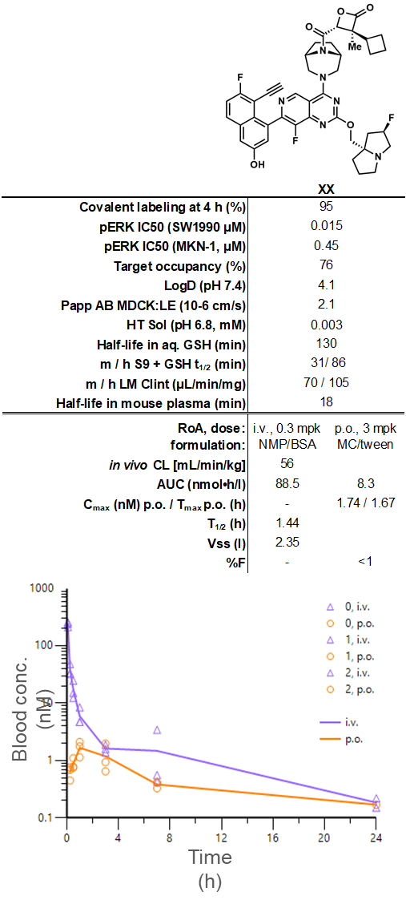

### PK/PD study

PK/PD studies and DUSP6 analysis were performed as previously described (Weiss et al, Cancer Discovery, 2022). Female athymic Clr:NU(NCr)-*Foxn1nu*-homozygous nude mice were subcutaneously injected with 5x106 PK-59 tumor cells in HBSS/Matrigel (50/50) matrigel. Animals were treated once intraperitoneally. Compounds were formulated in PG/Kolliphor/Water (20/5/75) (for 3*S*,4*R*-**11**) or 20% SBE-β-CD in 50 mM citric acid pH5 (for MRTX-1133).

# SYNTHETIC METHODS AND PROCEDURES

Unless otherwise specified, all solvents and reagents were obtained from commercial suppliers and used without further drying or purification. SiliaMetS®Thiol SiliCYCLE thiol metal scavenger – (R51030B, Particle Size: 40-63 µm) was obtained from SiliCYCLE. Normal-phase flash chromatography was run on silica gel using prepacked columns: pre-packed RediSep Rf cartridges, or SNAP cartridges. 1H NMR and 13C spectra were recorded on a Bruker Ultrashield™400 (400 MHz), Bruker Ultrashield™600 (600 MHz) and Bruker AscendTM400 (400 MHz) spectrometers, both with and without tetramethylsilane as an internal standard. High-resolution mass spectra (HRMS) measurements: LC/ESI-MS and LC-UV data were recorded using a Thermo Scientific Q Exactive Plus mass spectrometer equipped with an electrospray ionization source and coupled to a Thermo Ultimate 3000 liquid chromatograph equipped with a diode array detector. The instrument was lock mass calibrated with the protonated di-octylphtalate ion (m/z 391.28429). The accurate mass was obtained by averaging 6 scans at a mass resolution of ca 70000 (FWHM definition). The mass accuracy of the system has been found to be better than 2 ppm. The chromatography was performed at 150 µL/min flow rate (1 mm C18-column) with a polar gradient from 5% to 100% acetonitrile in 5 min. 0.05 % and 0.04% formic acid was used as the modifier additive in the mobile phases water and acetonitrile, respectively. Liquid chromatography mass spectra (LC−MS) were determined by using electrospray ionization in positive and negative ion modus using a Waters Acquity UPLC instrument with Waters SQ detector. Purity was determined by integration of the area under the UV absorption curve at λ 210 to 450 nm and by 1H NMR, all final compounds reported were ≥95%. Rt refers to retention time. The following conditions were used for analytical UPLC:

LCMS_10_MIN_FINAL_ANALYSIS BS_SQ22 and LCMS_10_MIN_FINAL_ANALYSIS BS_SQ02

UPLC-MS-1: Column Type: ACQUITY UPLC® BEH C18 1.7µm, Column Dimension: 2.1x100 mm, Column Temperature:80.0 °C, Gradient: from 5 to 60 % B in 8.4 min; 60 to 98 % B in 1.0 min, Eluent A: water + 0.05 % FA + 3.75 mM AA, Eluent B: isopropanol + 0.05 % FA, Flow: 0.4 mL/min

LCMS_**02**_MIN_FINAL_ANALYSISBS_SQ22

UPLC-MS-2: Column Type: CORTECS™ C18+ 2.7µm, Column Dimension: 2.1x50 mm, Column Temperature:80.0 °C, Gradient: from 5 to 50 % B in 1.4 min; 50 to 98 % B in 0.3 min, Eluent A: water + 0.05 % FA + 3.75 mM AA, Eluent B: isopropanol + 0.05 % FA, Flow: 1.0 mL/min.

LCMS_02_MIN_ELSD:

LCMS-1: HALO C18; particle size: 5 µm; column size: 3.0 x 30 mm; eluent A: H2O + 0.0375% TFA, B: Acetonitrile + 0.01875% TFA; gradient: 0.01 min 5% B; 5 to 95% B in 0.5 min, 0.3 min 95% B, 95 to 5% B in 0.01 min, 0.24 min 5% B; flow rate: 1.5 mL/min; column temperature: 50°C.

LCMS-2: HALO 90A C18; particle size: 5 µm; column size: 3.0 x 30 mm; eluent A: H2O + 0.0375% TFA, B: Acetonitrile + 0.01875% TFA; gradient: 5 to 95% B in 0.5 min, 0.3 min 95% B, 95 to 5% B in 0.01 min, 0.24 min 5% B; flow rate: 1.5 mL/min; column temperature: 50°C.

LCMS-3: HALO 90A C18; particle size: 5 µm; column size: 3.0 x 30 mm; eluent A: H2O + 0.0375% TFA, B: Acetonitrile + 0.01875% TFA; gradient: 0 to 60% B in 0.5 min, 0.3 min 60% B, 60 to 0% B in 0.01 min, 0.24 min 0% B; flow rate: 1.5 mL/min; column temperature: 50°C.

LCMS-4: HALO C18; particle size: 5 µm; column size: 3.0 x 30 mm; eluent A: H2O + 0.0375% TFA, B: Acetonitrile + 0.01875% TFA; gradient: 0 to 60% B in 0.5 min, 0.3 min 60% B, 60 to 0% B in 0.01 min, 0.24 min 0% B; flow rate: 1.5 mL/min; column temperature: 50°C.

LCMS-5: Kinetex EVO C18; particle size: 5 µm; column size: 2.1 x 30 mm; eluents A: H2O + 0.025% NH3•H2O; B: Acetonitrile; gradient: 5 to 95% B in 0.8 min, 0.4 min 95% B, 95 to 5% B in 0.01 min, 0.34 min 5% B; flow rate: 1.5 mL/min; column temperature: 50°C.

LCMS-6: Kinetex EVO C18; particle size: 5 µm; column size: 2.1 x 30 mm; eluents A: H2O + 0.025% NH3•H2O; B: Acetonitrile; gradient: 0 to 60% B in 0.8 min, 0.4 min 60% B, 60 to 0% B in 0.01 min, 0.34 min 0% B; flow rate: 1.5 mL/min; column temperature: 50°C.

HPLC-1: HALO C18; particle size: 2.7 µm; column size: 3.0 x 50 mm; A: H2O + 0.0375% TFA, B: Acetonitrile + 0.01875% TFA; gradient: 10 to 80% B in 4.1 min, 0.9 min 80% B, 80 to 10% B in 0.01 min, 0.19 min 10% B; flow rate: 1.2 mL/min; column temperature: 50°C.

HPLC-2: HALO C18; particle size: 2.7 µm; column size: 3.0 x 50 mm; A: H2O + 0.0375% TFA, B: Acetonitrile + 0.01875% TFA; gradient: 10 to 80% B in 1.9 min, 0.7 min 80% B, 80 to 10% B in 0.01 min, 0.59 min 10% B; flow rate: 1.2 mL/min; column temperature: 50°C.

HPLC-3: X Bridge C18; particle size: 5 µm; column size: 2.1 x 50 mm; eluents A: H2O + 0.025% NH3•H2O; B: Acetonitrile; gradient: 10 to 80% B in 2.4 min, 0.4 min 80% B, 80 to 10% B in 0.01 min, 0.79 min 10% B; flow rate: 0.8 mL/min; column temperature: 40°C.

SFC-1: Chiralpak IF-3; particle size: 3 µm; column size: 50 × 4.6 mm I.D.; mobile phase: phase A for CO2, and phase B for IPA(0.05%DEA); gradient elution: IPA(0.05%DEA) in CO2 from 5% to 40%; flow rate: 3 mL/min; detector: PDA; column temperature: 35 °C; back pressure: 100 bar.

SFC-2: Chiralpak IC-3; particle size: 3 µm; column size: 50 × 4.6 mm I.D.; mobile phase: phase A for CO2, and phase B for IPA + MeCN (0.05%DEA); gradient elution: IPA + MeCN (0.05%DEA) in CO2 from 20% to 60%; flow rate: 3 mL/min; detector: PDA; column temperature: 35 °C; back pressure: 100 bar.

SFC-3: Chiralcel OD-3; particle size: 3 µm; column size: 50 × 4.6 mm I.D.; mobile phase: phase A for CO2, and phase B for EtOH (0.05%DEA); gradient elution: EtOH (0.05%DEA) in CO2 from 5% to 40%; flow rate: 3 mL/min; detector: PDA; column temperature: 35 °C; back pressure: 100 bar.

SFC-4: Chiralcel OJ-3; particle size: 3 µm; column size: 50 × 4.6 mm I.D.; mobile phase: phase A for CO2, and phase B for MeOH (0.05%DEA); gradient elution: 40% MeOH(0.05%DEA) in CO2; flow rate: 3 mL/min; detector: DAD; column temperature: 35 °C; back pressure: 100 bar.

SFC-5: Chiralpak IC-3; particle size: 3 µm; column size: 50 × 4.6 mm I.D.; mobile phase: phase A for CO2, and phase B for IPA (0.05%DEA); gradient elution: IPA (0.05%DEA) in CO2 from 5% to 40%; flow rate: 3 mL/min; detector: PDA; column temperature: 35 °C; back pressure: 100 bar.

SFC-6: Chiralpak AD-3; particle size: 3 µm; column size: 50 × 4.6 mm I.D.; mobile phase: phase A for CO2, and phase B for IPA+ACN(0.05%DEA); gradient elution: IPA+ACN(0.05%DEA) in CO2 from 20% to 60%,; flow rate: 3 mL/min; detector: PDA; column temperature: 35 °C; back pressure: 100 bar.

SFC-7: Chiralpak IE-3; particle size: 3 µm; column size: 50 × 4.6 mm I.D.; mobile phase: phase A for CO2, and Phase B for IPA(0.05%DEA); gradient elution: IPA(0.05%DEA) in CO2 from 5% to 40%,; flow rate: 3 mL/min; detector: PDA; column temperature: 35 °C; back pressure: 100 bar.

SFC-8: Chiralpak IG-3; particle size: 3 µm; column size: 50 × 4.6 mm I.D.; mobile phase: phase A for CO2, and Phase B for EtOH(0.05%DEA); gradient elution: EtOH (0.05%DEA) in CO2 from 5% to 40%,; flow rate: 3 mL/min; detector: PDA; column temperature: 35 °C; back pressure: 100 bar.

SFC-9: Chiralcel OJ-3; particle size: 3 µm; column size: 50 × 4.6 mm I.D.; mobile phase: phase A for CO2, and phase B for EtOH (0.05%DEA); gradient elution: EtOH(0.05%DEA) in CO2 from 5% to 40%; flow rate: 3 mL/min; detector: DAD; column temperature: 35 °C; back pressure: 100 bar.

SFC-10: Chiralpak IG-3; particle size: 3 µm; column size: 50 × 4.6 mm I.D.; mobile phase: phase A for CO2, and Phase B for IPA(0.05%DEA); gradient elution: IPA (0.05%DEA) in CO2 from 5% to 40%,; flow rate: 3 mL/min; detector: PDA; column temperature: 35 °C; back pressure: 100 bar.

SFC-11: Chiralpak AD-3; particle size: 3 µm; column size: 50 × 4.6 mm I.D.; mobile phase: phase A for CO2, and phase B for EtOH(0.05%DEA); gradient elution: EtOH(0.05%DEA) in CO2 from 20% to 60%,; flow rate: 3 mL/min; detector: PDA; column temperature: 35 °C; back pressure: 100 bar.

SFC-12: Chiralpak AS-3; particle size: 3 µm; column size: 50 × 4.6 mm I.D.; mobile phase: phase A for CO2, and phase B for IPA(0.05%DEA); gradient elution: IPA (0.05%DEA) in CO2 from 5% to 40%,; flow rate: 3 mL/min; detector: PDA; column temperature: 35 °C; back pressure: 100 bar.

SFC-13: Lux 3um Cellulose-4; particle size: 3 µm; column size: 50 × 4.6 mm I.D.; mobile phase: phase A for CO2, and phase B for IPA(0.05%DEA); gradient elution: IPA (0.05%DEA) in CO2 from 5% to 40%,; flow rate: 3 mL/min; detector: PDA; column temperature: 35 °C; back pressure: 100 bar.

SFC-14: Chiralpak IC-3; particle size: 3 µm; column size: 50 × 4.6 mm I.D.; mobile phase: phase A for CO2, and phase B for EtOH + MeCN (0.05%DEA); gradient elution: 50% EtOH+ MeCN (0.05%DEA) in CO2; flow rate: 3 mL/min; detector: PDA; column temperature: 35 °C; back pressure: 100 bar.

SFC-15: Chiralpak IC-3; particle size: 3 µm; column size: 50 × 4.6 mm I.D.; mobile phase: phase A for CO2, and phase B for EtOH + MeCN (0.05%DEA); gradient elution: 40% EtOH+ MeCN (0.05%DEA) in CO2; flow rate: 3 mL/min; detector: PDA; column temperature: 35 °C; back pressure: 100 bar.

SFC-16: Chiralcel OD-3; particle size: 3 µm; column size: 50 × 4.6 mm I.D.; mobile phase: phase A for CO2, and phase B for IPA + MeCN (0.05%DEA); gradient elution: IPA + MeCN (0.05%DEA) in CO2 from 20% to 60%; flow rate: 3 mL/min; detector: PDA; column temperature: 35 °C; back pressure: 100 bar.

SFC-17: Chiralcel OX-3; particle size: 3 µm; column size: 50 × 4.6 mm I.D.; mobile phase: phase A for CO2, and phase B for IPA(0.05%DEA); gradient elution: IPA (0.05%DEA) in CO2 from 5% to 40%,; flow rate: 3 mL/min; detector: PDA; column temperature: 35 °C; back pressure: 100 bar.

SFC-18: Chiralpak AD-3; particle size: 3 µm; column size: 50 × 4.6 mm I.D.; mobile phase: phase A for CO2, and phase B for EtOH(0.05%DEA); gradient elution: 40% EtOH(0.05%DEA) in CO2,; flow rate: 3 mL/min; detector: PDA; column temperature: 35 °C; back pressure: 100 bar.

SFC-19: Chiralpak AD-3; particle size: 3 µm; column size: 50 × 4.6 mm I.D.; mobile phase: phase A for CO2, and phase B for IPA(0.05%DEA); gradient elution: IPA(0.05%DEA) in CO2 from 5% to 40%,; flow rate: 3 mL/min; detector: PDA; column temperature: 35 °C; back pressure: 100 bar.

SFC-20: Chiralpak IC-3; particle size: 3 µm; column size: 50 × 4.6 mm I.D.; mobile phase: phase A for CO2, and phase B for EtOH + MeCN (0.05%DEA); gradient elution: 60% EtOH+ MeCN (0.05%DEA) in CO2; flow rate: 3 mL/min; detector: PDA; column temperature: 35 °C; back pressure: 100 bar.

SFC-21: Chiralpak IH-3; particle size: 3 µm; column size: 50 × 4.6 mm I.D.; mobile phase: phase A for CO2, and phase B for IPA(0.05%DEA); gradient elution: IPA(0.05%DEA) in CO2 from 5% to 40%; flow rate: 3mL/min; detector: PDA; Column temp: 35 °C; back pressure:100 bar.

SFC-22: Chiralcel OD-3; particle size: 3 µm; column size: 50 × 4.6 mm I.D.; mobile phase: phase A for CO2, and phase B and phase B for MeOH(0.05%DEA); gradient elution: MeOH (0.05%DEA) in CO2 from 5% to 40%; flow rate: 3mL/min; detector: PDA; Column temp: 35 °C; back pressure:100 bar.

SFC-23: (S,S)Whelk-O1; particle size: 3.5 µm; column size: 50 × 4.6 mm I.D.; mobile phase: phase A for CO2, and phase B for IPA(0.05%DEA); gradient elution: IPA(0.05%DEA) in CO2 from 5% to 40%; flow rate: 3mL/min; detector: PDA; column temp: 35 °C; back pressure:100 bar.

SFC-24: Chiralcel OJ-3; particle size: 3 µm; column size: 50 × 4.6 mm I.D.; mobile phase: phase A for CO2, and phase B for IPA(0.05%DEA); gradient elution: 40% IPA (0.05%DEA) in CO2; flow rate: 3mL/min; detector: PDA; column temp: 35 °C; back pressure:100 bar.

SFC-25: Column:(S,S)Whelk-O1; particle size: 3 µm; column size: 50 × 4.6 mm I.D.; mobile phase: phase A for CO2, and phase B for EtOH(0.05%DEA); gradient elution: EtOH(0.05%DEA) in CO2 from 20% to 60%, flow rate: 3mL/min; detector: PDA; column temp: 35°C; back pressure:100 bar.

SFC-26: Chiralpak IC-3; particle size: 3 µm; 50*4.6mm I.D.,3um, mobile phase: phase A for CO2, and phase B for EtOH(0.05%DEA); gradient elution: EtOH(0.05%DEA) in CO2 from 5% to 40%; flow rate:3mL/min; detector: PDA; column temp: 35°C; back pressure:100 bar.

Chiral HPLC-1: Chiralpak IK-3; particle size: 3 µm; column size: 50 × 4.6 mm I.D.; mobile phase: phase A for Heptane(0.05% DEA), and Phase B for IPA+ACN(0.05% DEA); gradient elution: 35% IPA+ACN(0.05% DEA) in Heptane(0.05% DEA); flow rate: 1 mL/min; detector: PDA; column temperature: 35 °C.

Chiral HPLC-2: Chiralpak ID-3; particle size: 3 µm; column size: 50 × 4.6 mm I.D.; mobile phase: phase A for Heptane(0.05% DEA), and Phase B for EtOH(0.05% DEA); gradient elution: 40% EtOH(0.05% DEA) in Heptane(0.05% DEA); flow rate: 1 mL/min; detector: PDA; column temperature: 35 °C.

Chiral RP-HPLC-1: Chiralpak IG-3; particle size: 3 µm; column size: 100 × 4.6 mm I.D.; mobile phase: phase A for Water with 0.0375%TFA, and Phase B for MeCN with 0.01875%TFA; gradient elution: MeCN (0.01875%TFA) in Water(0.0375%TFA) from 30% to 100% ; flow rate: 1 mL/min; detector: PDA; column temperature: 35 °C.

Chiral RP-HPLC-1: Chiralpak IG-3; particle size: 3 µm; column size: 100 × 4.6 mm I.D.; mobile phase: phase A for Water with 0.0375%TFA, and Phase B for MeCN with 0.01875%TFA; gradient elution: MeCN (0.01875%TFA) in Water(0.0375%TFA) from 30% to 100% ; flow rate: 1 mL/min; detector: PDA; column temperature: 35 °C.

## (3S,4R)-3-ethyl-3-methyl-4-(morpholine-4-carbonyl)oxetan-2-one



To a solution of (2*R*,3*S*)-3-ethyl-3-methyl-4-oxooxetane-2-carboxylic acid (81.7 mg, 1.50 equiv., 517 mmol) in dry DMF (2 mL) was added COMU (221 mg, 1.50 equiv., 517 mmol) and 2,6-lutidine (110 mg, 120 mL, 3.00 equiv., 1.03 mmol). The resultant mixture was stirred for 15 mins and then poured into sat. NaHCO3 and EtOAc. The layers were separated and the aqueous phase extracted twice with EtOAc. The combined organic layers were washed with sat. brine solution, dried over anhydrous Na2SO4 and concentrated in vacuo. The crude yellow oil was purified by reverse phase (Teledyne ACCQ Prep HP150: Waters XBridge C18 30×100mm, 5 µm column, Flow: 50 ml/min, eluting with a gradient of 5-20% MeCN in 0.2% aqueous formic acid). The product-containing fractions were lyophilized to give the title compound as a white amorphous powder (34.7 mg, 344 μmol, 42% yield, 95% purity).

1H NMR (400 MHz, DMSO) δ 5.53 (s, 1H), 3.67 – 3.50 (m, 5H), 3.44 – 3.34 (m, 2H), 3.26 – 3.16 (m, 1H), 1.93 – 1.69 (m, 2H), 1.13 (s, 3H), 1.00 (t, *J* = 7.4 Hz, 3H).

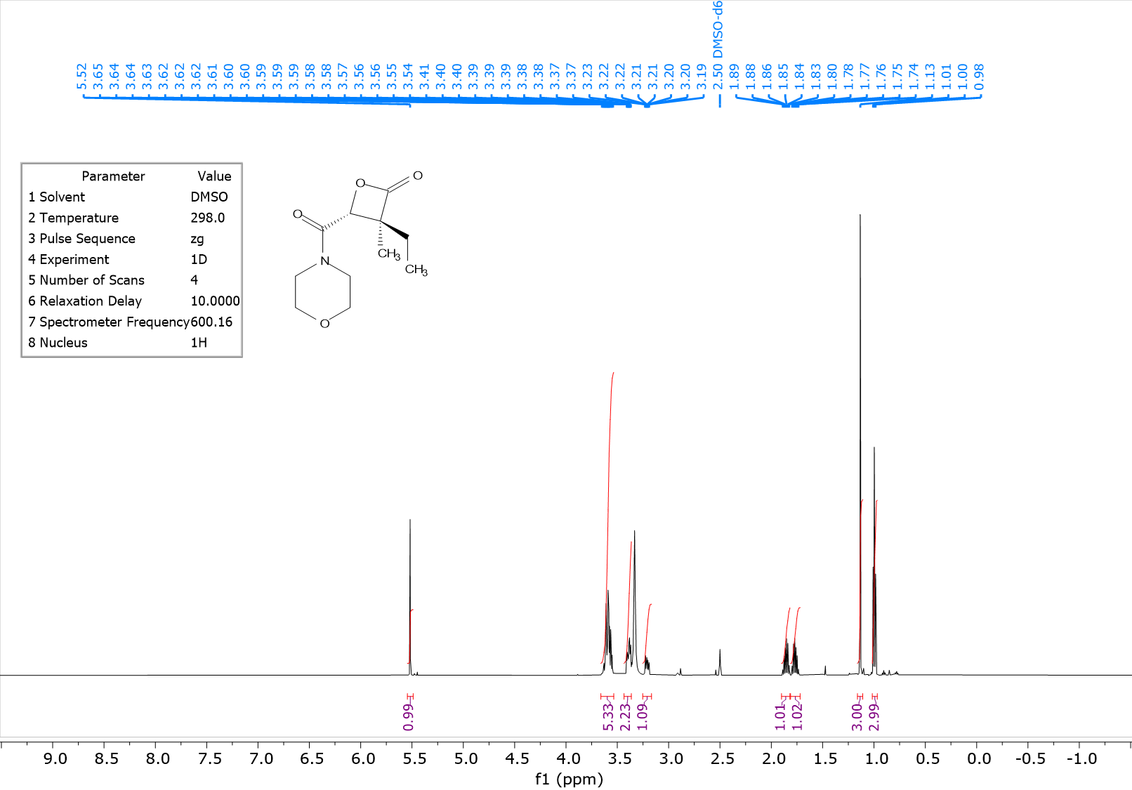

UPLC-MS-1; RT = 1.36 min; m/z = 228.2 [M+H]+

## (*4R)-4-(3-(7-(8-ethynyl-7-fluoro-3-hydroxynaphthalen-1-yl)-8-fluoro-2-(((2R,7aS)-2-fluorotetrahydro-1H-pyrrolizin-7a(5H)-yl)methoxy)pyrido[4,3-d]pyrimidin-4-yl)-3,8-diazabicyclo[3.2.1]octane-8-carbonyl)-3,3-dimethyloxetan-2-one* (R)-**1**



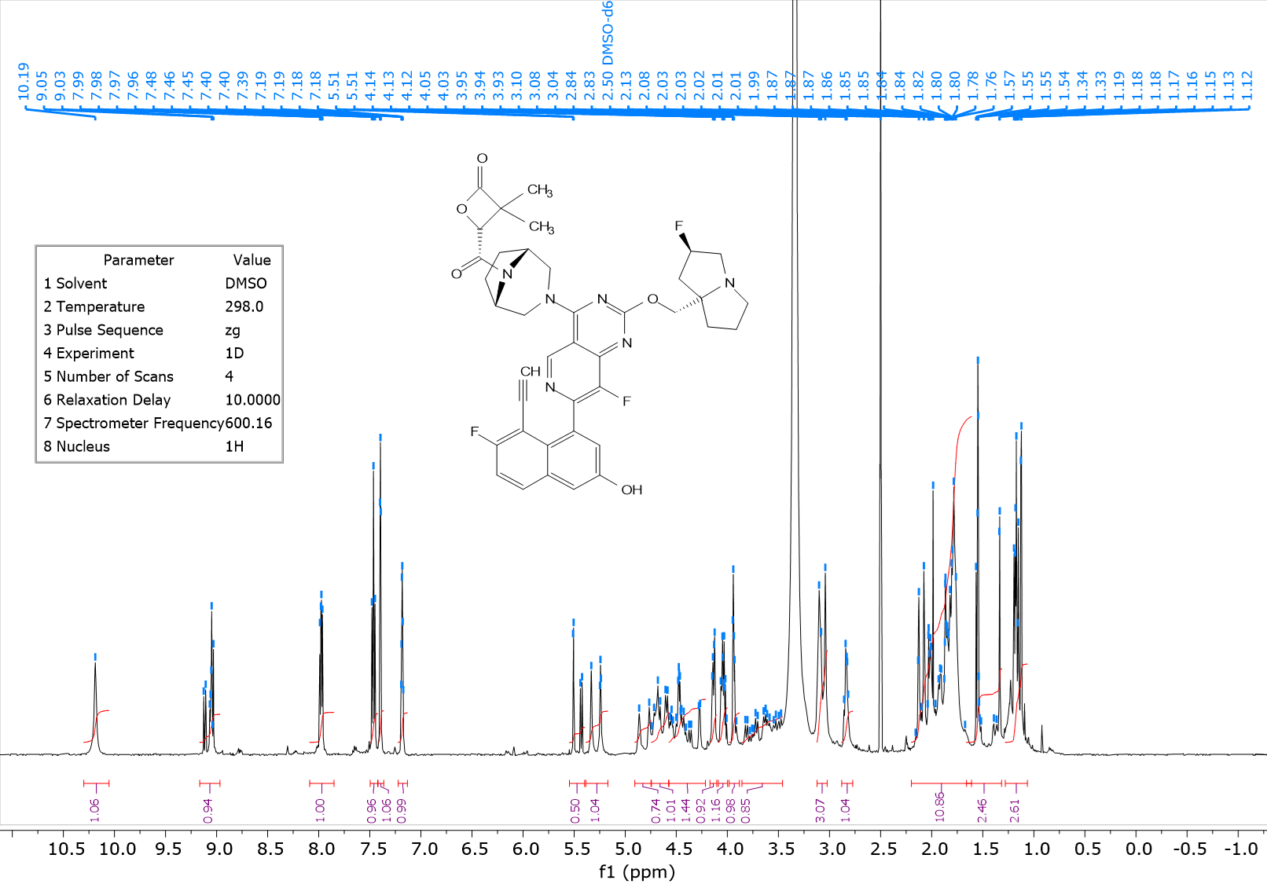

1H NMR (600 MHz, DMSO) δ 10.19 (s, 1 H), 8.97 - 9.17 (m, 1H), 7.98 (dd, J=9.20, 5.80 Hz, 1 H), 7.46 (t, J=9.00, 1 H), 7.40 (d, J=2.5 Hz, 1 H), 7.13 - 7.23 (m, 1 H), 5.48 - 5.63 (m, 1 H), 5.27 (d, 53.7 Hz, 1 H), 4.75 - 4.90 (m, 1H), 4.56 - 4.75 (m, 1 H), 4.22 - 4.53 (m, 2 H), 4.06 - 4.18 (m, 1 H), 4.00 - 4.06 (m, 1H), 3.86 - 4.01 (m, 1 H), 3.46 - 3.85 (m, 2 H), 2.99 - 3.16 (m, 3 H), 2.79 - 2.87 (m, 1 H), 1.60 - 2.21 (m, 10 H), 1.32 - 1.60 (m, 3H), 1.06 - 1.28 (m, 3H)

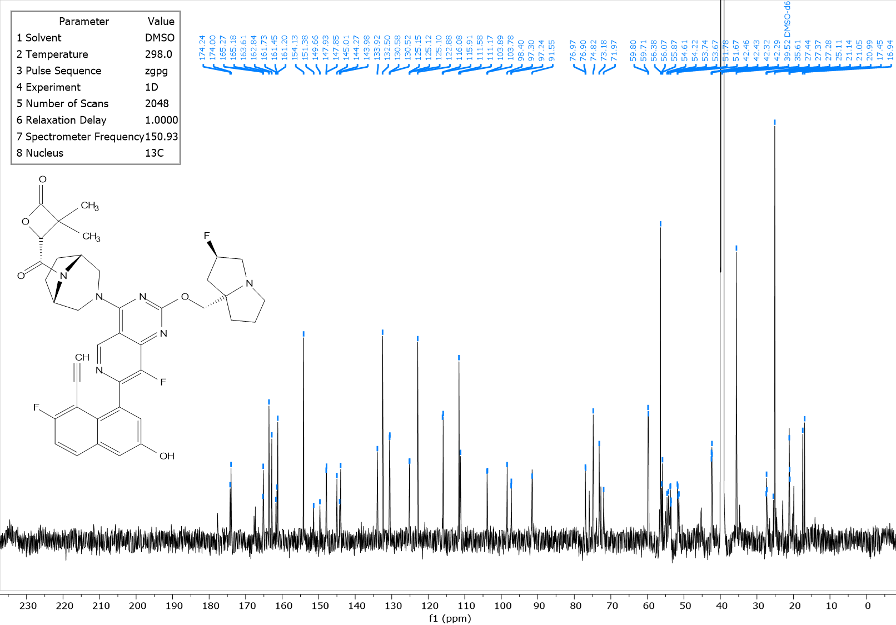

13C NMR (150 MHz, DMSO-d6) δ ppm 174.12 (m, 1 C), 165.23 (m, 1 C), 163.61 (m, 1 C), 162.02 (d, J=247.1 Hz, 1 C),161.59 (m, 1 C), 154.13 (s, 1 C), 150.52 (d, J=259.2 Hz, 1 C), 147.89 (d, J=12 Hz, 1 C), 145.01 (m, 1 C), 144.13 (m, 1 C), 133.92 (s, 1 C), 132.50 (s, 1 C), 130.55 (br d, J=9.5 Hz, 1 C), 125.12 (m, 1 C), 122.88 (s, 1 C), 115.99 (d, J=25.7 Hz, 1 C), 111.58 (s, 1 C), 111.17 (m, 1 C), 103.84 (d, J=16.50 Hz, 1 C), 97.65 (m, 1 C), 91.55 (m, 1C), 76.93 (m, 1 C), 74.82 (s, 1 C), 73.18 (m, 1 C), 71.97 (s, 1 C), 59.74 (d, J=14.5 Hz, 1 C), 56.38 (s, 1C), 55.97 (m, 1C), 54.61 (m, 1C), 53.75 (m, 2C), 51.60 (m, 1 C), 42.38 (dd, J = 21.0, 5.1 Hz, 1 C), 35.61 (s, 1 C), 27.36 (m, 1 C), 25.49 (m, 1 C), 25.11 (m, 1 C), 21.06 (m, 1 C), 17.20 (m, 1C)

## 4-((1R,5S)-3-(7-(8-ethynyl-7-fluoro-3-hydroxynaphthalen-1-yl)-8-fluoro-2-(((2R,7aS)-2-fluorotetrahydro-1H-pyrrolizin-7a(5H)-yl)methoxy)pyrido[4,3-d]pyrimidin-4-yl)-3,8-diazabicyclo[3.2.1]octane-8-carbonyl)-3,3,4-trimethyloxetan-2-one (4-methyl **2)**



To a solution of 2,3,3-trimethyl-4-oxooxetane-2-carboxylic acid (39.5 mg, 250 μmol) in DMF (1.00 mL) was added COMU (107 mg, 1.50 equiv., 250 μmol) and 2,6-lutidine (53.5 mg, 57.9 μL, 3.00 equiv., 500 μmol) at room temperature, and the resultant mixture stirred for 15 mins. A solution of 4-(4-((1*R*,5*S*)-3,8-diazabicyclo[3.2.1]octan-3-yl)-8-fluoro-2-(((2*R*,7a*S*)-2-fluorotetrahydro-1H-pyrrolizin-7a(5H)-yl)methoxy)pyrido[4,3-d]pyrimidin-7-yl)-5-ethynyl-6-fluoronaphthalen-2-ol (MRTX1133; 100 mg, 167 μmol) in DMF (1.00 mL) was then added dropwise and the resultant mixture was stirred at room temperature for 2 hours. The reaction mixture was quenched with saturated NaHCO3 and extracted three times with EtOAc. The combined organic layers were washed with brine, dried over anhydrous Na2SO4, filtered and concentrated to dryness. The brown residue was purified by reversed phase preparative HPLC (Teledyne ACCQPrep HP150: Waters XBridge C18 30×100mm, 5 mm column, Flow: 50 ml/min, eluting with a gradient of 5-70% MeCN in 0.2% aqueous formic acid). After purification, the eluent was collected, then neutralized with saturated solution of NaHCO3, extracted with EtOAc and dried by passing through a phase separator. The solution was concentrated to dryness, redissolved in MeCN/water and dried by lyophilization to give a mixture of diastereomers as a yellow solid (35.3 mg). The mixture was further purified by preparative chiral SFC (Daicel ChiralPak IH 5 mm; 250×30 mm; flow rate: 75 ml/min; column temperature: 40 °C; back pressure: 120 bar; mobile phase: 20% MeOH in supercritical CO2 + 0.05% NH3), isolating the first (RT = 2.1 mins) and second (RT = 2.5 mins) peaks. The fractions for each peak were respectively combined, concentrated *in vacuo* and lyophilized to give the title compound (peak 1) as a yellow powder (13.0 mg, 16 mmol, 9.50%) and the title compound (peak 2) as a yellow power (13.1 mg, 18 mmol, 9.50%).

Peak 1:

1H NMR (600 MHz, DMSO) δ 10.18 (s, 1 H), 9.04 - 9.12 (m, 1H), 7.98 (dd, J=9.20, 5.90 Hz, 1 H), 7.47 (t, J=9.00, 1 H), 7.40 (d, J=2.5 Hz, 1 H), 7.15 - 7.21 (m, 1 H), 5.28 (d, J = 54.1 Hz, 1 H), 4.82 - 4.96 (m, 1H), 4.62 - 4.76 (m, 1 H), 4.40 - 4.55 (m, 2 H), 4.10 - 4.17 (m, 1 H), 4.00 - 4.08 (m, 1 H), 3.90 - 3.99 (m, 1 H), 3.45 - 3.81 (m, 2 H), 2.91 - 3.19 (m, 3 H), 2.78 - 2.89 (m, 1 H), 2.04 - 2.16 (m, 2H), 1.92 - 2.04 (m, 2H), 1.73 - 1.93 (m, 9 H), 1.27 - 1.39 (m, 6H)

19F NMR (376 MHz, DMSO) δ -68.16 – -74.06 (m), -109.73 – -111.61 (m), -139.13 – -141.33 (m).

1H NMR (600 MHz, DMSO) δ 10.18 (s, 1 H), 9.04 - 9.12 (m, 1H), 7.98 (dd, J=9.19, 5.91 Hz, 1 H), 7.47 (t, J=9.01 , 1 H), 7.40 (d, J=2.54 Hz, 1 H), 7.15 - 7.21 (m, 1 H), 5.28 (d, J=54.06 Hz, 1 H), 4.78 - 5.01 (m, 1H), 4.58 - 4.78 (m, 1 H), 4.37 - 4.57 (m, 2 H), 4.09 - 4.21 (m, 1H), 3.99 - 4.08 (m, 1H), 3.87 - 3.99 (m, 1H), 3.44 - 3.84 (m, 2 H), 2.91 - 3.19 (m, 3 H), 2.77 - 2.90 (m, 1 H), 1.92 - 2.19 (m, 4 H), 1.63 - 1.91 (m, 9 H), 1.18 - 1.41 (m, 6H)

19F NMR (376 MHz, DMSO) δ -66.26 – -71.81 (m), -110.75, -138.50 – -141.82 (m).

UPLC-MS-1; RT = 3.20 min; m/z = 741.1 [M+H]+

Peak 2:



1H NMR (600 MHz, DMSO) δ 10.20 (s, 1 H), 9.04 - 9.12 (m, 1H), 7.98 (dd, J=9.20, 5.90 Hz, 1 H), 7.46 (t, J=9.00 , 1 H), 7.40 (d, J=2.6 Hz, 1 H), 7.16 - 7.20 (m, 1 H), 5.21 - 5.35 (m, 1 H), 4.82 - 4.96 (m, 1H), 4.63 - 4.77 (m, 1 H), 4.40 - 4.63 (m, 2 H), 4.11 - 4.18 (m, 1H), 4.03 - 4.09 (m, 1H), 3.90 - 3.95 (m, 1H), 3.56 - 3.79 (m, 2 H), 3.00 - 3.18 (m, 3 H), 2.81 - 2.88 (m, 1 H), 2.07 - 2.18 (m, 2 H), 2.00 - 2.06 (m, 1 H), 1.92 - 2.00 (m, 1 H), 1.71 - 1.92 (m, 9 H), 1.28 - 1.38 (m, 6H)



13C NMR (150 MHz, DMSO-d6) δ ppm 173.76 (m, 1 C), 165.23 (m, 1 C), 163.56 (m, 1 C), 162.00 (d, J=247.3 Hz, 1 C), 154.11 (m, 1 C), 150.24 (m, 2 C), 147.86 (m, 1 C), 145.07 (m, 1 C), 144.08 (m, 1 C), 133.91 (m, 1 C), 132.49 (s, 1 C), 130.53 (d, J=9.4 Hz, 1 C), 125.10 (d, J= 11.6 Hz, 1 C), 122.85 (s, 1 C), 115.98 (d, J=25.9 Hz, 1 C), 111.57 (s, 1 C), 111.18 (m, 1 C), 103.81 (d, J=15.6 Hz, 1 C), 97.76 (d, J = 179.4, 1 C), 91.55 (m, 1 C), 84.66 (m, 1C), 74.80 (m, 1 C), 73.04 (m, 1 C), 72.04 (m, 1 C), 59.73 (dd, J=19.2, 5.2 Hz, 1 C), 57.13 (m, 1C), 56.39 (s, 1C), 54.71 (m, 2 C), 52.77 (m, 1 C), 51.91 (m, 1 C), 42.31 (m, 1 C), 35.57 (s, 1 C), 27.73 (m, 1 C), 25.02 (s, 2 C), 21.20 (m, 1 C), 20.90 (m, 1 C), 16.92 (m, 1C)

UPLC-MS-1; RT = 3.14 min; m/z = 741.1 [M+H]+

(3S,4R)-3-ethyl-4-((1R,5S)-3-(7-(8-ethynyl-7-fluoro-3-hydroxynaphthalen-1-yl)-8-fluoro-2-(((2R,7aS)-2-fluorotetrahydro-1H-pyrrolizin-7a(5H)-yl)methoxy)pyrido[4,3-d]pyrimidin-4-yl)-3,8-diazabicyclo[3.2.1]octane-8-carbonyl)-3-methyloxetan-2-one (3S, 4R)-4





*diethyl (2R)-2-hydroxy-3-methylsuccinate*



To a solution of diethyl (*R*)-2-hydroxysuccinate (CAS [7554-28-1], 105 g, 552 mmol) in THF (2.10 L) was added dropwise LDA (635 mL, 1.27 mol, 2M in THF/heptane) at -60 °C under N2. The solution was stirred at -60 °C for 1 hour under N2 and then at 0 °C for 0.5 hour. Iodomethane (CAS [74-88-4], 69 mL, 1.10 mol, 2.28 g/cm3) in THF (69 mL) was added slowly at -60 °C. The mixture was stirred at -60 °C for 1 hour. The reaction mixture was quenched with saturated solution of NH4Cl and then extracted with EtOAc. The organic layers were dried over Na2SO4 and concentrated under vacuum to give a residue. The residue was purified by automated flash column chromatography (ISCO®; 880 g SepaFlash® Silica Flash Column, eluting with a gradient of 0-50% EtOAc in petroleum ether) and the eluent was concentrated under reduced pressure to give the title compound (73 g, 357 mmol, 65% yield) as a yellow oil.

1H NMR (400 MHz, CDCl3) δ 4.31 – 4.22 (m, 3H), 4.19 – 4.10 (m, 2H), 3.14 (d, *J* = 6.5 Hz, 1H), 3.09 – 2.96 (m, 1H), 1.32 – 1.24 (m, 9H).

LCMS-2: Rt = 0.52 min; MS m/z [M+H]+: 204.1

Rf = 0.65 (silica, petroleum ether: EtOAc 2: 1).

*diethyl (2S,3R)-2-ethyl-3-hydroxy-2-methylsuccinate*



To a solution of diethyl (2*R*)-2-hydroxy-3-methylsuccinate (10 g, 49.0 mmol) in THF (220 mL) was added dropwise LDA (56 mL, 112.6 mmol, 2M in a mixture of THF and heptane) at -60 °C under N2. The solution was stirred at -60 °C for 0.5 hour under N2 and stirred at 0 °C for 1 hr. Then the reaction mixture was cooled to -60°C and the solution of iodoethane (CAS [75-03-6], 7.9 mL, 97.9 mmol) in THF (13 mL) was added slowly at -60 °C. The mixture was stirred at -60 °C under N2 for 2 hours. The reaction mixture was quenched with saturated solution of NH4Cl and then extracted with EtOAc. The organic layers were dried over Na2SO4 and concentrated under vacuum to give a residue. The residue was purified by flash chromatography (ISCO®; 220 g SepaFlash® Silica Flash Column, eluting with a gradient of 0-19% EtOAc in petroleum ether) and the eluent was concentrated under reduced pressure to give the title compound as a yellow oil (5.0 g, 21.5 mmol, 44% yield).

1H NMR (400 MHz, CDCl3) δ 4.29 – 4.10 (m, 5H), 3.37 (d, *J* = 7.9 Hz, 1H), 1.93 – 1.78 (m, 1H), 1.66 – 1.53 (m, 1H), 1.32 – 1.24 (m, 6H), 1.14 (s, 3H), 0.88 (t, *J* = 7.4 Hz, 3H).

LCMS-2: Rt = 0.83 min; MS m/z [M+H]+: 232.0

Rf = 0.7 (silica, petroleum ether: EtOAc 2: 1).

*(2S,3R)-2-ethyl-3-hydroxy-2-methylsuccinic acid*



To a solution of diethyl (2S,3R)-2-ethyl-3-hydroxy-2-methylsuccinate (5.00 g, 21.5 mmol) and K2CO3 (17.85 g, 129 mmol) in H2O (77 mL) was reflux at 100 °C for 16 hours. Then NaOH (2.58 g, 64.6 mmol) was added to the reaction mixture. The reaction mixture was stirred at 100 °C for 1 hr. The reaction mixture was cooled to 20 °C and acidified with concentrated HCl to pH ~ 2. Then the mixture was concentrated to give a white solid. The white solid was diluted with EtOAc, dried over Na2SO4. The suspension was filtered, and the filter cake was washed with EtOAc. Then the combined filtrate was concentrated to give the title compound as yellow oil (3.5 g, crude). The crude was used to next step directly without any other purification.

1H NMR (400 MHz, CDCl3) δ 4.34 (s, 1H), 1.98 – 1.85 (m, 1H), 1.85 – 1.66 (m, 1H), 1.29 (s, 3H), 0.97 (t, *J* = 7.4 Hz, 3H).

LCMS-6: Rt = 0.075 min; MS: m/z (M-H)+: 175.0.

*(2S,3R)-4-(benzyloxy)-2-ethyl-3-hydroxy-2-methyl-4-oxobutanoic acid*



(2*S*,3*R*)-2-ethyl-3-hydroxy-2-methylsuccinic acid (3.5 g, crude) was placed in a round-bottomed flask and cooled in an ice bath. Then trifluoroacetic anhydride (TFAA, 8.3 mL, 59.6 mmol) was added dropwise at 0 °C under nitrogen atmosphere. The mixture was stirred 30 min at 0 °C and then warmer up to 25 °C for another 2 hours. TFAA in excess and formed trifluoroacetic acid (TFA) were evaporated under vacuum at room temperature. Under nitrogen atmosphere BnOH (8.2 mL, 79.47 mmol) was added to the intermediate cyclic anhydride obtained. The mixture was stirred at 25 °C for 16 hours. The reaction mixture was diluted with water and extracted with EtOAc, the combined organic phases were dried over Na2SO4, filtered and concentrated under vacuum to give a residue. The residue was purified by flash silica gel chromatography (ISCO®; 80 g SepaFlash® Silica Flash Column, eluting with a gradient of 0-46% EtOAc in petroleum ether) and the eluent was concentrated to give the title compound as yellow oil (2.1 g, 7.9 mmol, 40% yield over two steps).

1H NMR (400 MHz, CDCl3) δ 7.52 – 7.29 (m, 5H), 5.22 (s, 2H), 4.37 (s, 1H), 1.89 – 1.75 (m, 1H), 1.71 – 1.54 (m, 1H), 1.13 (s, 3H), 0.90 (t, *J* = 7.5 Hz, 3H).

LCMS-4: Rt = 0.611 min; MS m/z [M+Na]+: 289.1; purity: 96.5%;

SFC-18: Rt = 1.676 min, ee: 96.9%.

*benzyl (2R,3S)-3-ethyl-3-methyl-4-oxooxetane-2-carboxylate*



To a mixture of (2S,3R)-4-(benzyloxy)-2-ethyl-3-hydroxy-2-methyl-4-oxobutanoic acid (2.00 g, 7.51 mmol) in CH2Cl2 (200 mL) was added NEt3 (5.23 mL, 37.6 mmol) and PyBOP (5.86 g, 11.3 mmol) at 0 °C. After 5 minutes at 0 °C, the mixture was warmed up to 25 °C and stirred for 2 hours. The reaction mixture was diluted with water and extracted with CH2Cl2, and the combined organic phases were dried over Na2SO4, filtered and concentrated *in vacuo*. The residue was purified by flash silica gel chromatography (ISCO®; 80 g SepaFlash® Silica Flash Column, eluting with a gradient of 0-10% EtOAc in petroleum ether) and the fractions were concentrated to give the title compound as a light-yellow oil (1.50 g, 6.04 mmol, 80% yield).

1H NMR (400 MHz, CDCl3) δ 7.44 – 7.31 (m, 5H), 5.27 (s, 2H), 4.71 (s, 1H), 1.93 – 1.75 (m, 2H), 1.17 (s, 3H), 1.04 (t, *J* = 7.5 Hz, 3H).

LCMS-1: Rt = 0.548 min; MS m/z [M+Na]+: N/A purity: 96.2%;

SFC-18 Rt = 0.774 min, ee: 96%;

*(2R,3S)-3-ethyl-3-methyl-4-oxooxetane-2-carboxylic acid*



To a mixture of Pd/C (400 mg, 10% wt.) in EtOAc (20 mL) was added a solution of benzyl (2R,3S)-3-ethyl-3-methyl-4-oxooxetane-2-carboxylate (1.50 g, 6.04 mmol) in EtOAc (100 mL), the reaction mixture was purged and degassed 3 times with H2 (15 psi) and stirred at 25°C for 16 hours. The reaction mixture was filtered over Celite pad, the filter cake was washed with EtOAc, and the combined filtrates were concentrated to give the title compound as brown oil (900 mg, 5.69 mmol, 94% yield).

1H NMR (400 MHz, CDCl3) δ 9.31 (s, 1H), 4.76 (s, 1H), 2.00 – 1.78 (m, *J* = 7.2 Hz, 2H), 1.37 (s, 3H), 1.09 (t, *J* = 7.4 Hz, 3H).

*(3S,4R)-3-ethyl-4-((1R,5S)-3-(7-(8-ethynyl-7-fluoro-3-hydroxynaphthalen-1-yl)-8-fluoro-2-(((2R,7aS)-2-fluorotetrahydro-1H-pyrrolizin-7a(5H)-yl)methoxy)pyrido[4,3-d]pyrimidin-4-yl)-3,8-diazabicyclo[3.2.1]octane-8-carbonyl)-3-methyloxetan-2-one (3S, 4R)-****4***



To a mixture of (2R,3S)-3-ethyl-3-methyl-4-oxooxetane-2-carboxylic acid (53 mg, 0.33 mmol) and COMU (214 mg, 0.50 mmol) in DMF (2 mL) was added 2,6-lutidine (233 mL, 2.0 mmol). The mixture was stirred at 25 °C for 15 min, then 4-(4-((1R,5S)-3,8-diazabicyclo[3.2.1]octan-3-yl)-8-fluoro-2-(((2R,7aS)-2-fluorotetrahydro-1H-pyrrolizin-7a(5H)-yl)methoxy)pyrido[4,3-d]pyrimidin-7-yl)-5-ethynyl-6-fluoronaphthalen-2-ol (MRTX1133, 200 mg, 0.33 mmol) was added. The reaction mixture was stirred at 25°C for 15 min. The reaction mixture was diluted with water and extracted with EtOAc, and the combined organic phases was dried over Na2SO4, filtered and concentrated under vacuum. The residue was purified by preparative HPLC, and the eluent was concentrated at 25 °C to remove organic solvents. The residual aqueous solution was lyophilized to give the title compound as a yellow solid (38.72 mg, 90% purity, 47 mmol, 14 % yield).



1H NMR (600 MHz, DMSO) δ 10.19 (s, 1 H),9.02 - 9.14 (m, 1H), 7.98 (dd, J=9.20, 5.80 Hz, 1 H), 7.46 (t, J=9.00 , 1 H), 7.40 (d, J=2.5 Hz, 1 H), 7.16 - 7.21 (m, 1 H), 5.42 - 5.53 (m, 1 H), 5.27 (d, 53.7 Hz, 1 H), 4.75 - 4.88 (m, 1H), 4.62 - 4.72 (m, 1 H), 4.46 - 4.60 (m, 1 H), 4.25 - 4.45 (m, 1H), 4.11 - 4.19 (m, 1H), 4.02 - 4.08 (m, 1 H), 3.90 - 3.96 (m, 1 H), 3.68 - 3.84 (m, 1 H), 3.44 - 3.68 (m, 1H), 3.01 - 3.15 (m, 3 H), 2.79 - 2.88 (m, 1 H), 2.05 - 2.18 (m, 2 H), 1.97 - 2.05 (m, 1 H), 1.69 - 1.97 (m, 9 H), 1.11 - 1.37 (m, 3 H) 0.74 - 1.09 (m, 3H)



13C NMR (150 MHz, DMSO-d6) δ ppm 173.51 (m, 1 C), 165.19 (m, 1 C), 163.60 (m, 1 C), 162.00 (d, J=246.9 Hz, 1 C),161.82 (m, 1 C), 154.12 (m, 1 C), 150.49 (d, J=259.2 Hz, 1 C), 147.86 (d, J=13.7 Hz, 1 C), 145.00 (m, 1 C), 144.10 (m, 1 C), 133.91 (m, 1 C), 132.48 (s, 1 C), 130.54 (d, J=13.7 Hz, 1 C), 125.11 (m, 1 C), 122.86 (s, 1 C), 115.98 (d, J=26.0 Hz, 1 C), 111.57 (s, 1 C), 111.13 (m, 1 C), 103.82 (dd, J=16.2, 3.3 Hz, 1 C), 97.79 (d, J = 175.2, 1 C), 91.51 (m, 1 C), 74.81 (m, 1 C), 74.66 (m, 1 C), 73.19 (m, 1 C), 72.01 (m, 1 C), 60.64 (m, 1 C), 59.74 (dd, J=19.0, 5.2 Hz, 1 C), 56.38 (s, 1C), 54.73 (m, 1C), 53.64 (m, 2 C), 51.68 (m, 1 C), 42.36 (m, 1 C), 35.59 (s, 1 C), 27.38 (m, 2 C), 25.54 (m, 1 C), 25.09 (s, 1 C), 15.41 (m, 1 C), 8.86 (m, 1C)

19F NMR (376 MHz, DMSO) δ -110.27 – -111.71 (m), -138.71 – -141.21 (m), -171.66 – -173.80 (m).

LCMS-5: Rt = 0.591 min; MS: m/z (M+H)+: 741.4;

HPLC-3: Rt = 2.536 min; purity: 90%;

SFC-9: Rt = 2.180 min, ee: 100%.

## (3R,4R)-3-ethyl-4-((1R,5S)-3-(7-(8-ethynyl-7-fluoro-3-hydroxynaphthalen-1-yl)-8-fluoro-2-(((2R,7aS)-2-fluorotetrahydro-1H-pyrrolizin-7a(5H)-yl)methoxy)pyrido[4,3-d]pyrimidin-4-yl)-3,8-diazabicyclo[3.2.1]octane-8-carbonyl)-3-methyloxetan-2-one (3R, 4R)-**3**



*diethyl (2S)-2-hydroxy-3-methylsuccinate*



To a solution of diethyl (S)-2-hydroxysuccinate (10 g, 52.6 mmol) in THF (200 mL) was added dropwise LDA (60.46 mL, 120.9 mmol, 2 M in a mixture of THF and hexane) at -60 °C under N2. The solution was stirred at -60 °C for 1 hour under N2 and stirred at -0 °C for 2 hours. Then iodomethane (6.55 mL, 105.2 mmol, 2.28 g/cm3) in THF (6 mL) was added at -60 °C slowly. The mixture was warmed to 25 °C slowly and stirred at this temperature for 15 hours. The mixture was quenched with saturated solution of NH4Cl, extracted with EtOAc. The combined organic phase was dried over anhydrous Na2SO4, filtered and concentrated in vacuum. The residue was purified by flash (ISCO®; 220 g SepaFlash® Silica Flash Column, Eluent of 0-50% EtOAc / petroleum ether) and the eluent was concentrated under reduced pressure to give the title compound as yellow oil (5.3 g, 25.95 mmol, 49% yield).

LCMS-1 Rt = 0.503 min; MS m/z [M+H]+: 205.1

1H NMR (400 MHz, CDCl3) δ 4.30 – 4.20 (m, 3H), 4.18 – 4.09 (m, 2H), 3.15 (d, *J* = 6.4 Hz, 1H), 3.04 – 2.96 (m, 1H), 1.33 – 1.21 (m, 9H).

Rf = 0.65 (silica, petroleum ether: EtOAc 2: 1).

*diethyl (2R,3S)-2-ethyl-3-hydroxy-2-methylsuccinate*



To a solution of diethyl (2S)-2-hydroxy-3-methylsuccinate (5.3 g, 25.95 mmol) in THF (100 mL) was added dropwise LDA (29.84 mL, 59.69 mmol, 2 M in a mixture of THF and hexane) at -60 °C under N2. The solution was stirred at -60 °C for 1 hour under N2 and stirred at -0 °C for 2 hours. Then iodoethane (4.15 mL, 51.90 mmol, 1.95 g/cm3) in THF (6 mL) was added at -60 °C slowly. The mixture was quenched with saturated solution of NH4Cl, extracted with EtOAc. The combined organic phase dried over anhydrous Na2SO4, filtered and concentrated in vacuum. The residue was purified by flash (ISCO®; 220 g SepaFlash® Silica Flash Column, Eluent of 30-60% EtOAc / petroleum ether) and the eluent was concentrated under reduced pressure to give the title compound as yellow oil (3.05 g, 13.13 mmol, 51% yield).

1H NMR (400 MHz, CDCl3) δ 4.34 – 4.04 (m, 5H), 3.37 (d, *J* = 7.9 Hz, 1H), 1.92 – 1.76 (m, 1H), 1.64 – 1.51 (m, 1H), 1.33 – 1.20 (m, 6H), 1.13 (s, 3H), 0.87 (t, *J* = 7.5 Hz, 3H).

Rf = 0.7 (silica, petroleum ether: EtOAc 2: 1)

*(2R,3S)-2-ethyl-3-hydroxy-2-methylsuccinic acid*



To a solution of diethyl (2R,3S)-2-ethyl-3-hydroxy-2-methylsuccinate (2.70 g, 11.62 mmol) and K2CO3 (9.64 g, 69.74 mmol) in H2O (42 mL) was refluxed at 100 °C for 16 hours. NaOH (1.40 g, 34.86 mmol) was added to the mixture and the mixture was stirred at 100 °C for 1 hour. The reaction mixture was cooled to 20 °C and acidified with concentrated HCl. Then the mixture was concentrated and the white solid was diluted with EtOAc, dried over Na2SO4 was added to the mixture. The mixture was filtered and the filtrate was concentrated to give the title compound as yellow oil (2.80 g, crude). The crude was used to next step directly without any other purification.

1H NMR (400 MHz, CDCl3) δ 4.35 (s, 1H), 1.95 – 1.82 (m, 1H), 1.82 – 1.63 (m, 1H), 1.26 (s, 3H), 0.95 (t, *J* = 7.5 Hz, 3H).

Rf = 0.0 (silica, petroleum ether: EtOAc 2: 1, the Cpd.4 Rf=0.7 was consumed completely)

*(2R,3S)-4-(benzyloxy)-2-ethyl-3-hydroxy-2-methyl-4-oxobutanoic acid*



(2R,3S)-2-ethyl-3-hydroxy-2-methylsuccinic acid (2.8 g, crude) was placed in a round-bottomed flask and cooled in an ice bath. Then TFAA (6.63 mL, 47.68 mmol, 1.511 g/cm3) was added dropwise at 0 °C under nitrogen atmosphere. The white mixture was stirred 30 min at 0 °C and 2 hours 30 min at 20 °C. TFAA in excess and formed trifluoroacetic acid (TFA) were evaporated under vacuum at room temperature. Under nitrogen atmosphere BnOH (6.58 mL, 63.58 mmol, 1.045 g/cm3) was added to the intermediate cyclic anhydride obtained. The mixture was stirred at 20°C for 16 hours. TLC (petroleum ether : EtOAc = 1:1, KMnO4) showed one new spot (Rf=0.5). The reaction mixture was acidified by HCl (1M, 2 mL) to pH~2-3. The resulting aqueous phase was extracted with EtOAc, and the combined organic phases were dried over Na2SO4, filtered and concentrated under vacuum to give a residue. The residue was purified by flash silica gel chromatography (ISCO®; 120 g SepaFlash® Silica Flash Column, Eluent of 0-50% EtOAc / petroleum ether) and the eluent was concentrated to give the title compound as yellow oil (1.6 g, 6.01 mmol, 52% yield for two steps).

1H NMR (400 MHz, CDCl3) δ 7.42 – 7.29 (m, 5H), 5.22 (s, 2H), 4.37 (s, 1H), 1.89 – 1.74 (m, 1H), 1.69 – 1.55 (m, 1H), 1.13 (s, 3H), 0.90 (t, *J* = 7.5 Hz, 3H).

Rf = 0.5 (silica, petroleum ether: EtOAc 1: 1)

*benzyl (2R,3R)-3-ethyl-3-methyl-4-oxooxetane-2-carboxylate*



To the mixture of (2R,3S)-4-(benzyloxy)-2-ethyl-3-hydroxy-2-methyl-4-oxobutanoic acid (800 mg, 3.00 mmol) and PPh3 (867 mg, 3.30 mmol) in THF (8 mL) was added the solution of DIAD (1.03 mL, 3.30 mmol, 1.027 g/cm3) in THF (4 mL) slowly at 0 °C under N2. The reaction mixture was warmed up to 10 °C and stirred under N2 for 16 hours. The reaction mixture was diluted with water and extracted with EtOAc, and the combined organic phases were dried over Na2SO4, filtered and concentrated under vacuum to give a residue. The residue was purified by was purified by flash silica gel chromatography (ISCO®; 40 g SepaFlash® Silica Flash Column, Eluent of 0%30% EtOAc /petroleum ether) and the eluent was concentrated under reduce pressure to give the title compound as colorless oil (450 mg, 1.81 mmol, 60.3% yield).

1H NMR (400 MHz, CDCl3) δ 7.47 – 7.28 (m, 5H), 5.31 – 5.21 (m, 2H), 4.65 (s, 1H), 1.78 – 1.63 (m, 1H), 1.62 – 1.52 (m, 1H), 1.51 (s, 3H), 0.89 (t, *J* = 7.5 Hz, 3H).

Rf = 0.7 (silica, petroleum ether: EtOAc 5: 1)

*(2R,3R)-3-ethyl-3-methyl-4-oxooxetane-2-carboxylic acid*



To a solution of benzyl (2R,3R)-3-ethyl-3-methyl-4-oxooxetane-2-carboxylate (400 mg, 1.61 mmol) in EA (40 mL) was added Pd/C (400 mg, 50% wet). the reaction mixture was purged and degassed with H2 (15 psi) for 3 times and stirred at 25°C for 16 hours. The reaction mixture was filtered over Celite pad, the filter cake was washed with EtOAc, and the combined filter liquors were concentrated to give the title compound as colorless oil (250 mg, crude). The crude used to next step directly without any other purification.

1H NMR (400 MHz, CDCl3) δ 4.70 (s, 1H), 1.95 – 1.81 (m, 1H), 1.80 – 1.66 (m, 1H), 1.57 (s, 3H), 1.05 (t, *J* = 7.5 Hz, 3H).

Rf = 0.0 (silica, petroleum ether: EtOAc 5: 1, the starting material Rf=0.7 was consumed completely)

*(3R,4R)-3-ethyl-4-((1R,5S)-3-(7-(8-ethynyl-7-fluoro-3-hydroxynaphthalen-1-yl)-8-fluoro-2-(((2R,7aS)-2-fluorotetrahydro-1H-pyrrolizin-7a(5H)-yl)methoxy)pyrido[4,3-d]pyrimidin-4-yl)-3,8-diazabicyclo[3.2.1]octane-8-carbonyl)-3-methyloxetan-2-one (3R, 4R)-****3***



To the mixture of (2R,3R)-3-ethyl-3-methyl-4-oxooxetane-2-carboxylic acid (21 mg, crude) and 2, 6-lutidine (0.080 mL, 0.19 mmol, 0.92 g/cm3) in DMF (1.6 mL) was added COMU (68 mg, 0.14 mmol), the mixture was stirred at -5 °C for 15 min, then 4-(4-((1R,5S)-3,8-diazabicyclo[3.2.1]octan-3-yl)-8-fluoro-2-(((2R,7aS)-2-fluorotetrahydro-1H-pyrrolizin-7a(5H)-yl)methoxy)pyrido[4,3-d]pyrimidin-7-yl)-5-ethynyl-6-fluoronaphthalen-2-ol (MRTX1133, 80 mg, 0.13 mmol) was added. The reaction mixture was stirred at -5 °C for 15 min. The reaction mixture was diluted with saturated solution of NaHCO3 and extracted with EtOAc, and the combined organic phase was washed with brine and 10% aqueous solution of LiCl, then the organic phase was dried over Na2SO4, filtered and concentrated under vacuum to give a residue. The residue was purified by preparative reversed phase (48g of SepaFlash® Spherical C18, 100 Å; mobile phase: A for H2O + 0.1% FA and B for acetonitrile; gradient: B 30 - 70% in 20 min, flow rate: 60 mL/min; column temperature: R.T. Wavelength: 220 nm/254 nm), the eluent was concentrated and lyophilized to give the title compound as a yellow solid (49.06 mg, 0.066 mmol, 49% yield).

1H NMR (400 MHz, DMSO) δ 8.94 - 9.16 (m, 1H), 7.95 (dd, J=9.20, 5.90 Hz, 1 H), 7.45 (t, J=9.00 , 1 H), 7.39 (d, J=2.6 Hz, 1 H), 7.10 - 7.23 (m, 1 H), 5.37 - 5.50 (m, 1 H), 5.29 (d, 54.4 Hz, 1 H), 4.69 - 4.90 (m, 1H), 4.54 - 4.69 (m, 1 H), 4.43 - 4.54 (m, 1 H), 4.22 - 4.41 (m, 1H), 4.16 (d, J= 10.5, 3.1 Hz, 1H), 4.07 (d, J= 10.7, 1 H), 3.85 - 3.92 (m, 1 H), 3.68 - 3.83 (m, 1 H), 3.44 - 3.68 (m, 1H), 3.00 - 3.20 (m, 3 H), 2.77 - 2.92 (m, 1 H), 2.05 - 2.22 (m, 2 H), 1.98 - 2.05 (m, 1 H), 1.58 - 1.91 (m, 8 H), 1.49 - 1.56 (m, 3 H), 1.35 - 1.46 (m, 1H), 0.79 - 1.03 (m, 3H)

19F NMR (376 MHz, DMSO) δ -109.93 – -110.93 (m), -139.25 – -140.67 (m), -171.04 – -173.06 (m).

LCMS-1: Rt = 0.463 min; MS m/z [M+H]+: 741.4

HPLC-2: Rt = 1.246 min; purity: 97.0%; Rt (SFC) = 2.216 min; ee: 100%;

SFC-9 Rt = 2.216 min; ee: 100%;

## (3S,4R)-4-((1R,5S)-3-(7-(8-ethynyl-7-fluoro-3-hydroxynaphthalen-1-yl)-8-fluoro-2-(((2R,7aS)-2-fluorotetrahydro-1H-pyrrolizin-7a(5H)-yl)methoxy)pyrido[4,3-d]pyrimidin-4-yl)-3,8-diazabicyclo[3.2.1]octane-8-carbonyl)-3-methyl-3-propyloxetan-2-one (3S, 4R)-**5**



*diethyl (2S,3R)-2-allyl-3-hydroxy-2-methylsuccinate*



To a solution of diisopropylamine (3.17 g, 4.42 mL, 31.3 mmol) in THF (20.0 mL) was added BuLi (2.11 g, 20.6 mL, 1.60 molar in hexanes, 32.9 mmol) at -78 °C. The reaction mixture was warmed to 0 °C and stirred for 1 hour. It was then added dropwise under a nitrogen atmosphere to another solution of diethyl (2*R*)-2-hydroxy-3-methylsuccinate (see example (3S, 4R)-**4**; 1.60 g, 7.83 mmol) in THF (40 mL) cooled to -78 °C. The resultant yellow mixture was stirred at -78 °C for 1 hour, and then 3-iodoprop-1-ene (3.95 g, 2.16 mL, 23.5 mmol) was added dropwise. The reaction was shielded from light with aluminium foil, stirred for a further 2 hours at -78 °C and warmed to room temperature over 18 hours. The mixture was quenched with saturated NH4Cl solution and extracted twice with EtOAc. The combined organic phases were dried over anhydrous Na2SO4, filtered and concentrated *in vacuo*. The crude orange-brown oil was purified by automated chromatography (Isolera; 100 g SNAP cartridge, eluting with a gradient of 0-25% EtOAc in cyclohexane) to provide the title compound as an orange oil (673 mg, 2.76 mmol, 35%).

LCMS_02_MIN_FINAL_ANALYSIS; RT = 0.87 min; m/z = 245.3 [M+H]+

*(2S,3R)-2-allyl-3-hydroxy-2-methylsuccinic acid*



To a suspension of diethyl (2*S*,3*R*)-2-allyl-3-hydroxy-2-methylsuccinate (673 mg, 2.76 mmol) in water (15 mL) was added K2CO3 (2.28 g, 16.5 mmol) and the mixture heated overnight at 100 °C. The reaction mixture was the cooled to 0 °C and acidified to pH 2 with conc. HCl. The mixture was concentrated to dryness and redissolved in EtOAc. The solution was dried over anhydrous Na2SO4, filtered and concentrated in vacuo to provide crude (*S*)-2-((*R*)-2-(benzyloxy)-1-hydroxy-2-oxoethyl)-2-methylpent-4-enoic acid as an orange oil, which was used without further purification (576 mg).

1H NMR (400 MHz, DMSO) δ 12.61 (s, 1H), 12.31 (s, 1H), 5.75 – 5.60 (m, 1H), 5.41 (s, 1H), 5.08 – 5.02 (m, 1H), 5.01 (s, 1H), 4.16 (s, 1H), 2.39 (dd, *J* = 13.7, 6.6 Hz, 1H), 2.17 (dd, *J* = 13.6, 8.0 Hz, 1H), 1.00 (s, 3H).

*(S)-2-((R)-2-(benzyloxy)-1-hydroxy-2-oxoethyl)-2-methylpent-4-enoic acid*



To a solution of crude (2*S*,3*R*)-2-allyl-3-hydroxy-2-methylsuccinic acid (518 mg) in dry CH2Cl2 (2.0 mL) was slowly added trifluoroacetic anhydride (1.73 g, 1.17 mL, 8.26 mmol) at 0 °C under argon. The brown mixture was first stirred for 30 mins at 0 °C and then 2.5 hours at room temperature. The reaction mixture was concentrated in vacuo to give a crude anhydride.

Benzyl alcohol (1.19 g, 1.15 mL, 11.0 mmol) was added, and the resultant solution was stirred overnight at room temperature. Water was then added and the aqueous mixture extracted three times with EtOAc. The combined organic phases were dried over anhydrous Na2SO4, filtered and concentrated in vacuo. The resultant yellow oil was purified by automated chromatography (Isolera; 50 g SNAP cartridge, eluting with a gradient of 0-25% EtOAc in cyclohexane) to provide the title compound as a yellow oil (385 mg, 2.75 mmol, 50% over two steps).

LCMS_02_MIN_FINAL_ANALYSIS; RT = 0.87 min; m/z = 279.3 [M+H]+

*benzyl (2R,3S)-3-allyl-3-methyl-4-oxooxetane-2-carboxylate*



To a solution of (*S*)-2-((*R*)-2-(benzyloxy)-1-hydroxy-2-oxoethyl)-2-methylpent-4-enoic acid (385 mg, 1.38 mmol) in CH2Cl2 (25 mL) was added NEt3 (700 mg, 964 μL, 6.92 mmol) and PyBOP (CAS [128625-52-5] 1.08 g, 2.08 mmol), 585 mg, 1.13 mmol) at 0 °C. The reaction mixture was stirred at 0 °C for 5 mins and then warmed to 22 °C over 2 hours. The reaction mixture was diluted with water and extracted with CH2Cl2. The organic phase was dried by passing through a separation cartridge and concentrated under vacuum to give a residue. The resultant residue was purified by automated chromatography (Isolera; 25 g SNAP cartridge, eluting with a gradient of 0-10% EtOAc in cyclohexane) to provide the title compound as a colorless oil (235 mg, 1.38 mmol, 65%).

1H NMR (400 MHz, DMSO) δ 7.45 – 7.32 (m, 5H), 5.84 – 5.69 (m, 1H), 5.31 – 5.20 (m, 4H), 5.19 (s, 1H), 2.62 – 2.52 (m, 1H), 2.50 – 2.42 (m, 1H), 1.09 (s, 3H).

LCMS_02_MIN_FINAL_ANALYSIS; RT = 1.14 min; m/z = 278.4 [M+18]

*benzyl (2R,3S)-3-methyl-4-oxo-3-propyloxetane-2-carboxylic acid*



To a colorless solution of  benzyl (2R,3S)-3-allyl-3-methyl-4-oxooxetane-2-carboxylate (50.00 mg, 192 μmol)  in EtOAc (3.000 mL) at rt was added  Pd/C (20.44 mg, 10% Wt, 19 μmol). The mixture was purged and degassed with Nitrogen (3 times) and hydrogenated at rt for 18h. The mixture was filtered over a celite cartridge, washed with EtOAc and evaporated to dryness to afford the title compound as colorless oil, which was directly subjected to the next step (33 mg; 192 mmol, 100 %).

1H NMR (400 MHz, DMSO) δ 13.80 (s, 1H), 4.99 (s, 1H), 1.79 – 1.62 (m, 2H), 1.58 – 1.44 (m, 1H), 1.37 – 1.24 (m, 1H), 1.19 (s, 3H), 0.92 (t, *J* = 7.3 Hz, 3H).

*(3S,4R)-4-((1R,5S)-3-(7-(8-ethynyl-7-fluoro-3-hydroxynaphthalen-1-yl)-8-fluoro-2-(((2R,7aS)-2-fluorotetrahydro-1H-pyrrolizin-7a(5H)-yl)methoxy)pyrido[4,3-d]pyrimidin-4-yl)-3,8-diazabicyclo[3.2.1]octane-8-carbonyl)-3-methyl-3-propyloxetan-2-one (3S, 4R)-****5***



To a solution of benzyl (2*R*,3*S*)-3-allyl-3-methyl-4-oxooxetane-2-carboxylate (167 mg, 0.642 mmol) in EtOAc (9 mL) was added Pd/C (68.3 mg, 10% wt) under N2. The suspension was degassed under vacuum and purged with N2 three times, and then H2. The reaction mixture was stirred for 2 hours under H2 at room temperature. The reaction mixture was filtered over Celite, washing with EtOAc and concentrated under vacuum to give (2*R*,3*S*)-3-methyl-4-oxo-3-propyloxetane-2-carboxylic acid (120 mg) as a colorless oil, which was used crude in the next step.

To a mixture of crude (2*R*,3*S*)-3-methyl-4-oxo-3-propyloxetane-2-carboxylic acid (15.5 mg, 89.9 μmol) in DMF (700 μL) was added COMU (38.5 mg, 1.20 equiv., 89.9 μmol) and 2,6-lutidine (40.1 mg, 44.0 μL, 375 μmol) at 0 °C, the mixture was stirred at 0 °C for 15 min. A solution of 4-(4-((1*R*,5*S*)-3,8-diazabicyclo[3.2.1]octan-3-yl)-8-fluoro-2-(((2*R*,7a*S*)-2-fluorotetrahydro-1H-pyrrolizin-7a(5H)-yl)methoxy)pyrido[4,3-d]pyrimidin-7-yl)-5-ethynyl-6-fluoronaphthalen-2-ol (45.0 mg, 74.9 μmol) in DMF (234 μL) was then added dropwise and the resultant mixture was stirred at 0 °C for 30 mins. The reaction mixture was quenched with saturated NaHCO3 and extracted with EtOAc. The organic layers were dried with anhydrous Na2SO4, filtered and concentrated to dryness. The residue was purified by reversed phase preparative HPLC (Teledyne ACCQPrep HP150: Waters XBridge C18 30×100 mm, 5 mm column, Flow: 50 ml/min, eluting with a gradient of 0-40% MeCN in 0.2% aqueous formic acid). After purification, the eluent was collected, then neutralized with saturated solution of NaHCO3, extracted with EtOAc and concentrated at 25 °C. The product was redissolved in MeCN/water and dried by lyophilization to give the title compound as an orange solid (30.1 mg, 74.9 μmol, 53 % yield, 99% purity).

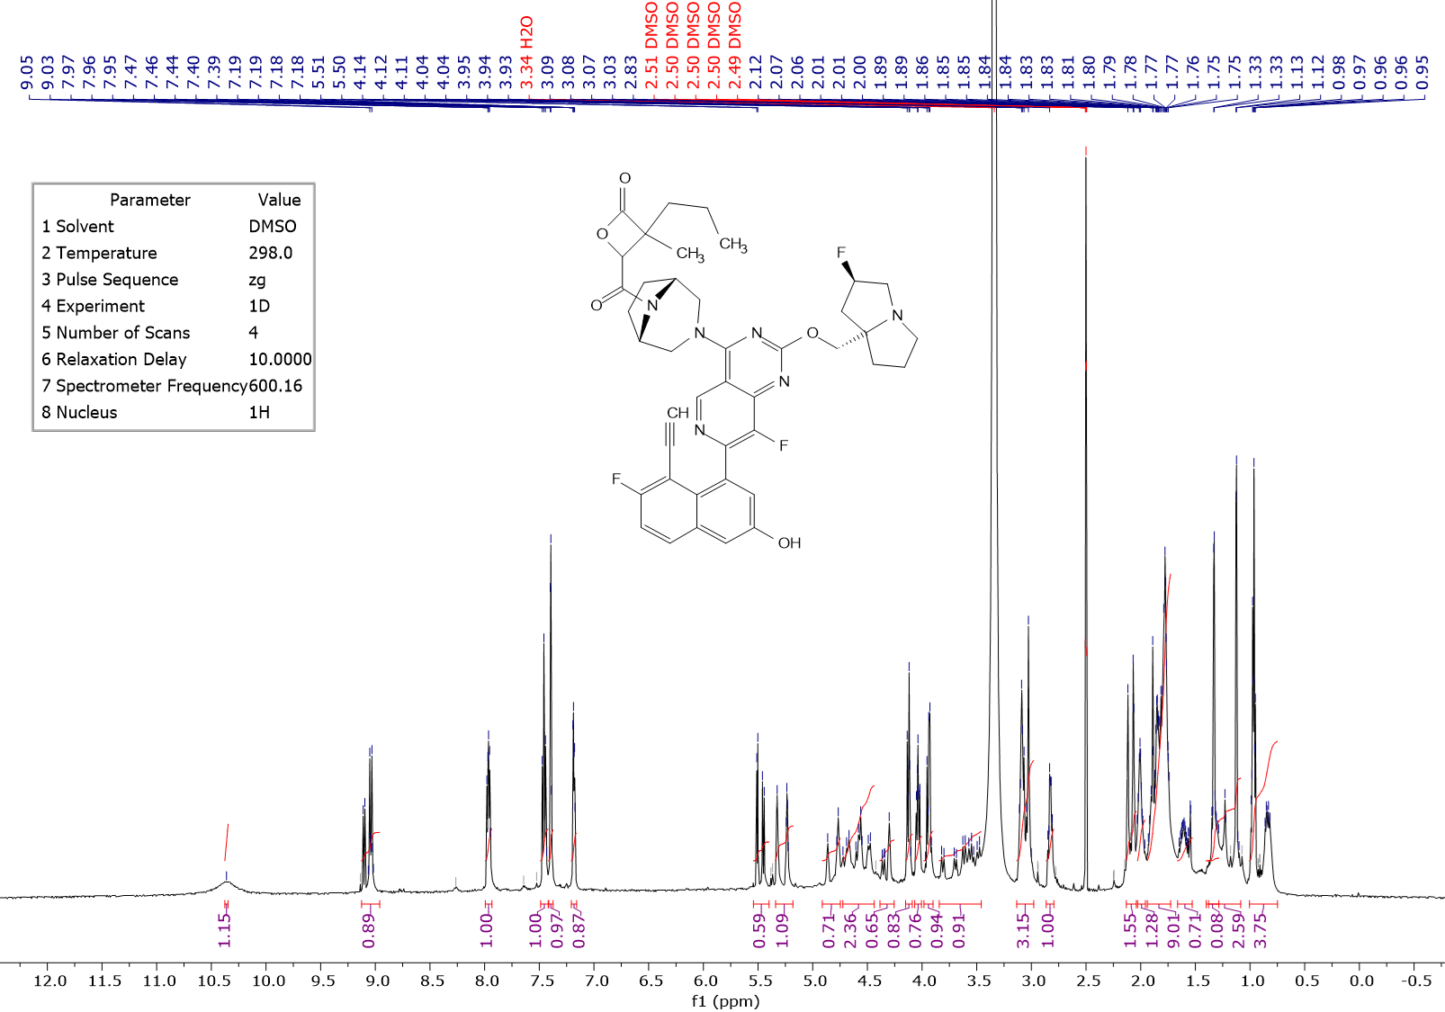1H NMR

1H NMR (600 MHz, DMSO) δ 10.36 (s, 1 H), 8.96 - 9.13 (m, 1H), 7.97 (dd, J=9.20, 5.80 Hz, 1 H), 7.46 (t, J=8.90 , 1 H), 7.40 (d, J=2.7 Hz, 1 H), 7.16 - 7.21 (m, 1 H), 5.40 - 5.54 (m, 1 H), 5.29 (d, 53.8 Hz, 1 H), 4.75 - 4.91 (m, 1H), 4.44 - 4.72 (m, 2 H), 4.25 - 4.38 (m, 1 H), 4.09 - 4.15 (m, 1H), 4.00 - 4.07 (m, 1 H), 3.90 - 3.98 (m, 1 H), 3.46 - 3.84 (m, 2 H), 2.98 - 3.13 (m, 3 H), 2.79 - 2.86 (m, 1 H), 2.04 - 2.13 (m, 2 H), 1.96 - 2.03 (m, 1 H), 1.73 - 1.94 (m, 9 H), 1.53 - 1.66 (m, 1H), 1.28 - 1.40 (m, 1H), 1.09 - 1.38 (m, 3 H) 0.75 - 1.00 (m, 3H)

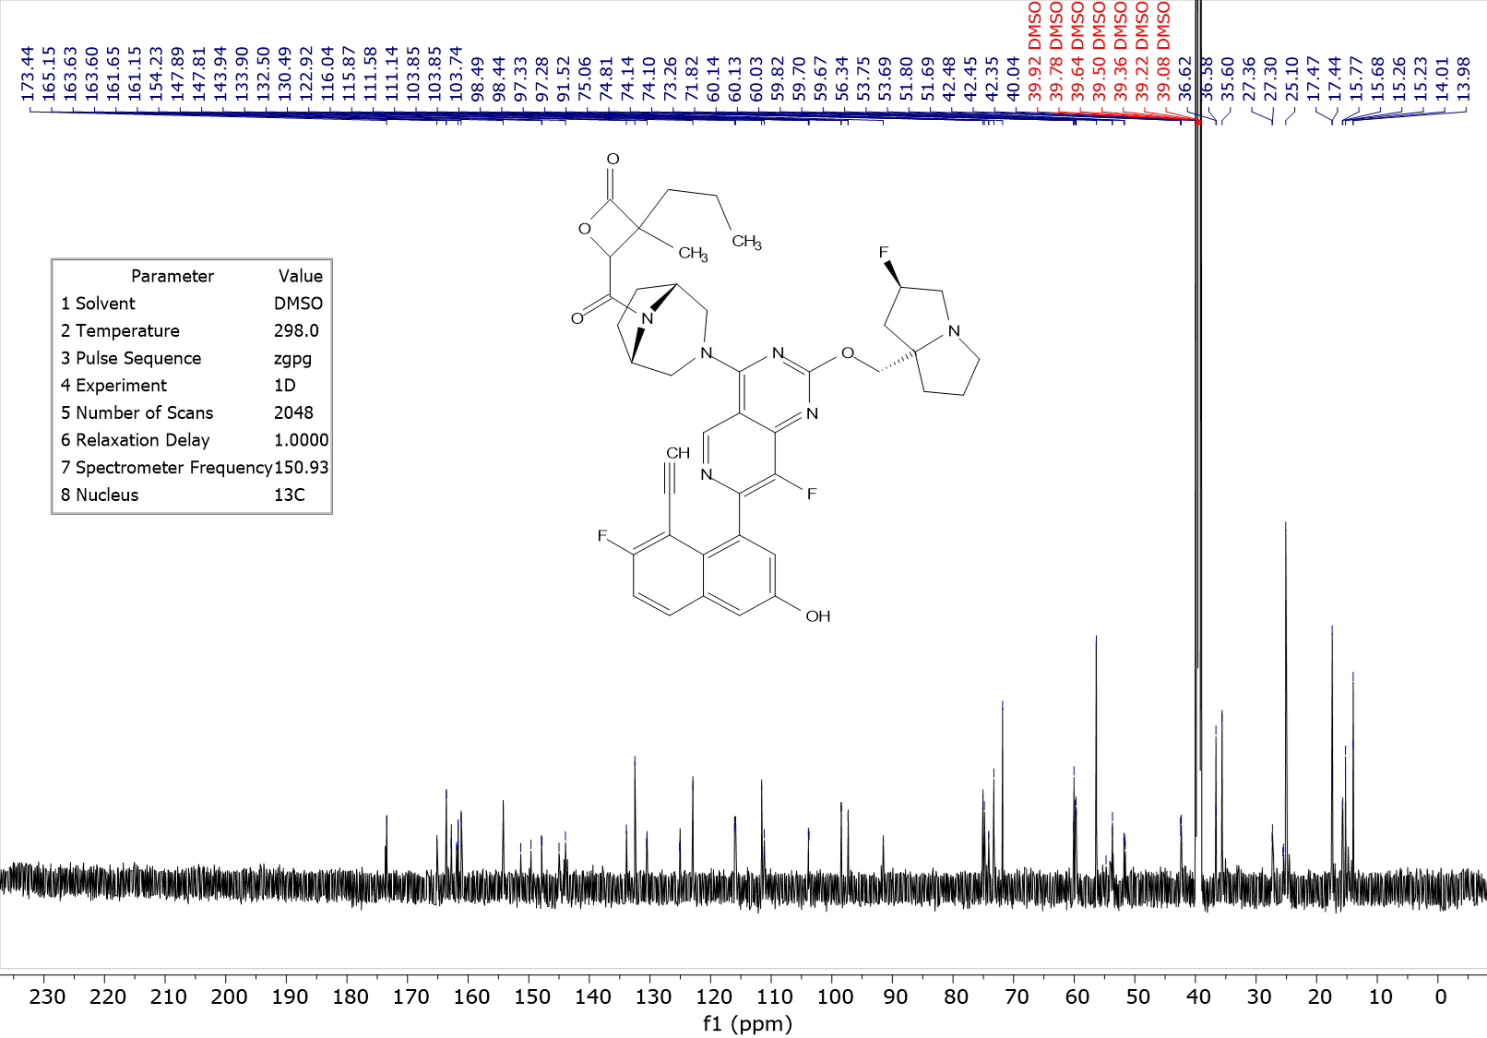

13C NMR (150 MHz, DMSO-d6) δ ppm 173.57 (m, 1 C), 165.15 (m, 1 C), 163.60 (m, 1 C), 161.97 (d, J=247.5 Hz, 1 C),161.74 (m, 1 C), 154.23 (m, 1 C), 150.48 (d, J=255.0 Hz, 1 C), 147.85 (d, J=12.1 Hz, 1 C), 145.00 (m, 1 C), 143.94 (m, 1 C), 133.90 (m, 1 C), 132.50 (s, 1 C), 130.52 (d, J=9.3 Hz, 1 C), 125.12 (m, 1 C), 122.92 (s, 1 C), 115.95 (d, J=25.7 Hz, 1 C), 111.58 (s, 1 C), 111.14 (m, 1 C), 103.81 (m, 1 C), 97.89 (dd, J = 174.3, 7.8 Hz, 1 C), 91.52 (m, 1 C), 75.06 (s, 1 C), 74.81 (m, 1 C), 73.26 (m, 1 C), 71.82 (s, 1 C), 60.10 (m, 1 C), 59.73 (dd, J=19.1, 4.8 Hz, 1 C), 56.34 (s, 1C), 54.75 (m, 1C), 53.72 (m, 2 C), 51.67 (m, 1 C), 42.43 (m, 1 C), 35.62 (s, 1 C), 35.60 (s, 1 C), 27.33 (m, 1 C), 25.53 (m, 1 C), 25.10 (s, 1 C), 17.45 (s, 1 C), 15.49 (m, 1 C), 14.01 (m, 1C)

19F NMR (376 MHz, DMSO) δ -111.15, -138.59 – -142.73 (m), -168.83 – -173.99 (m).

LCMS_10_MIN_FINAL_ANALYSIS; RT = 3.42 min; m/z = 755.1 [M+H]+

## (3S,4R)-4-((1R,5S)-3-(7-(8-ethynyl-7-fluoro-3-hydroxynaphthalen-1-yl)-8-fluoro-2-(((2R,7aS)-2-fluorotetrahydro-1H-pyrrolizin-7a(5H)-yl)methoxy)pyrido[4,3-d]pyrimidin-4-yl)-3,8-diazabicyclo[3.2.1]octane-8-carbonyl)-3-isopropyl-3-methyloxetan-2-one (3S, 4R-**6**



*benzyl 2-methyl-3-oxobutanoate*[1]



To a solution of benzyl 3-oxobutanoate (CAS[5396-89-4], 20 g, 104 mmol, 1 equiv.) in MeCN (200 mL) was added K2CO3 (28.76 g, 208 mmol) at 25 °C under N2 and the solution was stirred for 15 min. MeI (7.77 mL, 125 mmol) was then added and the mixture was heated to 80 °C and stirred for 12 hours. TLC analysis (petroleum ether: EtOAc = 3:1) indicated consumption of benzyl 3-oxobutanoate (Rf = 0.5), with formation of a new spot (Rf = 0.6). The mixture was quenched with water and extracted with EtOAc. The combined organic phases were dried over anhydrous Na2SO4, filtered and concentrated in vacuum. The residue was purified by flash column chromatography (ISCO®; 220 g SepaFlash® Silica Flash Column, gradient of 0-50% EtOAc in petroleum ether) and the eluent was concentrated under reduced pressure to give the title compound as colorless oil (14.6 g, 70.8 mmol, 68% yield).

1H NMR (400 MHz, CDCl3) δ 7.45 – 7.28 (m, 5H), 5.18 (s, 2H), 3.55 (q, *J* = 7.2 Hz, 1H), 2.19 (s, 3H), 1.36 (d, *J* = 7.1 Hz, 3H).

Rf = 0.6 (silica, petroleum ether: EtOAc 3: 1).

*benzyl 4-(tert-butyl) 2-acetyl-2-methylsuccinate*



To a solution of benzyl 2-methyl-3-oxobutanoate (14.6 g, 71.0 mmol) in MeCN (146 mL) was added Cs2CO3 (34.6 g, 106 mmol). Then *tert*-butyl 2-iodoacetate (CAS [49827-15-8], 12.38 mL, 85 mmol) was added at 0 °C, the reaction mixture was stirred for 16 hours at 25 °C. The reaction mixture was diluted with water and extracted with EtOAc. The combined organic phases were concentrated under reduced pressure to give a residue. The residue was purified by flash silica gel chromatography (ISCO®; 220 g SepaFlash® Silica Flash Column, eluting with a gradient of 0-30% EtOAc in petroleum ether) and the eluent was concentrated to give the title compound as colorless oil (24.6 g, used as crude for next step).

1H NMR (400 MHz, CDCl3) δ 7.40 – 7.28 (m, 5H), 5.19 (d, *J* = 12.3 Hz, 1H), 5.15 (d, *J* = 12.2 Hz, 1H), 2.89 (d, *J* = 16.3 Hz, 1H), 2.78 (d, *J* = 16.4 Hz, 1H), 2.15 (s, 3H), 1.48 (s, 3H), 1.40 (s, 9H).

Rf = 0.7 (silica, petroleum ether: EtOAc 3: 1).

*benzyl 4-(tert-butyl)-2-methyl-2-(prop-1-en-2-yl) succinate*



To a solution of methyltriphenylphosphonium bromide (CAS [1779-49-3], 55 g, 154 mmol) in THF (123 mL) was added *t-*BuOK (154 mL, 154 mmol, 1 M in THF) at 0 °C. The resultant mixture was stirred for 2 hours under N2, and then a solution of 1-benzyl 4-(tert-butyl) 2-acetyl-2-methylsuccinate (24.6 g, 77.0 mmol) in THF (123 mL) was added. The reaction mixture was heated to 80 °C and stirred for another 12 hours. The reaction was quenched with water, then extracted with EtOAc, and combined organic phases were dried with Na2SO4, filtered and concentrated *in vacuo*. The residue was purified by automated flash column chromatography (ISCO®; 220 g SepaFlash® Silica Flash Column, gradient of 0 to 40 % EtOAc/petroleum ether) and the eluent of product containing fractions was concentrated to give the title compound as colorless oil (15.7 g, 49.2 mmol, 69% yield over two steps).

1H NMR (400 MHz, CDCl3) δ 7.46 – 7.27 (m, 5H), 5.13 (s, 2H), 4.90 (s, 1H), 4.85 (s, 1H), 2.95 (d, *J* = 15.7 Hz, 1H), 2.54 (d, *J* = 15.4 Hz, 1H), 1.71 (s, 3H), 1.45 (s, 3H), 1.41 (s, 9H).

Rf = 0.5 (silica, petroleum ether: EtOAc 5: 1).

*4-(tert-butoxy)-2-isopropyl-2-methyl-4-oxobutanoic acid*



To a solution of 1-benzyl 4-(tert-butyl) 2-methyl-2-(prop-1-en-2-yl) succinate (15.65 g, 49 mmol) in MeOH (500 mL) was added Pd/C (7.5 g, 10% content) and Pd(OH)2/C (7.5 g, 20% content). The mixture was stirred for 12 hours at 25 °C under H2 atmosphere (15 PSI). The reaction mixture was filtered and concentrated to give the title compound as colorless oil (10 g, crude, directly used in next step).

1H NMR (400 MHz, CDCl3) δ 2.74 (d, *J* = 15.7 Hz, 1H), 2.32 (d, *J* = 15.8 Hz, 1H), 1.93 (p, *J* = 6.9 Hz, 1H), 1.43 (s, 9H), 1.21 – 1.13 (m, 3H), 0.90 (d, *J* = 6.8 Hz, 6H).

*tert-butyl 3-isopropyl-3-methyl-4-oxooxetane-2-carboxylate*



To a solution of 4-(tert-butoxy)-2-isopropyl-2-methyl-4-oxobutanoic acid (5.0 g, crude) in THF (50 mL) was added dropwise LiHMDS (54 mL, 54 mmol, 1 M in THF) at -60 °C under N2. The reaction mixture became viscous, then the reaction mixture was warmed up to 25 °C and stirred at this temperature for 1 hour to obtain a lightly yellow solution. This solution was added dropwise into the suspension of Br2•dioxane (8.1 g, 33 mmol) in THF (40 mL) at -60 °C under N2, resulting in a color change to red. The reaction mixture was stirred at -60 °C for 30 min then warmed up to 25 °C and stirred at this temperature for another 30 min associated with slow decolorization. The mixture was diluted with anhydrous EtOAc and quenched with 0.5 N aqueous HCl. After extraction with EtOAc, the separated organic layers were dried over anhydrous Na2SO4, concentrated to give the crude product as yellow oil (8 g). The crude product (8 g) was dissolved in THF (50 mL) and then added aqueous solution of NaHCO3 (50 mL, 4% w/w). Then the reaction mixture was stirred at 25 °C for 12 hrs. It was extracted into EtOAc and the combined organic layers were dried over anhydrous Na2SO4, filtered and concentrated to give a residue. The residue was purified by flash silica gel chromatography (ISCO®; 120 g SepaFlash® Silica Flash Column, eluent of 0-30% petroleum ether/EtOAc) and the eluent was concentrated to give the title compound as colorless oil (2.9 g, 12.7 mmol, 51% yield over two steps, 10:1 d.r. by integration of 1H NMR).

1H NMR (400 MHz, CDCl3, major isomer) δ 4.57 (s, 1H), 2.10 (p, *J* = 6.8 Hz, 1H), 1.51 (s, 9H), 1.27 (s, 3H), 1.06 (d, *J* = 3.1 Hz, 3H), 1.04 (d, *J* = 3.1 Hz, 3H).

1HNMR ratio of trans and cis isomers: 10:1. Major *trans-*isomer suggested by 2DNMR (NOESY);

Rf = 0.7 (silica, petroleum ether: EtOAc 5 : 1).

*3-isopropyl-3-methyl-4-oxooxetane-2-carboxylic acid*



To a solution of tert-butyl 3-isopropyl-3-methyl-4-oxooxetane-2-carboxylate (1.00 g, 4.38 mmol) in CH2Cl2 (5 mL) was added TFA (5 mL) at 0 °C, the mixture was stirred at 0 °C for 3 hours. TLC (petroleum ether : EtOAc = 1:1) showed the consumption of tert-butyl 3-isopropyl-3-methyl-4-oxooxetane-2-carboxylate (Rf = 0.9) and a new spot (Rf = 0.2) was detected. A gentle steam of N2 was passed through the reaction to remove all volatiles. The residue was purified by flash silica gel chromatography (ISCO®; 40 g SepaFlash® Silica Flash Column, eluting with a gradient of 0 to 100% EtOAc in petroleum ether) and the eluent was concentrated to give the title compound as yellow oil (386 mg, 2.24 mmol, 51 % yield).

1H NMR (400 MHz, CDCl3) δ 4.75 (s, 1H), 2.15 (p, *J* = 6.8 Hz, 1H), 1.34 (s, 3H), 1.09 (d, *J* = 1.9 Hz, 3H), 1.07 (d, *J* = 1.9 Hz, 3H).

Rf = 0.2 (silica, petroleum ether: EtOAc 1: 1).

*benzyl (2R,3S)-3-isopropyl-3-methyl-4-oxooxetane-2-carboxylate*



To a solution of 3-isopropyl-3-methyl-4-oxooxetane-2-carboxylic acid (300 mg, 1.74 mmol) in DMF (3 mL) was added DIPEA (0.86 mL, 5.23 mmol, 3 equiv.) and BnBr (310 mg, 1.74 mmol). The reaction mixture was stirred at 25 °C for 12 hours. The reaction mixture was quenched with water, extracted with EtOAc. The combined organic layers were dried over anhydrous Na2SO4, filtered and concentrated to give a residue. The residue was purified by flash silica gel chromatography (ISCO®; 40 g SepaFlash® Silica Flash Column, eluting with a gradient of 0-20% EtOAc in petroleum ether) and the eluent was concentrated to give benzyl 3-isopropyl-3-methyl-4-oxooxetane-2-carboxylate a mixture of diastereomers as yellow oil (400 mg; 1.54 mmol, 87.5 %).

1H NMR (400 MHz, CDCl3) δ 7.43 – 7.31 (m, 5H), 5.31 – 5.23 (m, 2H), 4.71 (s, 1H), 2.16 – 2.01 (m, 1H), 1.13 (s, 3H), 1.03 (d, *J* = 6.8 Hz, 6H).

The diastereomeric product mixture (400 mg) was separated by preparative chiral SFC to give benzyl (2*R\**,3*S\**)-3-isopropyl-3-methyl-4-oxooxetane-2-carboxylate as the second eluting peak (colorless oil, 115 mg, 438 mmol, 25% yield).Tentative assignment of absolute configuration based on OR value from next step.

1H NMR (400 MHz, CDCl3) δ 7.46 – 7.30 (m, 5H), 5.29 (d, *J* = 11.9 Hz, 1H), 5.25 (d, *J* = 12.1 Hz, 1H), 4.71 (s, 1H), 2.09 (p, *J* = 6.8 Hz, 1H), 1.13 (s, 3H), 1.03 (d, *J* = 6.8 Hz, 6H).

SFC-10: Rt = 1.560 min, ee: 100%.

The remaining isomers were obtained with the first eluting peak (approx.. 4:1 mixture of *trans* and *cis* isomers, colorless oil, 140 mg). The first eluting peak(140 mg) was further separated by preparative chiral SFC. Each of the two peaks was separately purified by flash silica gel chromatography (ISCO®; 12 g SepaFlash® Silica Flash Column, eluting with a gradient of 0-20% EtOAc in petroleum ether) to give benzyl (2S,3R)-3-isopropyl-3-methyl-4-oxooxetane-2-carboxylate as the second eluting peak (colorless oil, 80 mg, 305 mmol, 18% yield).

1H NMR (400 MHz, CDCl3) δ 7.47 – 7.31 (m, 5H), 5.29 (d, *J* = 9.8 Hz, 1H), 5.25 (d, *J* = 12.0 Hz, 1H), 4.71 (s, 1H), 2.09 (p, *J* = 6.8 Hz, 1H), 1.13 (s, 3H), 1.03 (d, *J* = 6.9 Hz, 6H).

SFC-26: Rt = 0.830 min, ee: 100%.

Cis-diastereomer was obtained as the first eluting peak (colorless oil, 20 mg, 76 mmol, 4% yield).

1H NMR (400 MHz, CDCl3) δ 7.46 – 7.33 (m, 5H), 5.31 (d, *J* = 11.9 Hz, 1H), 5.20 (d, *J* = 12.0 Hz, 1H), 4.62 (s, 1H), 2.22 (p, *J* = 6.8 Hz, 1H), 1.44 (s, 3H), 1.02 (d, *J* = 6.7 Hz, 3H), 0.71 (d, *J* = 6.8 Hz, 3H).

structure was confirmed by 2DNMR(NOESY);

(2R,3S)-3-isopropyl-3-methyl-4-oxooxetane-2-carboxylic acid



To a solution of benzyl (2*R\**,3*S\**)-3-isopropyl-3-methyl-4-oxooxetane-2-carboxylate (peak 2; 115 mg, 0.44 mmol) in EtOAc (5 mL) was addedPd/C (100 mg, 10% Wt) under N2. The suspension was degassed under vacuum and purged with H2 three times and then stirred at 25 °C for 2 hours under H2 (15 psi). TLC (petroleum ether: EtOAc = 10:1) showed starting material (Rf = 0.3) was consumed. The reaction mixture filtered over Celite pad, the filter cake was washed with EtOAc, and the combined filter liquor was concentrated to give (2*R*,3*S*)-3-isopropyl-3-methyl-4-oxooxetane-2-carboxylic acid as yellow oil (65 mg, 0.40 mmol, 90% yield). It was used to next step directly without any other purification.

1H NMR (400 MHz, CDCl3) δ 4.75 (s, 1H), 2.14 (p, *J* = 6.8 Hz, 1H), 1.33 (s, 3H), 1.08 (d, *J* = 6.8 Hz, 6H).

[α]25D= - 4.917° (C = 0.3864 g/100 mL, acetone).

*(3S,4R)-4-((1R,5S)-3-(7-(8-ethynyl-7-fluoro-3-hydroxynaphthalen-1-yl)-8-fluoro-2-(((2R,7aS)-2-fluorotetrahydro-1H-pyrrolizin-7a(5H)-yl)methoxy)pyrido[4,3-d]pyrimidin-4-yl)-3,8-diazabicyclo[3.2.1]octane-8-carbonyl)-3-isopropyl-3-methyloxetan-2-one (3S, 4R-)****6***



To a mixture of (2*R*,3*S*)-3-isopropyl-3-methyl-4-oxooxetane-2-carboxylic acid(23 mg, 0.13 mmol) and 2,6-lutidine (0.093 mL, 0.80 mmol, 6 equiv.) in DMF (1.6 mL) was added COMU (63 mg, 0.15 mmol, 1.1 equiv.), the mixture was stirred at - 5 °C for 15 min, then 4-(4-((1R,5S)-3,8-diazabicyclo[3.2.1]octan-3-yl)-8-fluoro-2-(((2R,7aS)-2-fluorotetrahydro-1H-pyrrolizin-7a(5H)-yl)methoxy)pyrido[4,3-d]pyrimidin-7-yl)-5-ethynyl-6-fluoronaphthalen-2-ol (MRTX1133, 80 mg, 0.13 mmol, 1 equiv.) was added. The reaction mixture was stirred at -5 °C for 15 min. The reaction mixture was quenched with a saturated solution of NaHCO3, then diluted with H2O and EtOAc, extracted with EtOAc. The combined organic layers were washed with brine and 10% aqueous solution of LiCl, and then dried with anhydrous Na2SO4, filtered through a sintered glass funnel and concentrated. The residue was purified by reversed phase preparative HPLC (48 g of SepaFlash® Spherical C18, 100 Å; mobile phase: A for H2O + 0.1% FA and B for acetonitrile; gradient: B 30 - 70% in 20 min, flow rate: 60 mL/min; column temperature: R.T. Wavelength: 220 nm/254 nm), the eluent was concentrated to remove organic solvents and lyophilized to give the title compound as a yellow solid (44.70 mg, 0.056 mmol, 43% yield).

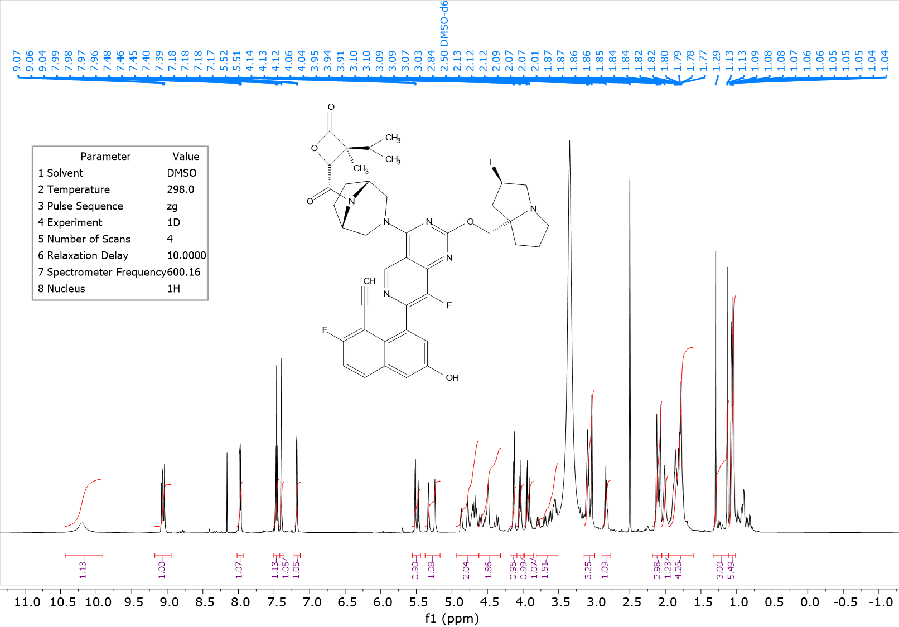

1H NMR (600 MHz, DMSO) δ 10.28 (s, 1 H), 8.95 - 9.18 (m, 1H), 7.98 (dd, J=9.20, 5.90 Hz, 1 H), 7.46 (t, J=9.00, 1 H), 7.40 (d, J=2.6 Hz, 1 H), 7.13 - 7.22 (m, 1 H), 5.44 - 5.56 (m, 1 H), 5.25 (d, 54.0 Hz, 1 H), 4.63 - 4.94 (m, 2H), 4.32 - 4.62 (m, 2 H), 4.10 - 4.18 (m, 1 H), 3.99 - 4.09 (m, 1 H), 3.85 - 3.98 (m, 1 H), 3.51 - 3.81 (m, 2 H), 2.99 - 3.14 (m, 3 H), 2.78 - 2.89 (m, 1 H), 2.05 - 2.18 (m, 3 H), 1.96 - 2.05 (m, 2 H), 1.61 - 1.95 (m, 6 H), 1.11 - 1.33 (m, 3 H), 1.01 - 1.11 (m, 6H)

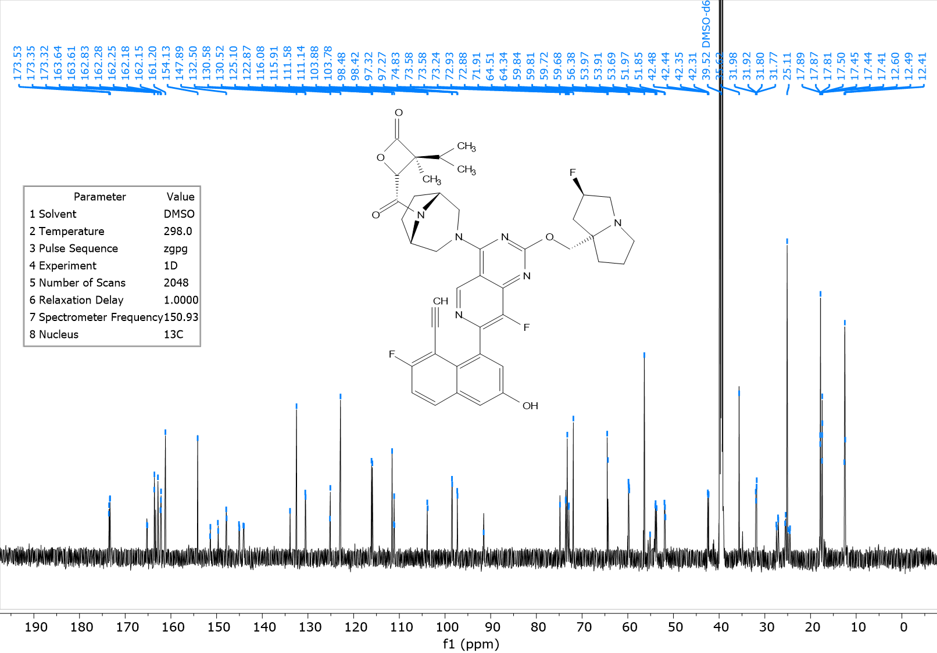

13C NMR (150 MHz, DMSO-d6) δ ppm 171.43 (m, 1 C), 165.18 (m, 1 C), 163.61 (m, 1 C), 162.20 (m, 1 C), 162.00 (d, J=247.1 Hz, 1 C), 154.11 (m, 1 C), 150.52 (d, J=256.7 Hz, 1 C), 147.83 (d, J=12.0 Hz, 1 C), 145.03 (br d, J=13.10 Hz, 1 C), 144.06 (m, 1 C), 133.91 (s, 1 C), 132.48 (s, 1 C), 130.53 (br d, J=9.4 Hz, 1 C), 125.121 (d, J=12.3 Hz, 1 C), 122.85 (s, 1 C), 115.97 (br d, J=25.7 Hz, 1 C), 111.56 (s, 1 C), 111.13 (m, 1 C), 103.81 (d, J=14.90 Hz, 1 C), 97.85 (br d, J=174.1 Hz, 1 C), 91.52 (m, 1 C), 74.81 (m, 1 C), 73.22 (m, 2 C), 71.89 (s, 1 C), 64.40 (m, 1 C), 59.74 (m, 1 C), 56.36 (s, 1C), 55.09 (m, 1C), 53.84 (m, 2C), 51.83 (m, 1 C), 42.37 (m, 1 C), 35.60 (s, 1 C), 31.85 (m, 1 C) 27.25 (m, 1 C), 24.99 (m, 2 C), 17.60 (m, 2 C), 12.48 (m, 1C)

19F NMR (376 MHz, DMSO) δ -110.12 – -111.17 (m), -139.17 – -141.10 (m), -171.32 – -173.20 (m).

LCMS-1: Rt = 0.482 min; MS m/z [M+H]+: 755.4;

HPLC-1: Rt = 1.732 min, purity: 96.9%;

Chiral HPLC-3: Rt = 3.384 min, ee: 100%.

## (3S,4R)-4-((1R,5S)-3-(7-(8-ethynyl-7-fluoro-3-hydroxynaphthalen-1-yl)-8-fluoro-2-(((2R,7aS)-2-fluorotetrahydro-1H-pyrrolizin-7a(5H)-yl)methoxy)pyrido[4,3-d]pyrimidin-4-yl)-3,8-diazabicyclo[3.2.1]octane-8-carbonyl)-3-isobutyl-3-methyloxetan-2-one (3S,4R)-**7**



To a solution of (2R,3S)-3-isobutyl-3-methyl-4-oxooxetane-2-carboxylic acid1 31 mg, 0.17 mmol) and COMU (71 mg, 0.17 mmol) in DMF (1 mL) was added 2,6-lutidine (0.12 mL, 1.00 mmol), the mixture was stirred at 15°C for 15 min, then 4-(4-((1R,5S)-3,8-diazabicyclo[3.2.1]octan-3-yl)-8-fluoro-2-(((2R,7aS)-2-fluorotetrahydro-1H-pyrrolizin-7a(5H)-yl)methoxy)pyrido[4,3-d]pyrimidin-7-yl)-5-ethynyl-6-fluoronaphthalen-2-ol (MRTX1133, 100 mg, 0.17 mmol) was added. The reaction mixture was stirred at 15°C for 15 min. The reaction mixture was added to a solution of saturated NaHCO3 (5 mL) diluted with water and EtOAc. It was extracted with EtOAc), and brine diluted with water and once with 10% aqueous solution of LiCl. The organic layers were combined, dried with anhydrous Na2SO4, filtered through a sintered glass funnel and concentrated to afford crude product. The crude residue was purified by reversed phase preparative HPLC (48 g) of SepaFlash® Spherical C18, 20 - 45 μm, 100 Å; mobile phase: A for H2O + 0.1% FA and B for acetonitrile; gradient: B 30- 50% in 30 min, flow rate: 40 mL/min; column temperature: RT, wavelength: 220 nm/254 nm), after purification, then concentrated to remove organic solvents then lyophilized to give the title compound as a yellow solid(79.14 mg, 0.10 mmol, 39% yield, FA salt).

1H NMR (400 MHz, DMSO) δ 10.38 (br s, 1 H),8.96 - 9.17 (m, 1H), 7.98 (dd, J=9.20, 5.90 Hz, 1 H), 7.47 (t, J=9.00 , 1 H), 7.40 (d, J=2.6 Hz, 1 H), 7.13 - 7.24 (m, 1 H), 5.39 - 5.63 (m, 1 H), 5.28 (d, 54.4 Hz, 1 H), 4.73 - 4.95 (m, 1H), 4.44 - 4.73 (m, 2 H), 4.27 - 4.41 (m, 1H), 4.08 - 4.19 (m, 1H), 4.01 - 4.09 (m, 1 H), 3.93 - 3.99 (m, 1 H), 3.74 - 3.93 (m, 1 H), 3.46 - 3.73 (m, 1H), 2.98 - 3.16 (m, 3 H), 2.76 - 2.89 (m, 1 H), 2.04 - 2.17 (m, 2 H), 1.96 - 2.03 (m, 1 H), 1.68 - 1.96 (m, 10 H), 1.11 - 1.46 (m, 3 H) 0.83 - 1.05 (m, 6H)

19F NMR (376 MHz, DMSO) δ -109.39 – -111.83 (m), -138.49 – -141.29 (m), -172.18.

LCMS-1: Rt = 0.493 min; MS m/z [M+H]+:

HPLC-2: Rt = 1.274 min; purity: 95.2%;

SFC-9; Rt = 2.125 min; ee: 100%;

## (3S,4R)-4-((1R,5S)-3-(7-(8-ethynyl-7-fluoro-3-hydroxynaphthalen-1-yl)-8-fluoro-2-(((2R,7aS)-2-fluorotetrahydro-1H-pyrrolizin-7a(5H)-yl)methoxy)pyrido[4,3-d]pyrimidin-4-yl)-3,8-diazabicyclo[3.2.1]octane-8-carbonyl)-3-methyl-3-((tetrahydro-2H-pyran-4-yl)methyl)oxetan-2-one (3S, 4R)-**8**



*(2R)-diethyl-2-hydroxy-3-methylsuccinate*2 *(***C-11086-057***)[2]CAS 107494-30-4*



To a solution of diethyl (R)-2-hydroxysuccinate (CAS [7554-28-1] 105 g, 552 mmol) in THF (2100 mL) was added dropwise LDA (635 mL, 1.27 mol, 2M in heptane) at -60 °C under N2. The solution was stirred at -60 °C for 1 hour under N2 and stirred at 0 °C for 0.5 hour. Then iodomethane (69 mL, 1104 mmol) in THF (69 mL) was added slowly at -60 °C. The mixture was stirred at -60 °C for 1 hour. Then it was carefully quenched with saturated solution of NH4Cl, extracted with EtOAc. The combined organic layers were dried over anhydrous Na2SO4, filtered and concentrated in vacuum. The residue was purified by flash chromatography (ISCO®; 880 g SepaFlash® Silica Flash Column, Eluent of 0-50% EtOAc/petroleum ether) and the eluent was concentrated under reduced pressure to give the title compound as yellow oil (73 g, 357.45 mmol, 65 % yield).

Rf = 0.4 (silica, petroleum ether : EtOAc 2: 1)

1H NMR (400 MHz, CDCl3) δ 4.31 – 4.22 (m, 3H), 4.19 – 4.10 (m, 2H), 3.14 (d, *J* = 6.5 Hz, 1H), 3.09 – 2.96 (m, 1H), 1.32 – 1.24 (m, 9H).

*diethyl (2S,3R)-3-hydroxy-2-methyl-2-((tetrahydro-2H-pyran-4-yl)methyl)succinate*



To a solution ofdiethyl (2R)-2-hydroxy-3-methylsuccinate (see *example* (3S, 4R)-**4***, 5 g, 24.5 mmol*) in THF (50 mL) was added dropwise LDA (28 mL, 56.3 mmol, 2M in mixture of THF and heptane) at -60 °C under N2. The solution was stirred at -60 °C for 0.5 hour, then warmed up to 0 °C and stirred for another 1 hr. It was cooled again to -60 °C and 4-(bromomethyl) tetrahydro-2H-pyran (CAS [125552-89-8] 8.77 g, 49 mmol) was added dropwise at -60 °C. The reaction mixture was warmed up to 25°C and stirred for 12 hours under N2. The mixture was quenched with saturated solution of NH4Cl, extracted with EtOAc. The combined organic layers were dried over anhydrous Na2SO4, filtered and concentrated in vacuum. The residue was purified by flash chromatography (ISCO®; 80 g SepaFlash® Silica Flash Column, Eluent of 0-80% EtOAc / petroleum ether) and the eluent was concentrated under reduced pressure to give the title compound as yellow oil (3.8 g, 12.6 mmol, 51 %).

1H NMR (400 MHz, CDCl3) δ 4.38 – 4.08 (m, 5H), 4.01 – 3.83 (m, 2H), 3.49 – 3.25 (m, 2H), 3.21 – 3.03 (m, 1H), 1.91 - 1.74 (m, 1H), 1.68 – 1.43 (m, 5H), 1.42 – 1.10 (m, 10H).

Rf = 0.2 (silica, petroleum ether: EtOAc 2: 1)

*(2S,3R)-3-hydroxy-2-methyl-2-((tetrahydro-2H-pyran-4-yl)methyl)succinic acid*



A solution of diethyl (2S,3R)-3-hydroxy-2-methyl-2-((tetrahydro-2H-pyran-4-yl) methyl)succinate (3 g, 9.9 mmol) in concentrated HCl (30 mL) was stirred at 100 °C for 12 hours. The mixture was concentrated in vacuum. The residual crude product was diluted with EtOAc and dried over anhydrous Na2SO4, filtered and concentrated to give the crude title compound as red oil (2.5 g) which was used for next step directly without further purification.

*(2S,3R)-4-(benzyloxy)-3-hydroxy-2-methyl-4-oxo-2-((tetrahydro-2H-pyran-4-yl)methyl)butanoic acid(C-11109-049)*



(2S,3R)-3-hydroxy-2-methyl-2-((tetrahydro-2H-pyran-4-yl) methyl) succinic acid (3.1 g, 10.2 mmol, crude) was placed in a round-bottomed flask and cooled in an ice bath. Then TFAA (5.25 mL, 37.8 mmol) was added dropwise at 0 °C under N2. The reaction mixture was stirred for 30 min at 0 °C and then at 25°C for 2.5 hours. Excess TFAA and trifluoroacetic acid (TFA) were evaporated under vacuum at room temperature. The residue was treated with benzyl alcohol (CAS [100-51-6] 5.2 mL, 50.4 mmol) under N2 atmosphere. The reaction was allowed to stirr at 25°C for 12 hours, then diluted with H2O and extracted with EtOAc. The combined organic layers were dried over anhydrous Na2SO4, filtered and concentrated in vacuum. The residue was purified by flash silica gel chromatography (ISCO®; 80 g SepaFlash® Silica Flash Column, gradient 0-80% EtOAc in petroleum ether) and concentrated. The residue was further purified by reversed phase preparative HPLC (80 g SepaFlash® Spherical C18, 20 - 45 μm, 100 Å; mobile phase: A for H2O + 0.1% FA and B for acetonitrile; gradient: B 0 - 100% 20 min, 100% 5 min, flow rate: 60 mL/min; column temperature: RT, wavelength: 220 nm/254 nm). Product containing fractions were extracted with saturated aqueous NaHCO3 solution and EtOAc, organic layers separated, dried and concentrated to give the title compound as colorless oil (300 mg, 0.89 mmol, 9.0 % over two steps).

1H NMR (400 MHz, CDCl3) δ 7.45 – 7.30 (m, 5H), 5.35 – 5.25 (m, 2H), 5.16 (d, *J* = 12.0 Hz, 1H), 4.32 (s, 1H), 3.97 – 3.77 (m, 2H), 3.53 – 3.16 (m, 2H), 1.86 – 1.70 (m, 1H), 1.67 – 1.42 (m, 4H), 1.43 – 1.18 (m, 2H), 1.13 (s, 3H).

LCMS-1: Rt = 0.458 min; MS m/z [M+Na]+: 359.1

*(2R,3S) benzyl -3-methyl-4-oxo-3-((tetrahydro-2H-pyran-4-yl) methyl) oxetane-2-carboxylate*



To (2S,3R)-4-(benzyloxy)-3-hydroxy-2-methyl-4-oxo-2-((tetrahydro-2H-pyran-4-yl)methyl) butanoic acid (250 mg, 0.19 mmol) in DCM (25 mL) was added TEA (0.31 mL, 2.25 mmol) and PyBOP (CAS[128625-52-5], 585 mg, 1.13 mmol) at 25 °C. The reaction mixture was stirred at 25 °C for 1 hour, then diluted with water and extracted with dichloromethane. The combined organic layers were dried over Na2SO4, filtered and concentrated under vacuum to give a residue. The crude product was purified by flash silica gel chromatography (ISCO®; 20 g SepaFlash® Silica Flash Column, Eluent of 0-30% EtOAc /petroleum ether) The product containing fractions were concentrated to give the title compound as colorless oil (200 mg, 0.063 mmol, 84% yield).

1H NMR (400 MHz, CDCl3) δ 7.37 (s, 5H), 5.47 – 5.16 (m, 2H), 4.75 (s, 1H), 4.01 – 3.83 (m, 2H), 3.49 – 3.17 (m, 2H), 1.86 – 1.74 (m, 2H), 1.74 – 1.61 (m, 3H), 1.45 – 1.28 (m, 2H), 1.19 (s, 3H).

LCMS-1: Rt = 0.538 min; MS m/z [M+Na]+: 341.1;

Rt = 0.984 min, ee: 100%;

[α]25D= -14.331° (C = 0.3810 g/100 mL, acetone)

*(2R,3S)-3-methyl-4-oxo-3-((tetrahydro-2H-pyran-4-yl)methyl)oxetane-2-carboxylic acid*



To a solution of benzyl (2R,3S)-3-methyl-4-oxo-3-((tetrahydro-2H-pyran-4-yl) methyl)oxetane-2-carboxylate (200 mg, 0.63 mmol) in THF (4 mL) was added Pd/C (40 mg, 10% Wt) under N2. The suspension was degassed under vacuum, purged with H2 three times and stirred for 2 hours under H2 (15 psi) at 25°C. The reaction mixture was filtered and concentrated under vacuum to give the title compound as a white solid (120 mg, 0.053 mmol, 83% yield).

1H NMR (400 MHz, CDCl3) δ 4.77 (s, 1H), 4.03 – 3.95 (m, 2H), 3.59 – 3.24 (m, 2H), 2.00 – 1.58 (m, 5H), 1.38 (s, 5H).

TLC Rf = 0.1 (silica, petroleum ether: EtOAc 5 : 1)

*(3S,4R)-4-((1R,5S)-3-(7-(8-ethynyl-7-fluoro-3-hydroxynaphthalen-1-yl)-8-fluoro-2-(((2R,7aS)-2-fluorotetrahydro-1H-pyrrolizin-7a(5H)-yl)methoxy)pyrido[4,3-d]pyrimidin-4-yl)-3,8-diazabicyclo[3.2.1]octane-8-carbonyl)-3-methyl-3-((tetrahydro-2H-pyran-4-yl)methyl)oxetan-2-one* *(3S, 4R)-****8***



To the mixture of (2R,3S)-3-methyl-4-oxo-3-((tetrahydro-2H-pyran-4-yl)methyl)oxetane-2-carboxylic acid (68 mg, 300 μmol) in DMF (1.0 mL) was added 2,6-lutidine (193 mg, 209 μL, 1.8 mmol) and COMU (CAS [1075198-30-9] 128 mg, 300 μmol) at -5°C, the mixture was stirred at -5°C for 15 min, then 4-(4-((*1R,5S*)-3,8-diazabicyclo[3.2.1]octan-3-yl)-8-fluoro-2-(((*2R,7aS*)-2-fluorotetrahydro-1H-pyrrolizin-7a(5H)-yl)methoxy)pyrido[4,3-d]pyrimidin-7-yl)-5-ethynyl-6-fluoronaphthalen-2-ol (MRTX1133, 180.0 mg, 300 μmol) in DMF (1.0 mL) was added. The reaction mixture was stirred at -5°C for 15 min. The reaction mixture was added to a saturated solution of NaHCO3 and diluted with water, and then extracted with EtOAc. The combined organic layers were washed with brine and 10% aqueous solution of LiCl. The organic layers were dried with anhydrous Na2SO4, filtered through a sintered glass funnel and concentrated. The the crude product was purified by reversed phase preparative HPLC (48 g of SepaFlash® Spherical C18, 20 - 45 μm, 100 Å; mobile phase: A for H2O + 0.1% FA and B for acetonitrile; gradient: B 30- 50% in 30 min, flow rate: 40 mL/min; column temperature: RT, wavelength: 220 nm/254 nm). Product containing fractions were neutralized with saturated solution of NaHCO3, extracted with dichloromethane and concentrated at 25 °C. The product was dried by lyophilization to give the title compound as a yellow solid (66.05 mg, 79 μmol, 26 % yield).

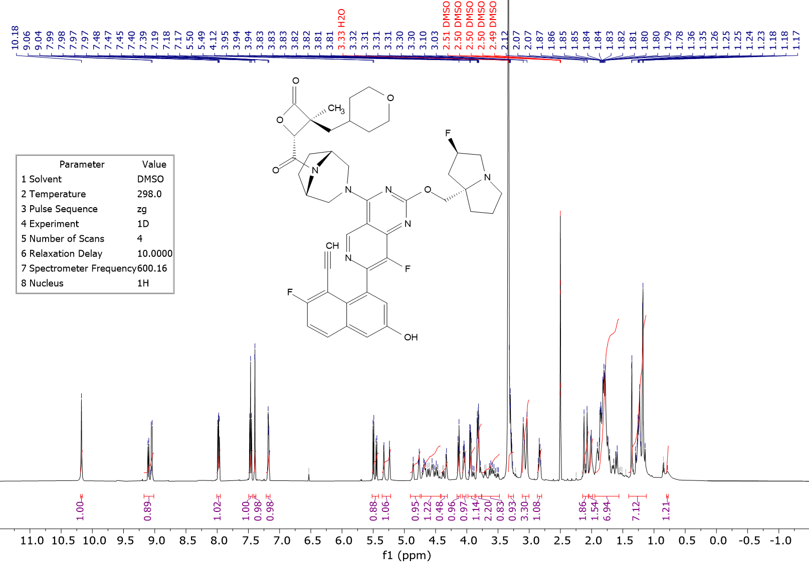

1H NMR (600 MHz, DMSO-d6) d ppm 10.18 (s, 1 H), 9.01 - 9.17 (m, 1H), 7.98 (dd, J=9.20, 5.95 Hz, 1 H), 7.46 (t, J=9.03, 1 H), 7.40 (d, J=2.47 Hz, 1 H), 7.16 - 7.20 (m, 1 H), 5.41 - 5.52 (m, 1 H), 5.28 (d, 53.9 Hz, 1 H), 4.75 - 4.90 (m, 1 H), 4.42 - 4.73 (m, 2 H), 4.31 - 4.41 (m, 1 H), 4.10 - 4.16 (m, 1 H), 4.01 - 4.07 (m, 1 H), 3.87 - 3.98 (m, 1 H), 3.74 - 3.85 (m, 2 H), 3.48 - 3.76 (m, 2 H), 3.19 - 3.31 (m, 2 H), 3.00 - 3.12 (m, 3 H), 2.80 - 2.87 (m, 1 H), 2.05 - 2.15 (m, 2 H), 1.98 - 2.04 (m, 2 H), 1.56 - 1.95 (m, 11 H), 1.12 - 1.41 (m, 5 H)

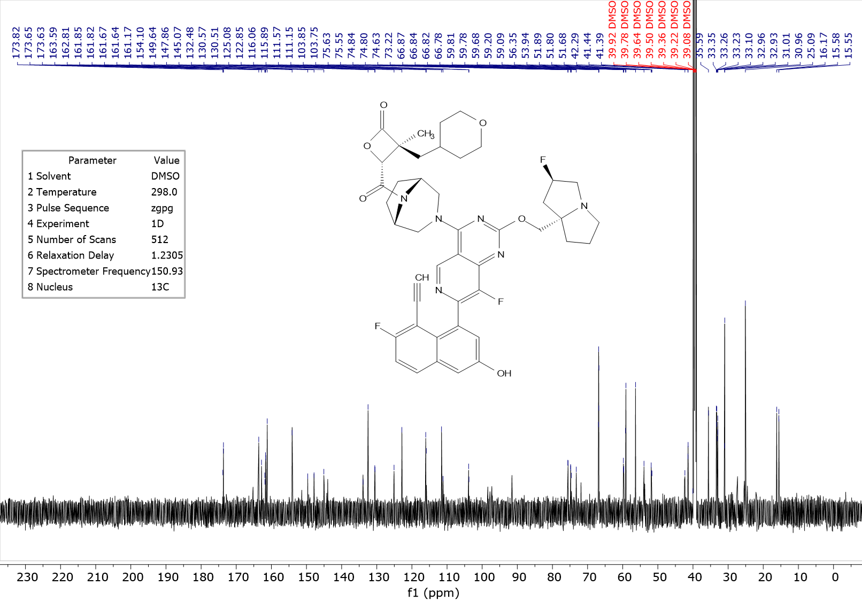

13C NMR (150 MHz, DMSO-d6) d ppm 173.82 (m, 1 C), 165.26 (m, 1 C), 163.59 (s, 1 C), 162.24 (d, J=247.37 Hz, 1 C), 161.64 (m, 1 C), 154.1 (s, 1 C), 150.52 (br d, J=249.51 Hz, 1 C), 147.8 3 (br d, J=11.02 Hz, 1 C), 145.02 (br d, J=14.41 Hz, 1 C), 144.05 (m, 1 C), 133.91 (m, 1 C), 132.48 (s, 1 C), 130.54 (br d, J=8.76 Hz, 1 C), 125.11 (m, 1 C), 122.86 (s, 1 C), 115.98 (br d, J=25.71 Hz, 1 C), 111.57 (s, 1 C), 111.15 (m, 1 C), 103.80 (br d, J=15.54 Hz, 1 C), 97.82 (br d, J=175.19 Hz, 1 C), 91.52 (m, 1 C), 75.59 (m, 1 C), 74.61 (m, 1 C), 73.22 (m, 1 C), 71.88 (m, 1 C), 66.84 (m, 2 C), 59.67 (m, 1 C), 59.09 (m, 1 C), 56.35 (s, 1C), 54.86 (m, 1C), 53.98 (m, 1C), 53.84 (m, 1 C), 51.79 (m, 1 C) 42.35 (m, 1C), 41.39 (m, 1 C), 35.59 (s, 1 C), 33.10 (m, 2 C), 31.01 (s, 1 C), 27.33 (m, 1 C), 25.44 (m, 1 C), 25.09 (s, 1 C), 15.55 (m, 1 C)

19F NMR (376 MHz, DMSO) δ -110.29 – -111.33 (m), -138.93 – -141.31 (m), -169.14 – -173.88 (m).

LCMS-2: Rt = 0.491 min; MS m/z [M+H]+: 811.3;

HPLC-2: Rt = 1.203 min; purity: 98%;

SFC-4: Rt = 0.653 min, ee: 100%;

## (3S,4R)-4-((1R,5S)-3-(7-(8-ethynyl-7-fluoro-3-hydroxynaphthalen-1-yl)-8-fluoro-2-(((2R,7aS)-2-fluorotetrahydro-1H-pyrrolizin-7a(5H)-yl)methoxy)pyrido[4,3-d]pyrimidin-4-yl)-3,8-diazabicyclo[3.2.1]octane-8-carbonyl)-3-methyl-3-(prop-1-en-2-yl)oxetan-2-one (3S, 4R)-**9**



*1-benzyl 4-(tert-butyl) 3-hydroxy-2-methyl-2-(prop-1-en-2-yl)succinate*



To a solution of 1-benzyl 4-(tert-butyl) 2-methyl-2-(prop-1-en-2-yl) succinate (29.0 g, 91.1 mmol) in THF (300 mL) was added KHMDS (109 mL, 109 mmol, 1 M in THF) at -65 °C under N2. The reaction mixture was stirred at -65 °C for 0.5 hour. Then a solution of Davis reagent (CAS [63160-13-4], 35.7 g, 136.6 mmol) in THF (150 mL) was added dropwise at -65 °C. The reaction mixture was stirred at -65 °C for 3 hours under N2. The reaction mixture was quenched with saturated solution of NH4Cl at 0 °C and extracted with EtOAc, the combined organic phases dried over anhydrous Na2SO4 and concentrated *in vacuo*. The residue was purified by flash silica gel chromatography (ISCO®; 330 g SepaFlash® Silica Flash Column, Eluent of 0 - 22% EtOAc/petroleum ether) and the eluent was concentrated under reduce pressure to give the title compound as a light-yellow solid (30 g, 72 mmol, 79% yield, 80% purity).

1H NMR (400 MHz, CDCl3) δ 7.39 – 7.29 (m, 5H), 5.19 (d, *J* = 12.7 Hz, 1H), 5.08 (d, *J* = 12.6 Hz, 1H), 5.04 (s, 1H), 5.01 (s, 1H), 4.76 (d, *J* = 4.5 Hz, 1H), 3.21 (d, *J* = 4.5 Hz, 1H), 1.90 (s, 3H), 1.45 (s, 9H), 1.33 (s, 3H).

*2-(2-(tert-butoxy)-1-hydroxy-2-oxoethyl)-2,3-dimethylbut-3-enoic acid*



To a solution of 1-benzyl 4-(tert-butyl) 3-hydroxy-2-methyl-2-(prop-1-en-2-yl)succinate (10 g, 80% purity, 23.92 mmol) in CH2Cl2 (100 mL) was added NEt3 (387 mg, 533 μL, 3.83 mmol), Et3SiH (5.56 g, 7.64 mL, 47.85 mmol) and Pd(OAc)2 (285 mg, 1.27 mmol). The reaction mixture was stirred at 25 °C for 16 hours. The reaction mixture was diluted with water, black precipitate was formed, the mixture was filtered over Celite pad, the filter cake was washed with CH2Cl2, the combined filter liquor was extracted with CH2Cl2, the combined organic phases were dried over anhydrous Na2SO4 and concentrated to give the residue. The residue was purified by preparative reversed phase chromatography (220 g of SepaFlash® Spherical C18, 100 Å; mobile phase: A for H2O + 0.1% FA and B for acetonitrile; gradient: B 0 - 100% in 40 min, flow rate: 100 mL/min; column temperature: R.T. Wavelength: 220 nm/254 nm), the eluent was concentrated to remove organic solvents and extracted with EtOAc, the combined organic phase was dried over anhydrous Na2SO4 and concentrated to give the title compound as a light yellow solid (2.0 g, 8.2 mmol, 34 % yield).

1H NMR (400 MHz, CDCl3) δ 5.08 (s, 1H), 5.06 (s, 1H), 4.71 (s, 1H), 1.96 (s, 3H), 1.46 (s, 9H), 1.30 (s, 3H).

LCMS-2: Rt = 0.435 min; MS m/z [M+Na]+: 267.2.

*tert-butyl 3-methyl-4-oxo-3-(prop-1-en-2-yl)oxetane-2-carboxylate*



To a solution of 2-(2-(tert-butoxy)-1-hydroxy-2-oxoethyl)-2,3-dimethylbut-3-enoic acid (1.2 g, 4.91 mmol) in THF (24 mL) was added PPh3 (1.93 g, 7.37 mmol) and DIAD (1.0 g, 1.43 mL, 7.37 mmol). The reaction mixture was stirred at 25 °C for 2 hours. The reaction mixture was diluted with water and extracted with EtOAc, the combined organic phase was dried over anhydrous Na2SO4 and concentrated to give the residue. The residue was purified by flash silica gel chromatography (ISCO®; 20 g SepaFlash® Silica Flash Column, Eluent of 0 - 10% EtOAc / petroleum ether) and the eluent was concentrated under reduce pressure to give the title compound as an off-white solid (490 mg, 2.16 mmol, 44% yield).

1H NMR (400 MHz, CDCl3) δ 5.13 (s, 1H), 5.00 (s, 1H), 4.71 (s, 1H), 1.86 (s, 3H), 1.53 (s, 9H), 1.46 (s, 3H).

Structure supported by 2D NMR (NOESY);

LCMS-2: Rt = 0.577 min; MS m/z [M+18]+: 244.2;

SFC-5: Rt = 0.629 min, 0.793 min.



Racemic 2-(2-(tert-butoxy)-1-hydroxy-2-oxoethyl)-2,3-dimethylbut-3-enoic acid (490 mg) was separated by preparative chiral SFC to give *tert*-butyl (2R*,3S*)-3-methyl-4-oxo-3-(prop-1-en-2-yl)oxetane-2-carboxylate as a yellow oil (first eluting peak, 160 mg, 693 mmol, 32% yield).

1H NMR (400 MHz, CDCl3) δ 5.13 (s, 1H), 5.00 (s, 1H), 4.71 (s, 1H), 1.86 (s, 3H), 1.53 (s, 9H), 1.46 (s, 3H).

LCMS-2: RT = 0.575 min; MS m/z [M+18]+: 244.2;

SFC-5: RT = 0.631 min, ee: 100%.

The other enantiomer, *tert*-butyl (2S*,3R*)-3-methyl-4-oxo-3-(prop-1-en-2-yl)oxetane-2-carboxylate, was obtained as a light yellow oil (second eluting peak, 160 mg, 693 mmol, 32% yield).

SFC-5: Rt = 0.781 min, ee: 100%.

*(2R,3S)-3-methyl-4-oxo-3-(prop-1-en-2-yl)oxetane-2-carboxylic acid*



To a solution of *tert*-butyl (2R*,3S*)-3-methyl-4-oxo-3-(prop-1-en-2-yl)oxetane-2-carboxylate (160 mg, 707 μmol) in CH2Cl2 (1 mL) was added TFA (1 mL) at 0 °C. The reaction mixture was stirred at 0 °C for 7 hours. The solvent was removed under a stream of N2 and the residue was purified by flash silica gel chromatography (ISCO®; 12 g SepaFlash® Silica Flash Column, Eluent of 0-100% EtOAc/petroleum ether) to give the title compound as a light-yellow oil (80 mg, 467 μmol, 66% yield).

1H NMR (400 MHz, CDCl3) δ 5.16 (s, 1H), 5.05 (s, 1H), 4.90 (s, 1H), 1.89 (s, 3H), 1.52 (s, 3H).

[α] 25D = - 23.499° (C=0.1088g/100 mL, acetone).

*(3S,4R)-4-((1R,5S)-3-(7-(8-ethynyl-7-fluoro-3-hydroxynaphthalen-1-yl)-8-fluoro-2-(((2R,7aS)-2-fluorotetrahydro-1H-pyrrolizin-7a(5H)-yl)methoxy)pyrido[4,3-d]pyrimidin-4-yl)-3,8-diazabicyclo[3.2.1]octane-8-carbonyl)-3-methyl-3-(prop-1-en-2-yl)oxetan-2-one (3S, 4R)-****9***



To a mixture of (2R,3S)-3-methyl-4-oxo-3-(prop-1-en-2-yl)oxetane-2-carboxylic acid (28 mg, 0.164 mmol) in DMF (1 mL) was added 2,6-Lutidine (116 μL, 1.0 mmol) and COMU (CAS [1075198-30-9], 71 mg, 0.17 mmol) at -5 °C. The mixture was stirred at -5 °C for 15 mins, then 4-(4-((1R,5S)-3,8-diazabicyclo[3.2.1]octan-3-yl)-8-fluoro-2-(((2R,7aS)-2-fluorotetrahydro-1H-pyrrolizin-7a(5H)-yl)methoxy)pyrido[4,3-d]pyrimidin-7-yl)-5-ethynyl-6-fluoronaphthalen-2-ol (MRTX1133, 100 mg, 0.17 mmol) was added and the solution was stirred at -5 °C for 15 mins. The reaction mixture was quenched with a saturated solution of NaHCO3, diluted with water and extracted with EtOAc, the combined organic phases were washed with brine and 10% aqueous solution of LiCl. And then dried with anhydrous Na2SO4, filtered through a sintered glass funnel and concentrated to afford crude product. The solid was dissolved in MeCN (0.5 mL) and dispersed in H2O (20 mL), then the mixture was lyophilized to give the title compound as a yellow solid (45 mg, 60 mmol, 36% yield).

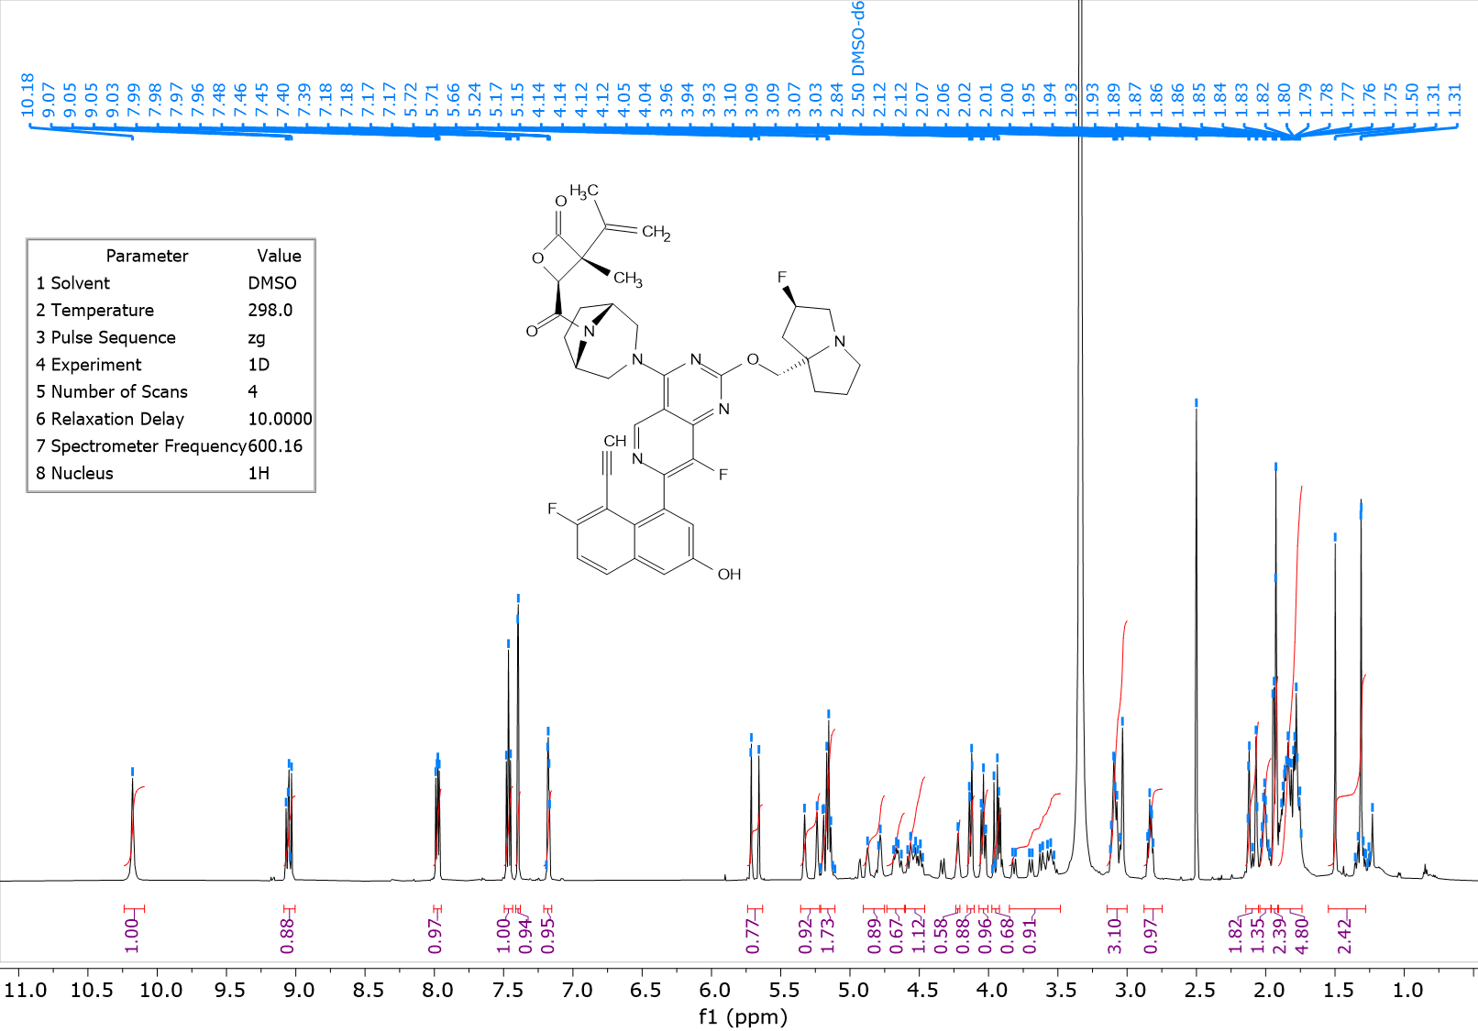

1H NMR (600 MHz, DMSO) δ 10.18 (s, 1 H), 9.00 - 9.09 (m, 1H), 7.98 (dd, J=9.20, 5.90 Hz, 1 H), 7.46 (t, J=9.00, 1 H), 7.40 (d, J=2.5 Hz, 1 H), 7.15 - 7.21 (m, 1 H), 5.63 - 5.74 (m, 1 H), 5.28 (d, 54.3 Hz, 1 H), 5.11 - 5.21 (m, 2H), 4.75 - 4.90 (m, 1H), 4.61 - 4.73 (m, 1 H), 4.46 - 4.60 (m, 1 H), 4.21 - 4.24 (m, 1 H), 4.10 - 4.15 (m, 1 H), 4.00 - 4.07 (m, 1 H), 3.92 - 3.98 (m, 1 H), 3.48 - 3.85 (m, 2 H), 2.99 - 3.15 (m, 3 H), 2.75 - 2.88 (m, 1 H), 2.05 - 2.15 (m, 2 H), 1.96 - 2.04 (m, 2H), 1.91 - 1.96 (m, 3 H), 1.74 - 1.91 (m, 6 H), 1.28 - 1.55 (m, 3H)

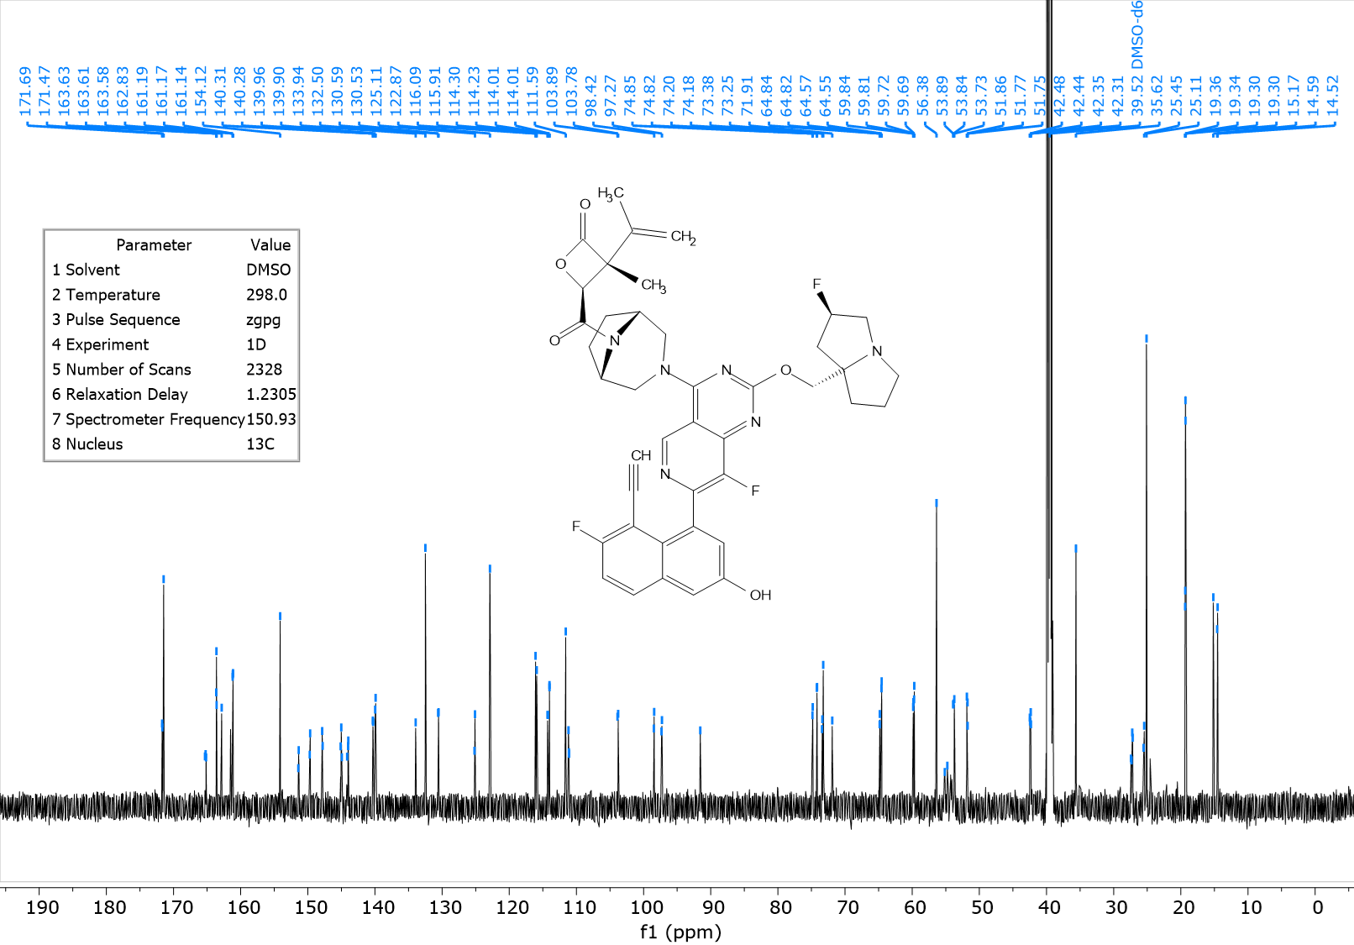

13C NMR (150 MHz, DMSO-d6) δ ppm 171.61 (m, 1 C), 165.23 (m, 1 C), 163.61 (m, 1 C), 162.01 (d, J=247.0 Hz, 1 C),161.59 (m, 1 C), 154.12 (s, 1 C), 150.54 (d, J=257.2 Hz, 1 C), 147.83 (d, J=11.4 Hz, 1 C), 145.02 (m, 1 C), 144.04 (m, 1 C), 140.11 (m, 1C), 133.94 (s, 1 C), 132.50 (s, 1 C), 130.56 (br d, J=9.0 Hz, 1 C), 125.11 (m, 1 C), 122.87 (s, 1 C), 115.99 (d, J=25.8 Hz, 1 C), 114.14 (m, 1 C), 111.59 (s, 1 C), 111.13 (m, 1 C), 103.83 (d, J=16.30 Hz, 1 C), 97.87 (dd, J = 174.1, 8.2 Hz, 1 C), 91.56 (m, 1 C), 74.83 (m, 1 C), 73.80 (s, 1 C), 73.25 (m, 1 C), 71.91 (s, 1 C), 64.69 (m, 1 C), 59.76 (dd, J=19.2, 4.4 Hz, 1 C), 56.38 (s, 1C), 54.96 (m, 1C), 53.82 (m, 2 C), 51.79 (m, 1 C), 42.39 (dd, J = 19.7, 5.5 Hz, 1 C), 35.62 (s, 1 C), 27.29 (m, 1 C), 25.49 (m, 1 C), 25.11 (s, 1 C), 19.33 (m, 1 C), 14.76 (m, 1C)

19F NMR (376 MHz, DMSO) δ -110.17 – -111.52 (m), -138.74 – -140.83 (m), -170.28 – -173.34 (m).

HPLC-1: Rt = 2.071 min; purity: 98.2%;

SFC-4: Rt = 1.785 min, ee: 100%.

## (3S,4R)-3-cyclopropyl-4-((1R,5S)-3-(7-(8-ethynyl-7-fluoro-3-hydroxynaphthalen-1-yl)-8-fluoro-2-(((2R,7aS)-2-fluorotetrahydro-1H-pyrrolizin-7a(5H)-yl)methoxy)pyrido[4,3-d]pyrimidin-4-yl)-3,8-diazabicyclo[3.2.1]octane-8-carbonyl)-3-methyloxetan-2-one (3S, 4R)-**10**







*ethyl 2-cyclopropylpropanoate*[3]



To a solution of ethyl 2-cyclopropylacetate (14.00 g, 109.2 mmol) in THF (140 mL) was added MeI (77.52 g, 34.15 mL, 546.1 mmol) at -78 °C. The reaction mixture was stirred at -78 °C for 0.5 hour. Then LiHMDS (218.5 mL, 218.5 mmol, 1M in THF) was added dropwise to the mixture at -78 °C. The reaction mixture was stirred at -78 °C for 2 hours and warmed up to 25 °C for another 16 hours. The reaction mixture was poured into saturated NH4Cl solution and extracted with EtOAc, the combined organic phase was concentrated under reduced pressure to give a residue. The residue was purified by flash silica gel chromatography (ISCO®; 330 g SepaFlash® Silica Flash Column, Eluent of 0-20% EtOAc/petroleum ether) and the eluent was concentrated to give the title compound as yellow oil (6.0 g, 42.19 mmol, 38% yield).

1H NMR (400 MHz, CDCl3) δ 4.21 – 4.03 (m, 2H), 1.72 – 1.63 (m, 1H), 1.26 (t, *J* = 7.1 Hz, 3H), 1.22 (d, *J* = 7.0 Hz, 3H), 0.99 – 0.87 (m, 1H), 0.55 – 0.42 (m, 2H), 0.33 – 0.22 (m, 1H), 0.17 – 0.02 (m, 1H).

Rf = 0.4 (silica, petroleum ether: EtOAc 10:1).

*diethyl 2-cyclopropyl-3-hydroxy-2-methylsuccinate*



To a solution of ethyl 2-cyclopropylpropanoate (6.0 g, 42.19 mmol) in THF (60 mL) was added LDA (42.19 mL, 84.39 mmol, 2M in mixture of THF and heptane) at -65 °C under N2. The reaction solution was stirred at 25 °C for 2 hours. Then ethyl 2-oxoacetate (25.85 g, 50% in toluene, 126.6 mmol) was added dropwise to the mixture at -65 °C. The reaction solution was stirred at 25 °C for 16 hours. The reaction mixture was quenched with saturated solution of NH4Cl, extracted with EtOAc. The combined organic phase was dried over anhydrous Na2SO4, filtered and concentrated in vacuum. The residue was purified by flash silica gel chromatography (ISCO®; 220 g SepaFlash® Silica Flash Column, Eluent of 0-20% EtOAc/petroleum ether) to give the title compound as yellow oil (3.50 g, 14.33 mmol, 34% yield).

1H NMR (400 MHz, CDCl3) δ 4.61 – 4.41 (m, 1H), 4.29 – 4.09 (m, 4H), 3.38 – 3.08 (m, 1H), 1.34 – 1.19 (m, 7H), 0.94 – 0.82 (m, 3H), 0.54 – 0.17 (m, 4H).

Rf = 0.2 (silica, petroleum ether: EtOAc 10: 1).

*2-cyclopropyl-3-hydroxy-2-methylsuccinic acid*



To a solution of diethyl 2-cyclopropyl-3-hydroxy-2-methylsuccinate (4.2 g, 17.19 mmol) in H2O (42 mL) was added NaOH (2.75 g, 68.77 mmol). The mixture was stirred at 100 °C for 1 hour. The mixture was purified by preparative reversed phase chromatography (220 g of XB - C18, 20 - 45 μm, 100 Å; mobile phase: A for H2O + 0.1% FA and B for acetonitrile; gradient: B 0 - 20% in 20 min, flow rate: 40 mL/min; column temperature: R.T. Wavelength: 220 nm/254 nm) to the title compound as a white solid (3.00 g, 15.94 mmol, 93% yield) directly used for next step.

LCMS-5: Rt = 0.075 min; MS: m/z (M-H)+: 187.1

*(2R*,3R*)-4-(benzyloxy)-2-cyclopropyl-3-hydroxy-2-methyl-4-oxobutanoic acid (diastereomers) & (2R*, 3S*)-4-(benzyloxy)-2-cyclopropyl-3-hydroxy-2-methyl-4-oxobutanoic acid*



A solution of 2-cyclopropyl-3-hydroxy-2-methylsuccinic acid (3 g, 15.94 mmol) in TFAA (10.05 g, 6.76 mL, 47.83 mmol) was stirred at 25 °C for 2 hours. The mixture was concentrated and benzyl alcohol (6.9 g, 6.63 mL, 63.77 mmol) was added to the mixture. The mixture was stirred at 25 °C for 16 hours. LCMS showed 5.5% and 9% of desired MW LCMS: Rt = 0.935 min, 1.002 min; MS m/z [M+Na]+: 301.0; The mixture was purified by preparative reversed phase HPLC (220 g of XB - C18, 20 - 45 μm, 100 Å; mobile phase: A for H2O + 0.1% FA and B for acetonitrile; gradient: B 0 - 60% in 20 min, flow rate: 100 mL/min; column temperature: R.T. Wavelength: 220 nm/254 nm) and then purified by flash silica gel chromatography (ISCO®; 120 g SepaFlash® Silica Flash Column, Eluent of 0-100% EA/PE) and the eluent was concentrated to give racemic (*2R*, 3R*\*)-4-(benzyloxy)-2-cyclopropyl-3-hydroxy-2-methyl-4-oxobutanoic acid as the first eluting peak (colorless oil, 680 mg, 2.44 mmol, 15% yield).

1H NMR (400 MHz, CDCl3) δ 7.43 – 7.30 (m, 5H), 5.21 (s, 2H), 4.57 (s, 1H), 1.32 – 1.23 (m, 1H), 0.90 (s, 3H), 0.51 – 0.31 (m, 3H), 0.29 – 0.15 (m, 1H).

HPLC-2: Rt = 1.267 min; 95% purity

The racemate of (2R*, 3S*)-4-(benzyloxy)-2-cyclopropyl-3-hydroxy-2-methyl-4-oxobutanoic acid was obtained as the second eluting peak (white solid, 660 mg, 2.37 mmol, 14% yield).

1H NMR (400 MHz, CDCl3) δ 7.42 – 7.29 (m, 5H), 5.24 (d, *J* = 12.1 Hz, 1H), 5.20 (d, *J* = 12.1 Hz, 1H), 4.57 (s, 1H), 1.20 – 1.08 (m, 1H), 0.86 (s, 3H), 0.52 – 0.18 (m, 4H).

HPLC-2: Rt = 1.349 min; 91% purity

*(2R*,3S*)-benzyl-3-cyclopropyl-3-methyl-4-oxooxetane-2-carboxylate*



To a solution of racemic (*2R*, 3S*\*)-4-(benzyloxy)-2-cyclopropyl-3-hydroxy-2-methyl-4-oxobutanoic acid (second eluting peak, 655 mg, 2.35 mmol) in DCM (65 mL) was added TEA (714 mg, 984 μL, 7.06 mmol) and PyBOP (1.84 g, 3.53 mmol). The reaction mixture was stirred at 25 °C for 2 hours. The mixture was quenched with H2O, extracted with DCM. The combined organic phases were dried over anhydrous Na2SO4, filtered and concentrated in vacuum. The residue was purified by flash silica gel chromatography (ISCO®; 40 g SepaFlash® Silica Flash Column, Eluent of 0-50% EtOAc/ petroleum ether) to give the title compound as yellow oil (490 mg, 1.88 mmol, 79% yield).

The relative stereochemistry by 2D NMR(NOESY).

1H NMR (400 MHz, CDCl3) δ 7.47 – 7.30 (m, 5H), 5.27 (s, 2H), 4.69 (s, 1H), 1.26 (s, 3H), 1.21 – 1.11 (m, 1H), 0.70 – 0.58 (m, 3H), 0.49 – 0.36 (m, 1H).

HPLC-2: Rt = 1.604 min; 96.7% purity

Rf = 0.5 (silica, petroleum ether: EtOAc 5:1)

(*2R,RS*)-benzyl-3-cyclopropyl-3-methyl-4-oxooxetane-2-carboxylate



To a solution of racemic (*2R*, 3R*\*)-4-(benzyloxy)-2-cyclopropyl-3-hydroxy-2-methyl-4-oxobutanoic acid (first eluting peak, 675 mg, 2.43mmol) in DCM (67 mL) was added TEA (736 mg, 1001 μL, 7.3 mmol) and PyBOP (1.89 g, 3.63 mmol). The reaction mixture was stirred at 25 °C for 2 hours. The mixture was quenched with H2O, extracted with DCM. The combined organic phase dried over anhydrous Na2SO4, filtered and concentrated in vacuum. The residue was purified by flash silica gel chromatography (ISCO®; 40 g SepaFlash® Silica Flash Column, Eluent of 0-50% EtOAc/ petroleum ether) to give the title compound as yellow oil (490 mg, 1.88 mmol, 77% yield).

1H NMR (400 MHz, CHLOROFORM-*d*) δ 7.45 - 7.33 (m, 5H), 5.33 - 5.24 (m, 2H), 4.71 (s, 1H), 1.58 (s, 3H), 0.92 - 0.80 (m, 1H), 0.60 - 0.48 (m, 1H), 0.47 - 0.33 (m, 2H), 0.28 - 0.12 (m, 1H)

1H NMR (400 MHz, CDCl3) δ 7.50 – 7.32 (m, 5H), 5.27 (s, 2H), 4.71 (s, 1H), 1.57 (s, 3H), 0.93 – 0.77 (m, 1H), 0.57 – 0.47 (m, 1H), 0.46 – 0.31 (m, 2H), 0.28 – 0.11 (m, 1H).

the structure was confirmed by 2DNMR (NOESY).

HPLC-2: Rt = 1.556 min; 98.4% purity

Rf = 0.5 (silica, petroleum ether: EtOAc 5:1)

(*2R,3S)-3-cyclopropyl-3-methyl-4-oxooxetane-2-carboxylate*



The racemate of benzyl (2R*,3S*)-3-cyclopropyl-3-methyl-4-oxooxetane-2-carboxylate (490 mg, 1.88 mmol) was separated by preparative chiral SFC (column: DAICEL CHIRALPAK IG 10 µm; 250 x 50 mm; flow rate: 150 g/min; column temperature: 35°C; back pressure: 80 bars; mobile phase: 17 % IPA in Supercritical CO2) to give title compound as second eluting peak (colorless oil, 200 mg, 0.77 mmol, 42% yield).

1H NMR (400 MHz, CDCl3) δ 7.48 – 7.32 (m, 5H), 5.27 (s, 2H), 4.69 (s, 1H), 1.26 (s, 3H), 1.21 – 1.11 (m, 1H), 0.75 – 0.57 (m, 3H), 0.53 – 0.35 (m, 1H).

Rt = 1.101 min; ee: 100%;

[α]25D = -40.787° (C=0.1270 g/100 mL, acetone)

The other isomer was obtained as first eluting peak (colorless oil, 200 mg, 0.77 mmol, 42% yield).

1H NMR (400 MHz, CDCl3) δ 7.44 – 7.31 (m, 5H), 5.27 (s, 2H), 4.69 (s, 1H), 1.26 (s, 3H), 1.22 – 1.11 (m, 1H), 0.76 – 0.57 (m, 3H), 0.50 – 0.33 (m, 1H).

Rt = 0.894 min, ee: 99 %;

[α] 25D = +18.027° (C=0.1054 g/100 mL, acetone)

*(2R,3S)-3-cyclopropyl-3-methyl-4-oxooxetane-2-carboxylic acid*



To a solution of benzyl (2R,3S)-3-cyclopropyl-3-methyl-4-oxooxetane-2-carboxylate (200 mg, 768 μmol) in EA (5 mL) was added Pd/C (20 mg, 10% Wt) at 25 °C under N2. The suspension was degassed under vacuum and purged with H2 for three times and stirred at 25 °C for 1 hour under H2 (15 psi). The mixture was filtered and concentrated to give the title compound as colorless oil (120 mg, 0.71 mmol, 92% yield).

1H NMR (400 MHz, CDCl3) δ 4.73 (s, 1H), 1.45 (s, 3H), 1.26 – 1.17 (m, 1H), 0.80 – 0.62 (m, 3H), 0.54 – 0.36 (m, 1H).

Rf = 0 (silica, petroleum ether: EtOAc 5: 1, the educt was Rf=0.5 was consumed).

[α]25D = -30.534° (C=0.0524 g/100 mL, acetone)

*(3S,4R)-3-cyclopropyl-4-((1R,5S)-3-(7-(8-ethynyl-7-fluoro-3-hydroxynaphthalen-1-yl)-8-fluoro-2-(((2R,7aS)-2-fluorotetrahydro-1H-pyrrolizin-7a(5H)-yl)methoxy)pyrido[4,3-d]pyrimidin-4-yl)-3,8-diazabicyclo[3.2.1]octane-8-carbonyl)-3-methyloxetan-2-one (3S,4R)-****10***



To a solution of (*2R,3S*)-3-cyclopropyl-3-methyl-4-oxooxetane-2-carboxylic acid (30 mg, 176 μmol) in DMF (1 mL) was added COMU (83 mg, 194 μmol) and 2,6-lutidine (113 mg, 123 μL, 1.06 mmol) at -5 °C. The mixture was stirred at -5 °C for 15 min. A solution of 4-(4-((1R,5S)-3,8-diazabicyclo[3.2.1]octan-3-yl)-8-fluoro-2-(((2R,7aS)-2-fluorotetrahydro-1H-pyrrolizin-7a(5H)-yl)methoxy)pyrido[4,3-d]pyrimidin-7-yl)-5-ethynyl-6-fluoronaphthalen-2-ol (MRTX1133, 106 mg, 176 μmol) in DMF (1 mL) was added to the mixture at -5 °C and stirred at -5 °C for 15 min. The reaction mixture was diluted with a saturated solution of NaHCO3, extracted with EtOAc. The combined organic phase was washed with brine and 10% aqueous solution of LiCl, dried over Na2SO4, filtered and concentrated to give a residue. The residue was purified by reversed phase flash silica gel chromatography (48 g of SepaFlash® Spherical C18, 100 Å; mobile phase: A for H2O + 0.1% FA and B for acetonitrile; gradient: B 0 - 100% in 20 min, flow rate: 60 mL/min; column temperature: R.T. Wavelength: 220 nm/254 nm). The eluent was collected and concentrated, neutralized with NaHCO3, extracted with DCM. The combined organic phase was dried over Na2SO4, filtered and concentrated to give the title compound as a yellow solid (42 mg, 53.19 μmol, 30% yield).



1H NMR (600 MHz, DMSO) δ 10.18 (s, 1 H), 9.01 - 9.17 (m, 1H), 7.98 (dd, J=9.20, 5.90 Hz, 1 H), 7.46 (t, J=9.03, 1 H), 7.40 (d, J=2.5 Hz, 1 H), 7.16 - 7.20 (m, 1 H), 5.41 - 5.55 (m, 1 H), 5.28 (d, 53.9 Hz, 1 H), 4.76 - 4.88 (m, 1 H), 4.42 - 4.73 (m, 2 H), 4.31 - 4.41 (m, 1 H), 4.10 - 4.16 (m, 1 H), 4.01 - 4.07 (m, 1 H), 3.92 - 3.98 (m, 1 H), 3.46 - 3.88 (m, 2 H), 3.00 - 3.13 (m, 3 H), 2.80 - 2.87 (m, 1 H), 2.06 - 2.17 (m, 2 H), 1.98 - 2.04 (m, 2 H), 1.71 - 1.95 (m, 6 H), 1.39 - 1.51 (m, 1H), 1.09 - 1.39 (m, 3 H), 0.49 - 0.72 (m, 3H), 0.34 - 0.43 (m, 1H)



13C NMR (150 MHz, DMSO-d6) δ ppm 171.93 (m, 1 C), 165.20 (m, 1 C), 163.60 (m, 1 C), 161.99 (d, J=247.1 Hz, 1 C), 161.37 (m, 1 C), 154.11 (m, 1 C), 150.22 (m, 1 C), 147.86 (br d, J=11.6 Hz, 1 C), 145.00 (br d, J=13.40 Hz, 1 C), 144.09 (m, 1 C), 133.93 (s, 1 C), 132.48 (s, 1 C), 130.53 (br d, J=9.5 Hz, 1 C), 125.11 (d, J=10.8 Hz, 1 C), 122.86 (s, 1 C), 115.98 (br d, J=25.8 Hz, 1 C), 111.57 (s, 1 C), 111.13 (m, 1 C), 103.82 (br d, J=16.50 Hz, 1 C), 97.87 (br d, J=174.1 Hz, 1 C), 91.54 (m, 1 C), 76.1 (m, 1 C), 74.81 (m, 1 C), 73.24 (s, 1 C), 71.85 (s, 1 C), 60.91 (m, 1 C), 59.74 (m, 1 C), 56.35 (s, 1C), 55.10 (m, 1C), 53.70 (m, 2C), 51.67 (m, 1 C), 42.39 (m, 1 C), 35.60 (s, 1 C), 27.31 (m, 1 C), 25.58 (m, 1 C), 25.10 (s, 1 C), 15.29 (m, 1 C), 14.37 (m, 1C), 2.19 (m, 1C), 1.44 (m, 1C)

19F NMR (376 MHz, DMSO) δ -110.12 – -111.20 (m), -139.35 – -140.58 (m), -171.21 – -173.02 (m).

Rt = 0.503 min; MS m/z [M+H]+: 753.4

Rt = 1.345 min; purity: 97%;

Rt = 2.017 min;100 % ee

## (3S,4R)-3-cyclobutyl-4-((1R,5S)-3-(7-(8-ethynyl-7-fluoro-3-hydroxynaphthalen-1-yl)-8-fluoro-2-(((2R,7aS)-2-fluorotetrahydro-1H-pyrrolizin-7a(5H)-yl)methoxy)pyrido[4,3-d]pyrimidin-4-yl)-3,8-diazabicyclo[3.2.1]octane-8-carbonyl)-3-methyloxetan-2-one (3S,4R)-**11**





Ethyl 2-cyclobutylidenepropanoate



To a solution of ethyl 2-(diethoxyphosphoryl)propanoate (CAS[3699-66-9], 18.35 g, 77.04 mmol) in THF (180.0 mL) was added NaH (5.14 g, 60% Wt, 128.4 mmol) in portions at 0°C, the mixture was stirred for 30 min at 0 °C. Then cyclobutanone (CAS[1191-95-3], 4.5 g, 64.20 mmol) was added dropwise, the reaction mixture was stirred for 1 hour at 25 °C. The reaction mixture was quenched with saturated solution of NH4Cl. The resulting solution was extracted with EA. The organic layer was dried over Na2SO4 and concentrated under vacuum to give a residue. The residue was purified by flash silica gel chromatography (ISCO®; 220 g SepaFlash® Silica Flash Column, Eluent of 0-10% EA/PE) and the eluent was concentrated to give the title compound as colorless oil (8.0 g, 81% yield). Rf = 0.7 (silica, petroleum ether: EtOAc 5: 1)

1H NMR (400 MHz, CDCl3) δ 4.15 (q, *J* = 7.1 Hz, 2H), 3.19 – 2.97 (m, 2H), 2.86 – 2.64 (m, 2H), 2.01 (p, *J* = 8.0 Hz, 2H), 1.77 – 1.64 (m, 3H), 1.27 (t, *J* = 7.1 Hz, 3H).

Ethyl 2-cyclobutylpropanoate



To a suspension of Pd/C (800 mg, 10% Wt) in THF (80 mL) under N2 was added ethyl 2-cyclobutylidene propanoate (8.0 g, 51.88 mmol) in THF (80.00 mL) at 25°C. The suspension was degassed under vacuum and purged with H2 for three times and stirred at 25 °C for 12 hours under H2 (15 psi) atmosphere. The mixture was filtered over Celite pad, the filter cake was washed with THF, and the combined filter liquor was concentrated to give the title compound as colorless oil (8.0 g, 99% yield). Rf = 0.7 (silica, petroleum ether: EtOAc 5: 1, revealed by KMnO4).

1H NMR (400 MHz, CDCl3) δ 4.22 – 3.98 (m, 2H), 2.51 – 2.29 (m, 2H), 2.11 – 1.94 (m, 2H), 1.89 – 1.69 (m, 4H), 1.23 (t, *J* = 7.1 Hz, 3H), 1.04 (d, *J* = 6.4 Hz, 3H).

Diethyl 2-cyclobutyl-3-hydroxy-2-methylsuccinate



To a solution of ethyl 2-cyclobutylpropanoate (8.0 g, 51.21 mmol) in THF (80 mL) was added dropwise LDA (51.21 mL, 102.4 mmol, 2M in mixture of THF and heptane) at -65 °C under N2. The solution was stirred at 25 °C for 1 hour. Then a solution of ethyl 2-oxoacetate (CAS [924-44-7], 31.37 g, 50% in toluene, 153.6 mmol) in THF (20 mL) was added dropwise to above solution at -65 °C slowly. The mixture was warmed to 25°C slowly and stirred for 12 hours under N2. The reaction mixture was quenched with saturated solution of NH4Cl, extracted with EtOAc. The combined organic phase was dried over anhydrous Na2SO4, filtered and concentrated in vacuum. The residue was purified by flash column chromatography (ISCO®; 220 g SepaFlash® Silica Flash Column, Eluent of 0-50% EtOAc / petroleum ether) and the eluent was concentrated under reduce pressure to give the title compound as yellow oil (8.0 g, 60% yield). No LC-MS. Rf = 0.5 (silica, petroleum ether: EtOAc 5: 1)

1H NMR (400 MHz, CDCl3) δ 4.31 – 4.02 (m, 5H), 3.40 (d, *J* = 8.5 Hz, 1H), 2.88 – 2.68 (m, 1H), 2.17 – 1.97 (m, 1H), 1.97 – 1.73 (m, 4H), 1.73 – 1.62 (m, 1H), 1.33 – 1.24 (m, 6H), 1.17 – 0.89 (m, 3H).

2-cyclobutyl-3-hydroxy-2-methylsuccinic acid



The solution of diethyl 2-cyclobutyl-3-hydroxy-2-methylsuccinate (6.0 g, 0.02 mol) in concentrated HCl (60 mL) was stirred at 100 °C for 16 hours. The reaction mixture was concentrated in vacuum to get a residue. The residue was dissolved in EA and then dried over anhydrous Na2SO4, filtered and concentrated to get the title compound as a brown solid (5.0 g, 100% yield). LCMS-6: Rt = 0.078 min; MS: m/z (M-H)+: 201.0;

1H NMR (400 MHz, DMSO) δ 12.19 (s, 1H), 5.23 (s, 1H), 4.30 – 4.12 (m, 1H), 2.71 – 2.52 (m, 1H), 2.10 – 1.87 (m, 3H), 1.90 – 1.64 (m, 4H), 1.63 – 1.47 (m, 1H), 1.01 – 0.89 (m, 3H).

4-(benzyloxy)-2-cyclobutyl-3-hydroxy-2-methyl-4-oxobutanoic acid



2-cyclobutyl-3-hydroxy-2-methylsuccinic acid (5.0 g, 24.73 mmol) was placed in a round-bottomed flask and cooled in an ice bath. Then TFAA (15.58 g, 10.48 mL, 74.18 mmol) was added dropwise at 0 °C under nitrogen atmosphere. The mixture was stirred at 0 °C for 0.5 hour and at 25 °C for 2.5 hours. The mixture was evaporated under vacuum at 25 °C to remove TFA and excess TFAA. Then benzyl alcohol (10.70 g, 10.25 mL, 98.91 mmol) was added to the mixture under N2. The reaction mixture was stirred at 25 °C for 12 hours. The mixture was purified by reverse-phase preparative HPLC (300 g) of SepaFlash® Spherical C18, 20 - 45 μm, 100 Å; mobile phase: A for H2O + 0.1% FA and B for acetonitrile; gradient: B 30- 50% in 30 min, flow rate: 100 mL/min; column temperature: RT, wavelength: 220 nm/254 nm) to give the diastereomers as first eluting peak (yellow solid, 1.5 g, 16% yield). LCMS-1: Rt = 0. 465 min; MS m/z [M+Na]+: 315.1; purity: 86%. 1H NMR (400 MHz, CDCl3) δ 7.41 – 7.29 (m, 5H), 5.25 – 5.14 (m, 2H), 4.52 (s, 1H), 3.03 (s, 1H), 2.88 – 2.67 (m, 1H), 2.18 – 1.98 (m, 2H), 1.97 – 1.71 (m, 4H), 1.71 – 1.59 (m, 1H), 1.19 – 0.96 (m, 3H). The other diastereomers as the second eluting peak (yellow solid, 1.4 g, 20% yield). LCMS-1: Rt = 0.482 min; MS m/z [M+Na]+: 315.0; purity: 97%; 1H NMR (400 MHz, CDCl3) δ 7.47 – 7.32 (m, 5H), 5.29 – 5.17 (m, 2H), 4.31 (s, 1H), 3.38 (s, 1H), 2.90 – 2.68 (m, 1H), 2.12 – 1.98 (m, 2H), 1.94 – 1.74 (m, 4H), 1.74 – 1.63 (m, 1H), 1.16 (s, 3H).

Benzyl (2R,3S)-3-cyclobutyl-3-methyl-4-oxooxetane-2-carboxylate



To a solution of 4-(benzyloxy)-2-cyclobutyl-3-hydroxy-2-methyl-4-oxobutanoic acid (second eluting peak, 1.4 g, 4.8 mmol) in DCM (70 mL) was added TEA (1.5 g, 2.0 mL, 14 mmol) and PyBOP (3.7 g, 7.2 mmol) at 0 °C. After 5 minutes at 0 °C, the mixture was warmed up to 25°C and stirred for another 1 hour. The reaction mixture was concentrated to give a residue. The residue was purified by flash silica gel chromatography (ISCO®; 40 g SepaFlash® Silica Flash Column, Eluent of 10-30% EA/PE) and the eluent was concentrated to give the trans-diastereomers as yellow oil (350 mg, 1.28 mmol, 27 % yield). Rf = 0.8 (silica, petroleum ether: EtOAc 1: 1). Rt (SFC-10) = 0.962 min, 1.207 min; The structure was confirmed by 2D NMR(NOESY).

1H NMR (400 MHz, CDCl3) δ 7.44 – 7.32 (m, 5H), 5.27 (s, 2H), 4.71 (s, 1H), 2.64 (p, *J* = 8.4 Hz, 1H), 2.22 – 1.75 (m, 6H), 1.09 (s, 3H).



The enantiomer pair were separated by chiral SFC (column: Daicel Chiralpak IG 10 µm; 250 x 50 mm; flow rate: 80 mL/min; column temperature: 40°C; back pressure: 100 bars; mobile phase: CO2/isopropanol 75/25), after purification, then the eluent was concentrated to give the title compound as the second eluting peak (yellow oil, 150 mg, 43% yield). Rt (SFC-10): 1.202 min, ee: 100%; [α]25D = -19.136° (C = 0.2038 g/100 mL, acetone); 1H NMR (400 MHz, CDCl3) δ 7.47 – 7.31 (m, 5H), 5.27 (s, 2H), 4.71 (s, 1H), 2.74 – 2.57 (m, 1H), 2.22 – 1.75 (m, 7H), 1.09 (s, 3H).The first eluting peak was the non-desired enantiomer, **XX** (yellow oil, 150.0 mg, 43% yield). Rt (SFC-10): 0.961 min, ee: 100%; [α]25D = +18.191° (C = 0.2034 g/100 mL, acetone); 1H NMR (400 MHz, CDCl3) δ 7.48 – 7.31 (m, 5H), 5.26 (s, 2H), 4.71 (s, 1H), 2.81 – 2.52 (m, 1H), 2.19 – 1.76 (m, 8H), 1.09 (s, 3H).

(2R,3S)-3-cyclobutyl-3-methyl-4-oxooxetane-2-carboxylic acid



To a suspension of Pd/C (30 mg, 10% wt) in THF (3 mL) was added benzyl (2R,3S)-3-cyclobutyl-3-methyl-4-oxooxetane-2-carboxylate (150 mg, 547 μmol) in THF (1 mL) under N2 at 25 °C. The suspension was degassed under vacuum and purged with H2 three times and then stirred at 25 °C for 1 hour under H2 (15 psi) atmosphere. The mixture filtered over Celite pad, the filter cake was washed with THF, and the combined filter liquor was concentrated to give the title compound as colorless oil (90 mg, 89% yield).

1H NMR (400 MHz, CDCl3) δ 4.74 (s, 1H), 2.69 (p, *J* = 8.3 Hz, 1H), 2.23 – 1.88 (m, 6H), 1.28 (s, 4H).

(3S,4R)-3-cyclobutyl-4-((1R,5S)-3-(7-(8-ethynyl-7-fluoro-3-hydroxynaphthalen-1-yl)-8-fluoro-2-(((2R,7aS)-2-fluorotetrahydro-1H-pyrrolizin-7a(5H)-yl)methoxy)pyrido[4,3-d]pyrimidin-4-yl)-3,8-diazabicyclo[3.2.1]octane-8-carbonyl)-3-methyloxetan-2-one



To the mixture of (2R,3S)-3-cyclobutyl-3-methyl-4-oxooxetane-2-carboxylic acid (30 mg, 163 μmol) in DMF (0.5 mL) was added 2,6-Lutidine (105 mg, 114 μL, 977 μmol) and COMU (70 mg, 163 μmol) at -5°C, the mixture was stirred at -5°C for 15 min, then 4-(4-((1R,5S)-3,8-diazabicyclo[3.2.1]octan-3-yl)-8-fluoro-2-(((2R,7aS)-2-fluorotetrahydro-1H-pyrrolizin-7a(5H)-yl)methoxy)pyrido[4,3-d]pyrimidin -7-yl)-5-ethynyl-6-fluoronaphthalen-2-ol (98 mg, 163 μmol) in DMF (0.5 mL) was added. The reaction mixture was stirred at -5°C for 15 min. The reaction mixture was quenched with a saturated solution of NaHCO3 and extracted with EA. The organic layer was washed with brine, 10% aqueous solution of LiCl, dried over anhydrous Na2SO4, filtered and concentrated to afford crude product. The crude residue was purified by reversed phase preparative HPLC (48 g) of SepaFlash® Spherical C18, 20 - 45 μm, 100 Å; mobile phase: A for H2O + 0.1% FA and B for acetonitrile; gradient: B 30- 50% in 30 min, flow rate: 40 mL/min; column temperature: RT, wavelength: 220 nm/254 nm). The desired eluting solution was neutralized with a saturated solution of NaHCO3, extracted with EA. The organic phase was dried by anhydrous Na2SO4, filtered and concentrated to give (3S,4R)-3-cyclobutyl-4-((1R,5S)-3-(7-(8-ethynyl-7-fluoro-3-hydroxynaphthalen-1-yl)-8-fluoro-2-(((2R,7aS)-2-fluorotetrahydro-1H-pyrrolizin-7a(5H)-yl)methoxy) pyrido[4,3-d]pyrimidin-4-yl)-3,8-diazabicyclo[3.2.1]octane-8-carbonyl)-3-methyloxetan-2-one as a yellow solid (50.31 mg, 65 μmol, 40% yield). LCMS-1: Rt = 0.494 min; MS m/z [M+H]+: 767.4; HPLC-1: Rt = 2.194 min; purity: 96%. Rt (SFC-11) = 0.683 min, ee: 100%;



1H NMR (600 MHz, DMSO) δ 10.17 (s, 1 H),9.00 - 9.15 (m, 1H), 7.98 (dd, J=9.20, 5.90 Hz, 1 H), 7.47 (t, J=9.00 , 1 H), 7.40 (d, J=2.5 Hz, 1 H), 7.15 - 7.22 (m, 1 H), 5.28 (d, J=52.7 Hz, 1 H), 4.75 - 4.88 (m, 1H), 4.64 - 4.74 (m, 1 H), 4.44 - 4.64 (m, 1 H), 4.25 - 4.38 (m, 1H), 4.10 - 4.15 (m, 1H), 4.01 - 4.07 (m, 1 H), 3.90 - 3.98 (m, 1 H), 3.66 - 3.86 (m, 1 H), 3.44 - 3.66 (m, 1H), 2.99 - 3.13 (m, 3 H), 2.74 - 2.87 (m, 2 H), 2.20 - 2.26 (m, 1 H), 2.07 - 2.14 (m, 2 H), 1.95 - 2.06 (m, 3 H), 1.83 - 1.94 (m, 4H), 1.72 - 1.82 (m, 6H), 10.99 - 1.26 (m, 3 H)



13C NMR (150 MHz, DMSO-d6) δ ppm 172.78 (m, 1 C), 165.17 (m, 1 C), 163.61 (m, 1 C), 162.00 (d, J=247.0 Hz, 1 C), 161.68 (m, 1 C), 154.11 (m, 1 C), 150.51 (d, J=259.2 Hz, 1 C), 147.90 (m, 1 C), 145.00 (m, 1 C), 144.10 (m, 1 C), 133.91 (m, 1 C), 132.48 (s, 1 C), 130.54 (m, 1 C), 125.11 (m, 1 C), 122.85 (s, 1 C), 115.99 (d, J=25.6 Hz, 1 C), 111.57 (s, 1 C), 111.13 (m, 1 C), 103.81 (d, J=16.2, 1 C), 97.79 (d, J = 173.8, 1 C), 91.47 (m, 1 C), 74.82 (m, 1 C), 73.33 (m, 1 C), 72.35 (m, 1 C), 71.85 (m, 1 C), 63.00 (m, 1 C), 59.76 (d, J=18.7 Hz, 1 C), 56.35 (s, 1C), 54.74 (m, 1C), 53.67 (m, 2 C), 51.73 (m, 1 C), 42.41 (m, 1 C), 38.32 (m, 1 C), 35.61 (s, 1 C), 27.95 (m, 1 C), 25.64 (m, 1 C), 25.10 (s, 1 C), 24.16 (m, 1C), 23.19 (m, 1C), 16.58 (m, 1 C), 13.10 (m, 1C)

## (3S,4R)-3-cyclopentyl-4-((1R,5S)-3-(7-(8-ethynyl-7-fluoro-3-hydroxynaphthalen-1-yl)-8-fluoro-2-(((2R,7aS)-2-fluorotetrahydro-1H-pyrrolizin-7a(5H)-yl)methoxy)pyrido[4,3-d]pyrimidin-4-yl)-3,8-diazabicyclo[3.2.1]octane-8-carbonyl)-3-methyloxetan-2-one (3S,4R)-**12**





*ethyl 2-cyclopentylidenepropanoate[4]*



To a solution of ethyl 2-(diethoxyphosphoryl)*propanoate* (CAS[3699-66-9], 33.98 g, 142.7 mmol) in THF (340.0 mL) was added NaH (9.51 g, 60% Wt, 237.8 mmol) in portions at 0°C under N2, the mixture was stirred at 0 °C for 30 min. Then cyclopentanone (CAS[120-92-3], 10.00 g, 118.9 mmol) was added dropwise and the mixture was stirred at 25 °C for 1 hour. The reaction mixture was quenched with a saturated solution of NH4Cl and then extracted with EtOAc. The organic layers were dried over Na2SO4 and concentrated under vacuum to give a crude residue. The crude product was purified by flash silica gel chromatography (ISCO®; 220 g SepaFlash® Silica Flash Column, eluent of 0-10% EtOAc / petroleum ether) and the product containing fractions were concentrated to give the title compound as colorless oil (9.0 g, 53.5 mmol, 45 % yield).

Rf = 0.7 (silica, petroleum ether: EtOAc 5: 1)

1H NMR (400 MHz, CDCl3) δ 4.17 (q, *J* = 7.1 Hz, 2H), 2.82 – 2.60 (m, 2H), 2.42 – 2.31 (m, 2H), 1.87 – 1.83 (m, 3H), 1.76 – 1.61 (m, 4H), 1.29 (t, *J* = 7.1 Hz, 3H).

ethyl 2-cyclopentylpropanoate[5]



diethyl 2-cyclopentyl-3-hydroxy-2-methylsuccinate



To a solution of ethyl 2-cyclopentylidenepropanoate(5.5 g, 32.3 mmol) in THF (35 mL) was added LDA (CAS [4111-54-0], 32.3 mL, 64.6 mmol, 2M in mixture of THF and heptane) at -65 °C under N2. The solution was stirred at 25 °C for 1 hour. Then a solution of ethyl 2-oxoacetate (CAS [924-44-7]19.8 g, 96.9 mmol, 50% in toluene) in THF (20 mL) was added dropwise to the above solution at -65 °C. After completion of the addition the mixture was allowed to warm to 25 °C and stirred for 12 hours under N2, quenched with saturated solution of NH4Cl and extracted with EtOAc. The combined organic phase was dried over anhydrous Na2SO4, filtered and concentrated in vacuum. The residue was purified by flash chromatography (ISCO®; 120 g SepaFlash® Silica Flash Column, Eluent of 0-50% EtOAc / petroleum ether) and the product containing fractions were concentrated under reduced pressure to give the title compound as yellow oil (4.50 g, 16.5 mmol, 51% yield).

Rf = 0.6 (silica, petroleum ether: EtOAc 3: 1)

1H NMR (400 MHz, CDCl3) δ 4.57 (d, *J* = 5.3 Hz, 1H), 4.30 – 4.06 (m, 4H), 3.04 (d, *J* = 5.3 Hz, 1H), 2.30 – 2.15 (m, 1H), 1.87 – 1.35 (m, 6H), 1.35 – 1.23 (m, 8H), 1.06 (s, 3H). (1:1 mixture of diastereomers)

*2-cyclopentyl-3-hydroxy-2-methylsuccinic acid*



The solution of (diethyl 2-cyclopentyl-3-hydroxy-2-methylsuccinate (4.5 g, 16.5 mmol) in concentrated HCl (45 mL) was stirred at 100 °C for 48 hours. The reaction mixture was concentrated in vacuum. The residue was diluted with EtOAc and dried over anhydrous Na2SO4, filtered and concentrated to get the crude title compound as a brown solid (3.0 g, 13.8 mmol, 84 % yield).

LCMS-6: Rt = 0.250 min; MS m/z [M-H]+: 215.2

1H NMR (400 MHz, DMSO) δ 12.28 (s, 2H), 5.28 (s, 1H), 4.27 (s, 1H), 2.16 – 1.94 (m, 1H), 1.85 – 1.33 (m, 7H), 1.23 – 1.07 (m, 1H), 1.00 (s, 3H).

*4-(benzyloxy)-2-cyclopentyl-3-hydroxy-2-methyl-4-oxobutanoic acid (diastereomers):*



2-cyclopentyl-3-hydroxy-2-methylsuccinic acid (3.0 g, 13.9 mmol) was placed in a round-bottomed flask and cooled in an ice bath. Then TFAA (8.74 g, 5.82 mL, 41.62 mmol) was added dropwise at 0 °C under nitrogen atmosphere. The mixture was stirred 0.5 hours at 0 °C and then at 25 °C for 3 hours. Excess TFAA and trifluoroacetic acid (TFA) were evaporated under vacuum at 25 °C. Benzyl alcohol (6.0 g, 5.75 mL, 55.50 mmol) was added to the intermediate anhydride. The reaction mixture was allowed to stir at 25 °C for 12 hours. The reaction was concentrated by evaporation of all volatiles under reduced pressure. The crude product was purified by reversed phase preparative HPLC (300 g of SepaFlash® Spherical C18, 20 - 45 μm, 100 Å; mobile phase: A for H2O + 0.1% FA and B for acetonitrile; gradient: B 30- 50% in 30 min, flow rate: 100 mL/min; column temperature: RT, wavelength: 220 nm/254 nm). After concentration of product containing fractions two diastereomeric products were isolated: First eluting peak: (1.30 g, 2.8 mmol, 19.9 %, yellow solid).

LCMS-1: Rt = 0.505 min; MS m/z [M+Na]+: 329.1; purity: 65 %;

1H NMR (400 MHz, CDCl3) δ 7.40 – 7.28 (m, 5H), 5.22 (d, *J* = 12.1 Hz, 1H), 5.17 (d, *J* = 12.1 Hz, 1H), 4.60 (s, 1H), 3.09 (s, 1H), 2.30 – 2.17 (m, 1H), 1.86 – 1.37 (m, 7H), 1.24 – 1.13 (m, 1H), 1.05 (s, 3H).

Second eluting peak (600 mg, 1.9 mmol, 14.1 % yield, yellow solid).

LCMS-1: Rt = 0.520 min; MS m/z [M+Na]+: 329.1; purity: 95 %;

1H NMR (400 MHz, CDCl3) δ 7.45 – 7.28 (m, 5H), 5.29 – 5.10 (m, 2H), 4.29 (s, 1H), 3.67 (s, 1H), 2.51 – 2.30 (m, 1H), 1.86 – 1.35 (m, 7H), 1.24 – 1.16 (m, 1H), 1.08 (s, 3H).

benzyl (*trans*-2R*,3S*)-3-cyclopentyl-3-methyl-4-oxooxetane-2-carboxylat



To the solution of 4-(benzyloxy)-2-cyclopentyl-3-hydroxy-2-methyl-4-oxobutanoic acid (800 mg, 2.61 mmol, 95% purity) in DCM (40 mL) was added TEA (793 mg, 1.09 mL, 7.83 mmol) and PyBOP (CAS[128625-52-5], 2.04 g, 3.92 mmol) at 0 °C, stirred for 5 mins at 0 °C, and then allowed to warm to 25°C and stirred for another 1 hour. The reaction mixture was concentrated and the crude product was purified by flash silica gel chromatography (ISCO®; 40 g SepaFlash® Silica Flash Column, eluent: 10-30% EtOAc /PE). The eluent was concentrated to give the title compound as colorless oil (440 mg, 1.5 mmol, 58.4 % yield).

Rf = 0.8 (silica, petroleum ether: EtOAc 1: 1)

LCMS-1: Rt = 0.582 min; MS m/z [M+H]+: N/A [no M+]

SFC-5 Rt = 1.241 min, 1.581 min;

1H NMR (400 MHz, CDCl3) δ 7.47 – 7.31 (m, 5H), 5.27 (s, 2H), 4.71 (s, 1H), 2.28 – 2.12 (m, 1H), 1.98 – 1.75 (m, 2H), 1.74 – 1.56 (m, 4H), 1.49 – 1.37 (m, 1H), 1.36 – 1.23 (m, 1H), 1.20 (s, 3H).

2D NMR (NOESY)

*benzyl (cis-2R*,3R*)-3-cyclopentyl-3-methyl-4-oxooxetane-2-carboxylate*



The first eluting product **Xa** (100 mg, 0.4 mmol) from the previous step was treated as described for **Xb** to give the second isomer of the title compound (50 mg, 0.32 mmol, 53 % yield, white solid.

Rt = 0.579 min; MS m/z [M+H]+: N/A [no M+]

SFC-5 Rt = 1.043 min, 1.055 min;

1H NMR (400 MHz, CDCl3) δ 7.46 – 7.30 (m, 5H), 5.29 (d, *J* = 12.0 Hz, 1H), 5.21 (d, *J* = 11.9 Hz, 1H), 4.62 (s, 1H), 2.21 (p, *J* = 8.2 Hz, 1H), 1.75 – 1.13 (m, 11H).

1H NMR (400 MHz, CDCl3) δ 7.47 – 7.31 (m, 5H), 5.27 (s, 2H), 4.71 (s, 1H), 2.28 – 2.12 (m, 1H), 1.98 – 1.75 (m, 2H), 1.74 – 1.56 (m, 4H), 1.49 – 1.37 (m, 1H), 1.36 – 1.23 (m, 1H), 1.20 (s, 3H).



The *trans* isomer (**Xbb**) was separated by preparative chiral SFC (column: Daicel Chiralpak IC 10 µm; 250 x 50 mm; flow rate: 150 g/min; column temperature: 35°C; back pressure: 80 bar; mobile phase: 25% IPA in Supercritical CO2) to give single enantiomers of the title compound: second eluting peak (colorless oil, 220.0 mg, 0.76 mmol, 46 % yield).

LCMS-1: Rt = 0.594 min; MS m/z [M+Na]+: 311.2

SFC-5 Rt = 1.560 min, ee: 100%;

1H NMR (400 MHz, CDCl3) δ 7.48 – 7.30 (m, 5H), 5.27 (s, 2H), 4.71 (s, 1H), 2.28 – 2.12 (m, 1H), 1.95 – 1.75 (m, 2H), 1.75 – 1.54 (m, 4H), 1.47 – 1.36 (m, 1H), 1.36 – 1.24 (m, 1H), 1.20 (s, 3H).

first eluting peak (colorless oil,180 mg, 0.74 mmol, 45% yield).

LCMS-1: Rt = 0.594 min; MS m/z [M+Na]+: 311.2

SFC-5: Rt = 1.261 min, ee: 100%;

1H NMR (400 MHz, CDCl3) δ 7.38 (d, *J* = 3.0 Hz, 5H), 5.27 (s, 2H), 4.71 (s, 1H), 2.28 – 2.10 (m, 1H), 1.96 – 1.75 (m, 2H), 1.74 – 1.57 (m, 4H), 1.48 – 1.36 (m, 1H), 1.36 – 1.24 (m, 1H), 1.20 (s, 3H).

*(2R,3S)-3-cyclopentyl-3-methyl-4-oxooxetane-2-carboxylic acid*



To the solution of (2R,3S)-benzyl-3-cyclopentyl-3-methyl-4-oxooxetane-2-carboxylate (second eluting peak from previous step; 220.0 mg, 0.76 mmol) in THF (6.0 mL) was added Pd/C (30 mg, 10% Wt) under N2. The suspension was degassed under vacuum and purged with H2 three times and then stirred at 25 °C for 1 hour under H2 (15 psi). The reaction mixture filtered over Celite pad, the filter cake was washed with EtOAc and the combined filter liquor was concentrated to give the title compound as pink oil (140 mg, 0.071 mmol, 92 % yield).

[α]25D= -34.244° (C = 0.1244 g/100 mL, acetone)

1H NMR (400 MHz, CDCl3) δ 4.75 (s, 1H), 2.36 – 2.18 (m, 1H), 2.01 – 1.78 (m, 2H), 1.78 – 1.57 (m, 4H), 1.53 – 1.21 (m, 5H).

(3S,4R)-3-cyclopentyl-4-((1R,5S)-3-(7-(8-ethynyl-7-fluoro-3-hydroxynaphthalen-1-yl)-8-fluoro-2-(((2R,7aS)-2-fluorotetrahydro-1H-pyrrolizin-7a(5H)-yl)methoxy)pyrido[4,3-d]pyrimidin-4-yl)-3,8-diazabicyclo[3.2.1]octane-8-carbonyl)-3-methyloxetan-2-one (3*S*,4*R*)-**13**



To the solution of (2R,3S)-3-cyclopentyl-3-methyl-4-oxooxetane-2-carboxylic acid (40 mg, 202 μmol) in DMF (0.5 mL) was added 2,6-lutidine (130 mg, 141 μL, 1.21 mmol) and COMU (CAS[1075198-30-9], 86 mg, 202 μmol) at -5°C, the reaction mixture was stirred at -5°C for 15 min, then 4-(4-((1R,5S)-3,8-diazabicyclo[3.2.1]octan-3-yl)-8-fluoro-2-(((2R,7aS)-2-fluorotetrahydro-1H-pyrrolizin-7a(5H)-yl)methoxy)pyrido[4,3-d]pyrimidin-7-yl)-5-ethynyl-6-fluoronaphthalen-2-ol (121 mg, 202 μmol) in DMF (1 mL) was added into the reaction mixture. The reaction mixture was stirred at -5 °C for 15 min. The reaction mixture was quenched with a saturated solution of NaHCO3, diluted with H2O and extracted with EtOAc. The combined organic layers were washed with brine and 10% aqueous solution of LiCl, dried with anhydrous Na2SO4, filtered through a sintered glass funnel and concentrated. The crude product was purified by reversed phase preparative HPLC (48 g of SepaFlash® Spherical C18, 20 - 45 μm, 100 Å; mobile phase: A for H2O + 0.1% FA and B for acetonitrile; gradient: B 30- 50% in 30 min, flow rate: 40 mL/min; column temperature: RT, wavelength: 220 nm/254 nm), after purification, the eluent was collected, then neutralized with saturated aqueous solution of NaHCO3, extracted with dichloromethane and concentrated at 25 °C. The product was dried by lyophilization to give the title compound as a yellow solid (63.53 mg, 81μmol, 40 % yield).

LCMS-1: Rt = 0.528 min; MS m/z [M+H]+: 781.3;

HPLC-2: Rt = 1.496 min, purity: 98%;

SFC-6: Rt = 1.676 min, ee: 100 %;



1H NMR (600 MHz, DMSO) δ 10.18 (s, 1 H), 9.01 - 9.16 (m, 1H), 7.98 (dd, J=9.20, 5.90 Hz, 1 H), 7.46 (t, J=9.00, 1 H), 7.40 (d, J=2.6 Hz, 1 H), 7.16 - 7.20 (m, 1 H), 5.39 - 5.48 (m, 1 H), 5.29 (d, 53.8 Hz, 1 H), 4.75 - 4.88 (m, 1H), 4.65 - 4.72 (m, 1 H), 4.45 - 4.62 (m, 1 H), 4.34 (s, 1 H), 4.11 - 4.16 (m, 1H), 4.01 - 4.07 (m, 1 H), 3.91 - 3.97 (m, 1 H), 3.65 - 3.84 (m, 1 H), 3.47 - 3.64 (m, 1H), 3.00 - 3.13 (m, 3 H), 2.80 - 2.87 (m, 1 H), 2.23 - 2.34 (m, 1H), 2.06 - 2.15 (m, 2 H), 1.98 - 2.05 (m, 3H), 1.74 - 1.94 (m, 8 H), 1.63 - 1.70 (m, 2H), 1.51 - 1.63 (m, 1H), 1.42 - 1.51 (m, 1H), 1.20 - 1.29 (m, 1H) 1.12 - 1.38 (m, 3H)



13C NMR (150 MHz, DMSO-d6) δ ppm 173.20 (m, 1 C), 165.20 (m, 1 C), 163.61 (m, 1 C), 162.02 (d, J=247.0 Hz, 1 C),161.92 (m, 1 C), 154.13 m, 1 C), 150.54 (m, 1 C), 147.85 (m, 1 C), 145.02 (m, 1 C), 144.10 (m, 1 C), 133.94 (m, 1 C), 132.50 (s, 1 C), 130.56 (d, J=9.3 Hz, 1 C), 125.14 (m, 1 C), 122.87 (m, 1 C), 116.00 (d, J=25.8 Hz, 1 C), 111.59 (s, 1 C), 111.15 (m, 1 C), 103.80 (m, 1 C), 97.88 (d, J = 170.5, 1 C), 91.56 (m, 1 C), 74.75 (m, 1 C), 73.77 (m, 1 C), 73.23 (m, 1 C), 71.91 (s, 1 C), 62.87 (m, 1 C), 59.76 (dd, J=19.1, 4.8 Hz, 1 C), 56.38 (s, 1C), 54.89 (m, 1C), 54.08 (m, 1C), 53.76 (m, 1 C), 51.74 (m, 1 C), 43.72 (s, 1C), 42.40 (dd, J = 20.0, 5.5 Hz, 1 C), 35.62 (s, 1 C), 27.88 (m, 1 C), 27.36 (m, 2 C), 25.56 (m, 1 C), 25.011 (s, 1 C), 24.69 (m, 2 C), 14.69 (m, 1C)

19F NMR (376 MHz, DMSO) δ -109.89 – -111.34 (m), -138.34 – -141.08 (m), -171.07 – -172.92 (m).

## (3S,4R)-3-(cyclopent-1-en-1-yl)-4-((1R,5S)-3-(7-(8-ethynyl-7-fluoro-3-hydroxynaphthalen-1-yl)-8-fluoro-2-(((2R,7aS)-2-fluorotetrahydro-1H-pyrrolizin-7a(5H)-yl)methoxy)pyrido[4,3-d]pyrimidin-4-yl)-3,8-diazabicyclo[3.2.1]octane-8-carbonyl)-3-methyloxetan-2-one (3S,4R)-**13**







*ethyl 2-cyclopentylidenepropanoate[6]*



To a solution of ethyl 2-(diethoxyphosphoryl)propanoate (15.58 g, 14.04 mL, 65.38 mmol) in THF (40 mL) was added NaH (4.76 g, 60% Wt, 119 mmol) in portions at 0°C under N2. The reaction solution was stirred at 0 °C for 0.5 hour. Then cyclopentanone (5 g, 59.44 mmol) in THF (100 mL) was added dropwise, the mixture was stirred at 25 °C for 1 hour. The reaction mixture was quenched with saturated solution of NH4Cl. The resulting solution was extracted with EA. The organic layer was dried over Na2SO4 and concentrated under vacuum to give a residue. The residue was purified by flash silica gel chromatography (ISCO®; 80 g SepaFlash® Silica Flash Column, Eluent of 0-30% PE/EA) and the eluent was concentrated to give the title compound as colorless oil (5.5 g, 32.7 mmol 50 % yield).

1H NMR (400 MHz, CDCl3) δ 4.17 (q, *J* = 7.1 Hz, 2H), 2.81 – 2.63 (m, 2H), 2.41 – 2.32 (m, 2H), 1.90 – 1.82 (m, 3H), 1.76 – 1.62 (m, 4H), 1.29 (t, *J* = 7.1 Hz, 3H).

No LC-MS.

Rf = 0.6 (silica, petroleum ether: EtOAc 5: 1).

diethyl 2-(cyclopent-1-en-1-yl)-3-hydroxy-2-methylsuccinate



To a solution of ethyl 2-cyclopentylidenepropanoate (8 g, 47.55 mmol) in THF (80 mL) was added LDA (47.55 mL, 95.10 mmol, 2M in mixture of THF and heptane) dropwise at -70 °C under N2 atmosphere. The reaction solution was stirred at -70 °C for 0.5 hour. Then ethyl 2-oxoacetate (14.56 g, 50% Wt in toluene, 71.33 mmol) was added dropwise at -70 °C. The reaction mixture was stirred at -70 °C for 2 hours and then the reaction solution was warmed to 25 °C and stirred for 12 hours. The mixture was quenched with saturated solution of NH4Cl and extracted with EtOAc, the combined organic extracts were washed with brine, dried over Na2SO4, filtered and concentrated. The residue was purified by flash (ISCO®; 80 g SepaFlash® Silica Flash Column, eluent of 0-60% petroleum ether/EtOAc) and the eluent was concentrated under reduce pressure to give the title compound as red oil (4.5 g, 16.65 mmol, 35 % yield).

1H NMR (400 MHz, CDCl3) δ 5.71 – 5.56 (m, 1H), 4.80 – 4.59 (m, 1H), 4.36 – 3.99 (m, 4H), 3.57 – 2.97 (m, 1H), 2.60 – 2.22 (m, 4H), 1.93 – 1.77 (m, 2H), 1.38 – 1.31 (m, 3H), 1.30 – 1.22 (m, 6H).

No LC-MS.

Rf = 0.5 (silica, petroleum ether: EtOAc 3: 1).

*2-(cyclopent-1-en-1-yl)-3-hydroxy-2-methylsuccinic acid*



To a solution of diethyl 2-(cyclopent-1-en-1-yl)-3-hydroxy-2-methylsuccinate (3.35 g, 12.39 mmol) in THF (13.4 mL) and MeOH (13.4 mL) was added a solution of LiOH•H2O (2.08 g, 49.57 mmol) in H2O (6.7 mL). The mixture was stirred at 25 °C for 16 hours. The reaction mixture was acidified by concentrated HCl and concentrated to give a residue. The residue was washed with EtOAc, the combined organic phase was dried over Na2SO4, then filtered and concentrated under reduced pressure to the title compound as yellow oil (2.5 g, 11.67 mmol 94.1 % yield).

1H NMR (400 MHz, CDCl3) δ 5.84 – 5.65 (m, 1H), 5.59 (s, 1H), 4.88 – 4.59 (m, 1H), 2.61 – 2.24 (m, 4H), 1.97 – 1.78 (m, 2H), 1.53 – 1.40 (m, 3H).

LCMS-6: Rt = 0.063 min; MS m/z [M-H]+: 213.2

*4-(benzyloxy)-2-(cyclopent-1-en-1-yl)-3-hydroxy-2-methyl-4-oxobutanoic acid*



To a solution of 2-(cyclopent-1-en-1-yl)-3- hydroxy-2-methylsuccinic acid (2.5 g, 11.6 mmol) in TFAA (7.35 g, 4.94 mL, 35 mmol) was stirred at 0 °C for 0.5 hour and at 25 °C for 2 hours. The mixture was concentrated and benzyl alcohol (5.05 g, 4.83 mL, 46.7 mmol) was added to the mixture. The mixture was stirred at 25 °C for 16 hours. The reaction mixture was purified by reversed phase HPLC (220 g of SepaFlash® Spherical C18, 100 Å; mobile phase: A for H2O + 0.1% TFA and B for acetonitrile; gradient: B 0 - 100% in 20 min, flow rate: 150 mL/min; column temperature: R.T. Wavelength: 220 nm/254 nm). The eluent was concentrated and extracted with EA. The combined organic extracts were dried over Na2SO4, then filtered and concentrated. The desired diastereoisomer was obtained as the second eluting peak (yellow oil, 820 mg, 2.69 mmol, 23.09 % yield).

1H NMR (400 MHz, CDCl3) δ 7.37 – 7.29 (m, 5H), 5.66 – 5.55 (m, 1H), 5.19 (d, *J* = 12.0 Hz, 1H), 5.11 (d, *J* = 12.1 Hz, 1H), 4.79 (s, 1H), 2.54 – 2.19 (m, 3H), 2.18 – 2.07 (m, 1H), 1.86 – 1.72 (m, 1H), 1.72 – 1.53 (m, 1H), 1.34 (s, 3H).LCMS-1: Rt: 0.519 min, MS m/z [M+H]+: 305.0; purity: 91 %;

The other diastereomer was obtained as the first eluting peak: (yellow oil, 1.1 g, 1.45 mmol, 31.16% yield contained 58% peak 2; no NMR characterization of mixture).

LCMS-1: Rt = 0.502 min, 0.521 min; MS m/z [M+Na]+: 327.0; purity: 40%.

*benzyl (2R*,3S*)-3-(cyclopent-1-en-1-yl)-3-methyl-4-oxooxetane-2-carboxylate*



To a solution of 4-(benzyloxy)-2-(cyclopent-1- en-1-yl)-3-hydroxy-2-methyl-4-oxobutanoic acid (second eluting peak from HPLC separation; 820 mg, 2.69 mmol) in DCM (82 mL) was added TEA (818 mg, 1.13 mL, 8.08 mmol) and PyBOP (2.10 g, 4.04 mmol) at 25 °C. The mixture was stirred at 25 °C for 1 hour. The reaction mixture was diluted with water and extracted with DCM, the combined organic phase was concentrated under reduced pressure to give a residue. The residue was purified by flash silica gel chromatography (ISCO®; 40 g SepaFlash® Silica Flash Column, Eluent of 0-30% PE/EA) and the eluent was concentrated to give the title compound as colorless oil (480 mg, 1.68 mmol, 62.22 % yield).

the structure was confirmed by 2DNMR.

1H NMR (400 MHz, CDCl3) δ 7.43 – 7.32 (m, 5H), 5.76 (p, *J* = 2.0 Hz, 1H), 5.28 (s, 2H), 4.85 (s, 1H), 2.52 – 2.24 (m, 4H), 2.00 – 1.86 (m, 2H), 1.32 (s, 3H).

HPLC-2: Rt = 1.809 min, purity: 96.6%;

*benzyl (2R*,RS*)-3-(cyclopent-1-en-1-yl)-3-methyl-4-oxooxetane-2-carboxylate*



The racemate of benzyl *(2R*,3S*\*)-3-(cyclopent-1-en-1-yl)-3-methyl-4-oxooxetane-2-carboxylate (480 mg, 1.68 mmol) was separated by preparative chiral SFC (column: DAICEL CHIRALPAK AD 10 µm; 250 x 30 mm; flow rate: 150 g/min; column temperature: 35 °C; back pressure: 80 bars; mobile phase: 15% IPA in Supercritical CO2) yielding the second eluting peak (yellow oil, 220 mg, 0.77 mmol, 45.8% yield).

1H NMR (400 MHz, CDCl3) δ 7.47 – 7.32 (m, 5H), 5.82 – 5.68 (m, 1H), 5.29 (s, 2H), 4.85 (s, 1H), 2.54 – 2.24 (m, 4H), 2.03 – 1.86 (m, 2H), 1.32 (s, 3H).

SFC-5Rt = 1.379 min, ee: 97.3 %;

and the first eluting peak (yellow oil, 220 mg, 0.77 mmol, 45.8 % yield).

1H NMR (400 MHz, CHLOROFORM-d) δ 7.46 - 7.32 (m, 5H), 5.82 - 5.72 (m, 1H), 5.30 (s, 2H), 4.86 (s, 1H), 2.53 - 2.27 (m, 4H), 2.11 - 1.89 (m, 2H), 1.33 (s, 3H).

1H NMR (400 MHz, CDCl3) δ 7.50 – 7.32 (m, 5H), 5.84 – 5.68 (m, 1H), 5.29 (s, 2H), 4.85 (s, 1H), 2.57 – 2.19 (m, 4H), 2.08 – 1.84 (m, 2H), 1.32 (s, 3H).

SFC-5Rt = 1.158 min, ee: 100%;

The first eluting diastereomer of was reacted under identical conditions as describe for P2

1H NMR (400 MHz, CDCl3) δ 7.37 – 7.29 (m, 5H), 5.66 – 5.55 (m, 1H), 5.19 (d, *J* = 12.0 Hz, 1H), 5.11 (d, *J* = 12.1 Hz, 1H), 4.79 (s, 1H), 2.54 – 2.19 (m, 3H), 2.18 – 2.07 (m, 1H), 1.86 – 1.72 (m, 1H), 1.72 – 1.53 (m, 1H), 1.34 (s, 3H).

*(2R,3S)-3-(cyclopent-1-en-1-yl)-3-methyl-4-oxooxetane-2-carboxylic acid*



To a solution of benzyl (2R,3S)-3-(cyclopent-1-en-1-yl)-3-methyl-4-oxooxetan (peak 2 from chiral SFC separation; 160 mg, 558.8 μmol) in DCM (5 mL) was added TEA (13 μL, 89.41 μmol), Et3SiH (179 μL, 1.12 mmol) and Pd(OAc)2 (7 mg, 29 μmol). The reaction mixture was stirred at 25 °C for 1 hour. The mixture was quenched with saturated solution of NH4Cl, filtered and extracted with DCM. The combined organic layers were dried over Na2SO4, then filtered and concentrated at 30 °C to give a crude residue. The residue was purified by preparative reversed phase (48 g of SepaFlash® Spherical C18, 100 Å; mobile phase: A for H2O + 0.1% FA and B for acetonitrile; gradient: B 0 - 40% in 20 min, flow rate: 60 mL/min; column temperature: R.T. Wavelength: 220 nm/254 nm), the eluent was concentrated to remove organic solvents and extracted with DCM, the combined organic phases were dried over anhydrous Na2SO4 and concentrated at 30°C to give the title compound (light yellow oil, 100 mg, 510 μmol, 91.2% yield).

1H NMR (400 MHz, CDCl3) δ 8.54 (s, 1H), 5.80 (p, *J* = 2.1 Hz, 1H), 4.88 (s, 1H), 2.58 – 2.27 (m, 4H), 2.04 – 1.87 (m, 2H), 1.50 (s, 3H).

No LC-MS.

Rf = 0 (silica, petroleum ether: EtOAc 5:1, the educt Rf=0.5 was consumed completely).

[α]25D = - 62.649 ° (C = 0.1344 g/100 mL, acetone);

*benzyl (3S,4R)-3-(cyclopent-1-en-1-yl)-4-((1R,5S)-3-(7-(8-ethynyl-7-fluoro-3-hydroxynaphthalen-1-yl)-8-fluoro-2-(((2R,7aS)-2-fluorotetrahydro-1H-pyrrolizin-7a(5H)-yl)methoxy)pyrido[4,3-d]pyrimidin-4-yl)-3,8-diazabicyclo[3.2.1]octane-8-carbonyl)-3-methyloxetan-2-one* (3*S*,4*R*)-**13**



To a solution of (2R,3S)-3-(cyclopent-1-en-1-yl)-3-methyl-4-oxooxetane-2-carboxylic acid (40 mg, 204 μmol) in DMF (1 mL) was added 2,6- lutidine (131 mg, 142 μL, 1.22 mmol) and COMU (96 mg, 224 μmol) at -5 °C. The mixture was stirred at -5 °C for 15 min. A solution of 4-(4-((1R,5S)-3,8-diazabicyclo[3.2.1]octan-3-yl)-8-fluoro-2-(((2R,7aS)-2-fluorotetrahydro-1H-pyrrolizin-7a(5H)-yl)methoxy)pyrido[4,3-d]pyrimidin-7-yl)-5-ethynyl-6-fluoronaphthalen-2-ol (MRTX1133, 123 mg, 204 μmol) in DMF (1 mL) was added to the mixture at -5 °C. The mixture was stirred at -5 °C for 15 min. The reaction mixture was quenched with saturated solution of NaHCO3 and extracted with EA. The combined organic layers were washed with brine and 10% aqueous solution of LiCl, then the organic phase was dried over Na2SO4, then filtered and concentrated under vacuum to give a crude residue. The residue was purified by preparative reversed phase chromatography (48 g of SepaFlash® Spherical C18, 100 Å; mobile phase: A for H2O + 0.1% FA and B for acetonitrile; gradient: B 0 - 23% in 20 min, flow rate: 60 mL/min; column temperature: R.T. Wavelength: 220 nm/254 nm), the eluent was concentrated to remove organic solvents and lyophilized to give the title compound as a yellow solid (60.93 mg, 38 yield %).

19F NMR (376 MHz, DMSO-*d6*) δ -110.713, -140.017, -172.101.



1H NMR (600 MHz, DMSO-*d*6) δ 10.18 (s, 1 H), 9.02 - 9.09 (m, 1H), 7.98 (dd, J=9.20, 5.90 Hz, 1 H), 7.46 (t, J=9.00, 1 H), 7.40 (d, J=2.5 Hz, 1 H), 7.15 - 7.21 (m, 1 H), 5.88 - 5.94 (m, 1H), 5.59 - 5.70 (m, 1 H), 5.28 (d, 54.2 Hz, 1 H), 4.77 - 4.91 (m, 1H), 4.55 - 4.72 (m, 1 H), 4.55 - 4.29 (m, 1 H), 4.11 - 4.16 (m, 2 H), 4.01 - 4.06 (m, 1 H), 3.93 - 3.99 (m, 1 H), 3.80 - 3.85 (m, 1 H), 3.43 - 3.72 (m, 1H), 3.01 - 3.13 (m, 3 H), 2.80 - 2.87 (m, 1 H), 2.56 - 2.65 (m, 1H), 2.36 - 2.42 (m, 2H), 2.22 - 2.34 (m, 1H), 2.05 - 2.14 (m, 2 H), 1.98 - 2.04 (m, 2H), 1.91 - 1.98 (m, 2 H), 1.71 - 1.89 (m, 6 H), 1.24 - 1.58 (m, 3H)



13C NMR (150 MHz, DMSO-d6) δ ppm 171.64 (m, 1 C), 165.22 (m, 1 C), 163.60 (m, 1 C), 162.01 (m, 1 C),161.43 (m, 1 C), 154.10 (s, 1 C), 150.54 (m, 1 C), 147.80 (m, 1 C), 145.00 (m, 1 C), 144.02 (m, 1 C), 138.97 (m, 1C), 133.91 (m, 1 C), 132.48 (s, 1 C), 130.54 (br d, J=8.7 Hz, 1 C), 128.46 (m, 1 C), 125.10 (m, 1 C), 122.86 (m, 1 C), 115.98 (d, J=25.8 Hz, 1 C), 111.58 (s, 1 C), 111.16 (m, 1 C), 103.83 (m, 1 C), 97.85 (dd, J = 174.1, 8.2 Hz, 1 C), 91.59 (m, 1 C), 74.83 (m, 1 C), 73.80 (m, 1 C), 73.22 (m, 1 C), 71.88 (s, 1 C), 61.11 (m, 1 C), 59.73 (dd, J=19.1, 4.4 Hz, 1 C), 56.35 (s, 1C), 54.52 (m, 1C), 53.72 (m, 2 C), 51.68 (m, 1 C), 42.37 (d, J = 20.4 Hz, 1 C), 35.59 (s, 1 C), 32.14 (m, 1 C), 31.60 (m, 1C), 27.33 (m, 1 C), 25.53 (m, 1 C), 25.09 (s, 1 C), 22.80 (s, 1 C), 14.76 (m, 1C)

LCMS-2: Rt = 0.483 min, MS m/z [M+H]+: 797.3

HPLC-2: Rt = 1.466 min, purity: 99.2%

SFC-11: Rt (SFC) = 1.560 min, ee: 100%;

## (3S,4R)-4-((1R,5S)-3-(7-(8-ethynyl-7-fluoro-3-hydroxynaphthalen-1-yl)-8-fluoro-2-(((2R,7aS)-2-fluorotetrahydro-1H-pyrrolizin-7a(5H)-yl)methoxy)pyrido[4,3-d]pyrimidin-4-yl)-3,8-diazabicyclo[3.2.1]octane-8-carbonyl)-3-methyl-3-((R)-tetrahydrofuran-2-yl)oxetan-2-one

and

## *(3S,4R)-4-((1R,5S)-3-(7-(8-ethynyl-7-fluoro-3-hydroxynaphthalen-1-yl)-8-fluoro-2-(((2R,7aS)-2-fluorotetrahydro-1H-pyrrolizin-7a(5H)-yl)methoxy)pyrido[4,3-d]pyrimidin-4-yl)-3,8-diazabicyclo[3.2.1]octane-8-carbonyl)-3-methyl-3-((S)-tetrahydrofuran-2-yl)oxetan-2-one*





methyl 2-(furan-2-yl)acetate



To the mixture of 2-(furan-2-yl)acetic acid (CAS[2745-26-8], 9.00 g, 71.37 mmol) in DCM (54 mL) and MeOH (27 mL) was added trimethylsilyl)diazomethane solution (16.30 g, , 0.14 mol, 71.37 mL, 2 M in hexane) under N2. The reaction mixture was stirred at 20 °C for 1 hour under N2. The reaction mixture was quenched with MeOH and stirred at 20 °C for 1 hour. The mixture was concentrated under vacuum. The residue was purified by flash silica gel chromatography (ISCO®; 120 g SepaFlash® Silica Flash Column, Eluent of 0-20% PE/EA) and the eluent was concentrated to give the title compound as yellow oil (9.50 g, 95.0% yield).

1H NMR (400 MHz, CDCl3) δ 7.36 (dd, *J* = 2.0, 0.9 Hz, 1H), 6.34 (dd, *J* = 3.3, 1.9 Hz, 1H), 6.23 (dd, *J* = 3.2, 0.9 Hz, 1H), 3.73 (s, 3H), 3.70 (s, 2H).

methyl 2-(furan-2-yl)propanoate



To a solution of methyl 2-(furan-2-yl)acetate (9.50 g, 67.79 mmol) in THF (95 mL) as added dropwise LDA (9.44 g, 44.06 mL, 88.13 mmol, 2M in mixture of THF and heptane) under N2, the mixture was stirred at -65 °C for 1 hour under N2. Then MeI (11.55 g, 5.09 mL, 81.35 mmol) was added into the reaction mixture. The mixture was stirred at -65 °C for 2 hours and warmed to 25 °C for 12 hours under N2. The reaction mixture was diluted with saturated solution of NH4Cl and extracted with EA, and the combined organic phase was dried over Na2SO4, filtered and concentrated under vacuum. The residue was purified by flash (ISCO®; 120 g SepaFlash® Silica Flash Column, Eluent of 0-14% EA / PE) and the eluent was concentrated under vacuum to give the title compound as yellow oil (6.5 g, 62.2 % yield).

1H NMR (400 MHz, CDCl3) δ 7.35 (dd, *J* = 2.0, 0.9 Hz, 1H), 6.33 (dd, *J* = 3.3, 1.9 Hz, 1H), 6.17 (d, *J* = 3.3 Hz, 1H), 3.83 (q, *J* = 7.3 Hz, 1H), 3.71 (s, 3H), 1.52 (d, *J* = 7.3 Hz, 3H).

4-ethyl 1-methyl 2-(furan-2-yl)-3-hydroxy-2-methylsuccinate



To a solution of 2-(furan-2-yl)propanoate (6.50 g, 42.16 mmol) in THF (65 mL) was added dropwise LDA (9.03 g, 42.16 mL, 84.32 mmol, 2M in mixture of THF and heptane) at -65 °C and was stirred at -65 °C for 0.5 hour under N2. Then ethyl 2-oxoacetate (25.83 g, 25.30 mL, 126.5 mmol, 50%Wt in toluene) in THF (26 mL) was added dropwise at -65 °C, the mixture was stirred for 2 hours at -65°C and warmed to 20 °C for 12 hours under N2. The reaction mixture was diluted with saturated solution of NH4Cl and extracted with EA, and the combined organic phase was dried over Na2SO4, then filtered and concentrated under vacuum. The residue was purified by flash (ISCO®; 120 g SepaFlash® Silica Flash Column, Eluent of 0-35% EA / PE) and the eluent was concentrated under vacuum to give the title compound as yellow oil (7 g, 64.8 % yield).

1H NMR (400 MHz, CDCl3) δ 7.38 (dd, *J* = 11.7, 1.8 Hz, 1H), 6.34 (dt, *J* = 5.6, 2.4 Hz, 1H), 6.27 (dd, *J* = 9.3, 3.3 Hz, 1H), 4.99 – 4.84 (m, 1H), 4.30 – 4.04 (m, 2H), 3.78 – 3.73 (m, 3H), 3.33 – 3.12 (m, 1H), 1.63 – 1.57 (m, 3H), 1.27 – 1.06 (m, 3H).

2-(furan-2-yl)-3-hydroxy-2-methylsuccinic acid



To a solution of 4-ethyl 1-methyl 2-(furan-2-yl)-3-hydroxy-2-methylsuccinate (7.00 g, 27.32 mmol) in H2O (70 mL) as added NaOH (4.37 g, 0.11 mol). The mixture was stirred at 100 °C for 2 hours under N2. The mixture was adjusted to pH = 3-4 with 1N aqueous solution of HCl and added NaCl solid, then extracted with EA. The organic layer was dried over anhydrous Na2SO4 and filtered. The filtrate was concentrated under vacuum to the title compound as yellow gum (5.7 g, 97.43 % yield

1H NMR (400 MHz, DMSO) δ 12.52 (s, 2H), 7.74 – 7.35 (m, 1H), 6.41 – 6.31 (m, 1H), 6.29 – 6.19 (m, 1H), 5.56 (s, 1H), 4.74 (s, 1H), 1.47 – 1.40 (m, 3H).

4-(benzyloxy)-2-(furan-2-yl)-3-hydroxy-2-methyl-4-oxobutanoic acid(mixture)

2-(furan-2-yl)-3-hydroxy-2-methylsuccinic acid (4.90 g, 22.88 mmol) was placed in a round-bottomed flask and cooled in an ice bath. Then TFAA (14.42 g, 9.70 mL, 68.64 mmol) was added dropwise at 0 °C under N2. The white mixture was stirred 0.5 hour at 0 °C and 2.5 hours at 25°C. TFAA in excess and formed TFA were evaporated under vacuum at 25 °C. Under N2, the Benzyl alcohol (9.90 g, 9.48 mL, 91.52 mmol) was added to the above residue. The mixture was stirred at 25 °C for 12 hours. The mixture was purified by prep-HPLC (Column: Phenomenex luna C18 10 um, 250 mm*100 mm, mobile phase: A for H2O + 0.1% TFA and B for acetonitrile; gradient: B 25 - 55% in 20 min, flow rate: 140 mL/min; column temperature: R.T. Wavelength: 220 nm/254 nm), after purification, then concentrated to remove MeCN. The aqueous phase was extracted with EA. The organic layer dried over anhydrous Na2SO4, was concentrated under vacuum to the title compound as yellow gum (5 g, 71.8 % yield).

1H NMR (400 MHz, DMSO) δ 12.68 (s, 1H), 7.54 – 7.48 (m, 1H), 7.42 – 7.25 (m, 3H), 7.22 – 7.11 (m, 2H), 6.33 (dd, *J* = 3.3, 1.8 Hz, 1H), 6.21 (dd, *J* = 3.3, 0.9 Hz, 1H), 5.75 (s, 1H), 4.99 (d, *J* = 12.5 Hz, 1H), 4.91 (s, 1H), 4.89 – 4.80 (m, 1H), 1.43 (s, 3H).

*benzyl (2R,3R)-3-(furan-2-yl)-3-methyl-4-oxooxetane-2-carboxylate & benzyl (2S,3S)-3-(furan-2-yl)-3-methyl-4-oxooxetane-2-carboxylate*



The mixture of 4-(benzyloxy)-2-(furan-2-yl)-3-hydroxy-2-methyl-4-oxobutanoic acid (5.50 g, 18.07 mmol) in DCM (550 mL) was added triethylamine (5.49 g, 7.56 mL, 54.22 mmol) and PyBOP (14.11 g, 27.11 mmol) at 25 °C. The mixture was stirred at 25 °C for 2 hours under N2. The reaction mixture was diluted with water and extracted with DCM and the combined organic phase was dried over Na2SO4, then filtered and concentrated under vacuum. The residue was purified by flash (ISCO®; 330 g SepaFlash® Silica Flash Column, Eluent of 0-16% EA / PE) and the eluent was concentrated under vacuum to give the faster peak as title diastereomers (yellow gum, 1.00 g, 19.3 % yield). 1H NMR (400 MHz, CDCl3) δ 7.43 (dd, *J* = 1.7, 0.8 Hz, 1H), 7.42 – 7.33 (m, 5H), 6.38 (dd, *J* = 3.4, 1.9 Hz, 1H), 6.32 (dd, *J* = 3.4, 0.9 Hz, 1H), 5.30 (s, 2H), 5.20 (s, 1H), 1.54 (s, 3H).

the structure was confirmed by 2D NMR(NOESY). The other diastereomers were obtained as slower peak (yellow solid, 1.8 g, 34 % yield). 1H NMR (400 MHz, CDCl3) δ 7.38 – 7.31 (m, 3H), 7.25 – 7.20 (m, 2H), 7.19 (dd, *J* = 1.9, 0.8 Hz, 1H), 6.31 (dd, *J* = 3.4, 0.8 Hz, 1H), 6.27 (dd, *J* = 3.4, 1.8 Hz, 1H), 5.05 (d, *J* = 12.0 Hz, 1H), 4.95 (d, *J* = 12.0 Hz, 1H), 4.89 (s, 1H), 1.93 (s, 3H).

the structure was confirmed by 2D NMR(NOESY).



The desired diastereomeric mixture (510 mg, 1.78 mmol) was separated preparative chiral SFC (column: Daicel Chiralpak IC 10 µm; 250 x 50 mm; flow rate: 150 g/min; column temperature: 35°C; back pressure: 80 bars; mobile phase: 17% IPA in Supercritical CO2) and the eluent was concentrated under vacuum under 35 °C to give to give the title as the second eluting peak (yellow gum, 240 mg, 47.1%yield). [α]D25 = +166° C = 0.3218, acetone. Rt (SFC-5): 1.193 min, ee: 98.9%; 1H NMR (400 MHz, CDCl3) δ 7.43 (d, *J* = 1.9 Hz, 1H), 7.42 – 7.34 (m, 5H), 6.38 (dd, *J* = 3.4, 1.9 Hz, 1H), 6.32 (d, *J* = 3.3 Hz, 1H), 5.30 (s, 2H), 5.20 (s, 1H), 1.54 (s, 3H).The other isomer was obtained as the first eluting peak (yellow gum, 230 mg, 45.1%yield). [α]D25 = -180° C = 0.2676, acetone. Rt (SFC-5): 1.044 min, ee: 98.9%; 1H NMR (400 MHz, CDCl3) δ 7.43 (d, *J* = 1.8 Hz, 1H), 7.41 – 7.34 (m, 5H), 6.38 (dd, *J* = 3.4, 1.9 Hz, 1H), 6.32 (d, *J* = 3.4 Hz, 1H), 5.30 (s, 2H), 5.20 (s, 1H), 1.54 (s, 3H).

1H NMR (400 MHz, CDCl3) δ 7.38 – 7.30 (m, 3H), 7.25 – 7.20 (m, 2H), 7.18 (dd, *J* = 1.9, 0.8 Hz, 1H), 6.31 (dd, *J* = 3.4, 0.8 Hz, 1H), 6.27 (dd, *J* = 3.4, 1.9 Hz, 1H), 5.05 (d, *J* = 12.0 Hz, 1H), 4.95 (d, *J* = 12.0 Hz, 1H), 4.89 (s, 1H), 1.93 (s, 3H).

1H NMR (400 MHz, CDCl3) δ 7.43 (d, *J* = 1.8 Hz, 1H), 7.42 – 7.33 (m, 5H), 6.41 – 6.36 (m, 1H), 6.32 (d, *J* = 3.4 Hz, 1H), 5.30 (s, 2H), 5.20 (s, 1H), 1.54 (s, 3H).

(2R,3S)-3-methyl-4-oxo-3-(tetrahydrofuran-2-yl)oxetane-2-carboxylic acid



The solution of benzyl (2R,3R)-3-(furan-2-yl)-3-methyl-4-oxooxetane-2-carboxylate (140 mg, 0.49 mmol) in *i*-PrOH (2 mL) was added Pd/C (30 mg, 10% Wt, 28 μmol) under N2. The suspension was degassed under vacuum and purged with H2 three times and then stirred at 25°C for 12 hours under H2 (50 psi). The reaction suspension was filtered, the filter cake was washed with THF and the filtrate was concentrated under vacuum give the title compound as colorless gum (70 mg, 71.5%yield).

1H NMR (400 MHz, CDCl3) δ 5.20 (s, 1H), 4.02 – 3.96 (m, 1H), 3.95 – 3.80 (m, 2H), 2.10 – 2.02 (m, 4H), 1.36 (s,3H).

(3S,4R)-4-((1R,5S)-3-(7-(8-ethynyl-7-fluoro-3-hydroxynaphthalen-1-yl)-8-fluoro-2-(((2R,7aS)-2-fluorotetrahydro-1H-pyrrolizin-7a(5H)-yl)methoxy)pyrido[4,3-d]pyrimidin-4-yl)-3,8-diazabicyclo[3.2.1]octane-8-carbonyl)-3-methyl-3-((R)-tetrahydrofuran-2-yl)oxetan-2-one

and

(3S,4R)-4-((1R,5S)-3-(7-(8-ethynyl-7-fluoro-3-hydroxynaphthalen-1-yl)-8-fluoro-2-(((2R,7aS)-2-fluorotetrahydro-1H-pyrrolizin-7a(5H)-yl)methoxy)pyrido[4,3-d]pyrimidin-4-yl)-3,8-diazabicyclo[3.2.1]octane-8-carbonyl)-3-methyl-3-((S)-tetrahydrofuran-2-yl)oxetan-2-one



To the mixture of (2R,3S)-3-methyl-4-oxo-3-(tetrahydrofuran-2-yl)oxetane-2-carboxylic acid (70 mg, 0.35 mmol) in DMF (2 mL) was added 2,6-Lutidine (CAS[108-48-5], 225 mg, 244 μL, 2.10 mmol) and COMU (CAS[1075198-30-9], 165 mg, 0.38 mmol) at - 5°C, the mixture was stirred at -5°C for 15 min, then W4-(4-((1R,5S)-3,8-diazabicyclo[3.2.1]octan-3-yl)-8-fluoro-2-(((2R,7aS)-2-fluorotetrahydro-1H-pyrrolizin-7a(5H)-yl)methoxy)pyrido[4,3-d]pyrimidin-7-yl)-5-ethynyl-6-fluoronaphthalen-2-ol (210 mg, 0.35 mmol) in DMF (2 mL) was added. The reaction mixture was stirred at -5 °C for 15 min. The reaction mixture was quenched with a saturated solution of NaHCO3, diluted with water and extracted with EA, the combined organic phase was washed with brine and 10% aqueous solution of LiCl. And then dried with anhydrous Na2SO4, filtered through a sintered glass funnel and concentrated to afford crude product. The residue was purified by reversed phase preparative HPLC (48 g) of SepaFlash® Spherical C18, 20 - 45 μm, 100 Å; mobile phase: A for water + 0.1% FA and B for acetonitrile; gradient: B 10- 35% in 30 min, flow rate: 80 mL/min; column temperature: 25 °C, wavelength: 220 nm/254 nm), after purification the eluent was collected, then neutralized with saturated solution of NaHCO3, extracted with DCM and concentrated at 25 °C to give the racemate as yellow solid (200 mg, 73.1 % yield). The racemate was separated by preparative chiral SFC (column: Daicel Chiralpak IK 10 µm; 250 x 30 mm; flow rate: 120 g/min; column temperature: 35°C; back pressure: 80 bars; mobile phase: 62% IPA (0.1%DEA) in Supercritical CO2) and the eluent was concentrated under vacuum under 35 °C to give the two peaks. The two peaks were purified by reversed phase preparative HPLC (48 g) of SepaFlash® Spherical C18, 20 - 45 μm, 100 Å; mobile phase: A for water + 0.1% FA and B for acetonitrile; gradient: B 10- 30% in 30 min, flow rate: 80 mL/min; column temperature: 25 °C, wavelength: 220 nm/254 nm), after purification the eluent was collected, then neutralized with saturated solution of NaHCO3, extracted with DCM and concentrated at 25 °C to give the first eluting peak (52.12 mg, 66 μmol, 26 % yield). LCMS-2: Rt = 0.480 min; MS m/z [M+H]+: 783.4; HPLC-2: Rt = 1.330 min; purity: 99.3%; Rt (SFC-4) = 2.089 min, ee: 100%;

1H NMR (600 MHz, DMSO) δ 9.05 (s, 1H), 7.85 - 8.01 (m, 1 H), 7.43 (t, J=8.9, 1 H), 7.35 (s, 1 H), 7.17 (s, 1 H), 5.40 - 5.53 (m, 1 H), 5.28 (d, 54.5 Hz, 1 H), 4.75 - 4.95 (m, 1H), 4.45 - 4.74 (m, 3 H), 4.09 - 4.22 (m, 2 H), 4.01 - 4.09 (m, 1 H), 3.83 - 3.99 (m, 3 H), 3.72 - 3.84 (m, 1 H), 3.54 - 3.71 (m, 1 H), 2.95 - 3.15 (m, 3 H), 2.78 - 2.87 (m, 1 H), 1.71 - 2.23 (m, 14 H), 1.07 - 1.41 (m, 3H)

19F NMR (376 MHz, DMSO) δ -111.10 – -111.42 (m, 0F), -138.50 – -140.26 (m, 1F), -171.25 – -172.84 (m, 1F).

The second eluting peak was obtained as yellow solid (84.26 mg, 42 % yield). LCMS-2: Rt = 0.77 min; MS m/z [M+H]+: 783.4; HPLC-2: Rt = 1.325 min; purity: 99.3%; Rt (SFC-4) = 2.371 min, ee: 99.5%; 1H NMR (400 MHz, DMSO-*d6*) δ 9.10 - 9.03 (m, 1H), 7.98 - 7.92 (m, 1H), 7.44 (t, J = 8.8 Hz, 1H), 7.36 (s, 1H), 7.17 (d, J = 2.4 Hz, 1H), 5.59 - 5.51 (m, 1H), 5.39 - 5.18 (m, 1H), 4.90 - 4.75 (m, 1H), 4.74 - 4.57 (m, 1H), 4.53 - 4.38 (m, 1H), 4.30 - 4.02 (m, 4H), 3.99 - 3.76 (m, 4H), 3.71 - 3.58 (m, 1H), 3.12 - 3.06 (m, 2H), 3.04 - 3.00 (m, 1H), 2.86 - 2.80 (m, 1H), 2.15 - 1.78 (m, 14H), 1.36 (s, 1H), 1.16 (d, J = 2.8 Hz, 2H); 19F NMR (376 MHz, DMSO-*d6*) δ -111.82, -110.21, -139.95, -172.12. The stereochemistry of tetrahydrofuran was assigned.



1H NMR (600 MHz, DMSO) δ 10.19 (s, 1 H), 8.99 - 9.14 (m, 1H), 7.98 (dd, J=9.20, 5.90 Hz, 1 H), 7.46 (t, J=9.00, 1 H), 7.40 (d, J=2.5 Hz, 1 H), 7.11 - 7.23 (m, 1 H), 5.48 - 5.63 (m, 1 H), 5.27 (d, 53.7 Hz, 1 H), 4.75 - 4.90 (m, 1H), 4.56 - 4.75 (m, 1 H), 4.22 - 4.53 (m, 2 H), 4.06 - 4.18 (m, 2 H), 4.00 - 4.06 (m, 1 H), 3.86 - 4.01 (m, 1 H), 3.75 - 3.85 (m, 3 H), 3.43 - 3.75 (m, 1 H), 2.99 - 3.16 (m, 3 H), 2.79 - 2.87 (m, 1 H), 1.60 - 2.21 (m, 14 H), 1.10 - 1.45 (m, 3H)



13C NMR (150 MHz, DMSO-d6) δ ppm 171.79 (m, 1 C), 165.13 (m, 1 C), 163.60 (m, 1 C), 161.99 (d, J=247.1 Hz, 1 C),161.53 (m, 1 C), 154.11 (m, 1 C), 150.22 (m, 1 C), 147.87 (d, J=11.3 Hz, 1 C), 144.99 (br d, J=14.3 Hz, 1 C), 144.04 (m, 1 C), 133.92 (s, 1 C), 132.48 (s, 1 C), 130.53 (br d, J=9.7 Hz, 1 C), 125.10 (d, J=11.3 Hz, 1 C), 122.85 (s, 1 C), 115.98 (br d, J=25.7 Hz, 1 C), 111.56 (s, 1 C), 111.12 (m, 1 C), 103.82 (d, J=16.20 Hz, 1 C), 97.88 (br d, J=174.1 Hz, 1 C), 91.52 (m, 1 C), 78.87 (m, 1 C), 74.82 (m, 1 C), 73.17 (m, 2 C), 71.83 (s, 1 C), 68.11 (m, 1 C), 63.43 (m, 1 C), 59.74 (m, 1 C), 56.34 (s, 1C), 55.06 (m, 1C), 53.70 (m, 2C), 51.66 (m, 1 C), 42.40 (m, 1 C), 35.61 (s, 1 C), 27.29 (m, 1 C), 27.04 (m, 1 C), 25.58 (m, 2 C), 25.10 (m, 1 C), 13.03 (m, 1C)

## (3S,4R)-3-(bicyclo[1.1.1]pentan-1-yl)-4-((1R,5S)-3-(7-(8-ethynyl-7-fluoro-3-hydroxynaphthalen-1-yl)-8-fluoro-2-(((2R,7aS)-2-fluorotetrahydro-1H-pyrrolizin-7a(5H)-yl)methoxy)pyrido[4,3-d]pyrimidin-4-yl)-3,8-diazabicyclo[3.2.1]octane-8-carbonyl)-3-methyloxetan-2-one





*benzyl 2-(bicyclo[1.1.1]pentan-1-yl)acetate[7]*



To a solution of 2-(bicyclo[1.1.1]pentan-1-yl)acetic acid (CAS[131515-31-6], 6.30 g, 49.94 mmol) and K2CO3 (20.70 g, 0.15 mol) in DMF (63 mL) was added benzyl bromide (12.81 g, 74.90 mmol). The mixture was stirred at 25 °C for 12 hours under N2, then diluted with EtOAc and washed with brine. The organic layer was separated, dried over anhydrous Na2SO4 and filtered. The filtrate was concentrated under vacuum. The remaining crude material was purified by flash (ISCO®; 330 g SepaFlash® Silica Flash Column, Eluent of 0 - 8% EtOAc/petroleum ether) and the eluent was concentrated under vacuum to give the title compound as colorless oil (10 g, 46.2 mmol, 93 % yield).

Rf = 0.6 (silica, petroleum ether: EtOAc 5 : 1).

1H NMR (400 MHz, CDCl3) δ 7.43 – 7.31 (m, 5H), 5.11 (s, 2H), 2.51 (s, 2H), 2.46 (s, 1H), 1.77 (s, 6H).

*benzyl 2-(bicyclo[1.1.1]pentan-1-yl)propanoate*



To a solution of benzyl 2-(bicyclo[1.1.1]pentan-1-yl)acetate (8.0 g, 37 mmol) in THF (200 mL) as added NaHMDS (44.39 mL, 1 M in THF solution, 44.39 mmol) under N2, the mixture was stirred at -65 °C for 1 hour under N2. Then MeI (15.75 g, 111.0 mmol) was added, the mixture was stirred at -65 °C for 3 hours under N2. The mixture was quenched with saturated solution of NH4Cl, extracted with EtOAc. The combined organic phase dried over anhydrous Na2SO4, then filtered and concentrated in vacuum. The residue was purified by flash (ISCO®; 330 g SepaFlash® Silica Flash Column, Eluent of 0 - 5 % EtOAc/petroleum ether) and the eluent was concentrated under vacuum to give the title compound as colorless oil (7.5 g, 32.6 mmol, 88 % yield).

Rf = 0.65 (silica, petroleum ether: EtOAc 5: 1).

1H NMR (400 MHz, CDCl3) δ 7.39 – 7.34 (m, 5H), 5.13 (d, *J* = 11.7 Hz, 1H), 5.09 (d, *J* = 12.3 Hz, 1H), 2.60 (q, *J* = 6.7 Hz, 1H), 2.45 (s, 1H), 1.67 (s, 6H), 1.09 (d, *J* = 7.0 Hz, 3H).

*1-benzyl 4-ethyl 2-(bicyclo[1.1.1]pentan-1-yl)-3-hydroxy-2-methylsuccinate*



To a solution of benzyl 2-(bicyclo[1.1.1]pentan-1-yl)propanoate (6.9 g, 30 mmol) in THF (69 mL) was added dropwise LDA (30 mL, 60 mmol, 2M in mixture of THF and heptane) at -65 °C under N2 and stirred at -65 °C for 0.5 hours. Then ethyl 2-oxoacetate (18.4 g, 50% in toluene, 89.9 mmol) in THF (18 mL) was added slowly at -65 °C. The mixture was stirred for 2 hours at -65 °C under N2, quenched with saturated solution of NH4Cl and extracted into EtOAc. The combined organic layers were dried over anhydrous Na2SO4, then filtered and concentrated in vacuum. The residue was purified by flash chromatography (ISCO®; 330 g SepaFlash® Silica Flash Column, eluent. 0 - 30% EtOAc/petroleum ether). The eluent was concentrated under vacuum to give the title compound as yellow gum (3.0 g, 9.0 mmol, 30 % yield).

LCMS-1: Rt = 0.599 min; MS m/z [M+Na]+: 355.3.

1H NMR (400 MHz, CDCl3) δ 7.45 – 7.31 (m, 5H), 5.28 – 4.98 (m, 2H), 4.76 – 4.62 (m, 1H), 4.26 – 4.06 (m, 2H), 2.49 – 2.42 (m, 1H), 2.02 – 1.63 (m, 6H), 1.25 (t, *J* = 7.2 Hz, 3H), 1.16 – 0.96 (m, 3H).

*2-(bicyclo[1.1.1]pentan-1-yl)-3-hydroxy-2-methylsuccinic acid*



To a solution of 1-benzyl 4-ethyl 2-(bicyclo[1.1.1]pentan-1-yl)-3-hydroxy-2-methylsuccinate (3.0 g, 9.03 mmol) in H2O (30 mL) as added solid NaOH (1.44 g, 36.1 mmol). The mixture was stirred at 100 °C for 12 hours under N2. The mixture was adjusted to pH =3-4 with 1N aqueous HCl solution. Solid NaCl was added and the mixture extracted into EtOAc. The organic layers were separated, dried over anhydrous Na2SO4 and filtered. The filtrate was concentrated under vacuum to give the crude title compound as yellow gum (1.90 g, 8.8 mmol, 98 % yield).

LCMS-6: Rt = 0.070 min; MS m/z [M-H]+: 213.0.

1H NMR (400 MHz, CDCl3) δ 4.75 (s, 1H), 4.23 (s, 1H), 2.58 – 2.48 (m, 1H), 1.96 – 1.66 (m, 6H), 1.44 – 1.03 (m, 3H).

*4-(benzyloxy)-2-(bicyclo[1.1.1]pentan-1-yl)-3-hydroxy-2-methyl-4-oxobutanoic acid*



2-(bicyclo[1.1.1]pentan-1-yl)-3-hydroxy-2-methylsuccinic acid (1.5 g, 7.0 mmol) was placed in a round-bottomed flask and cooled in an ice bath. Trifluoroaceticanhydride (TFAA; 4.41 g, 2.94 mL, 21.01 mmol) was added dropwise at 0 °C under N2. The reaction mixture was stirred for 30 min at 0 °C and for 1.5 h at 25 °C. All volatiles were removed under vacuum at 25 °C. Benzyl alcohol (3.03 g, 28.0 mmol) was added to the remaining residue under inert atmosphere. The reaction was allowed to stir at 25 °C for 12 hours, then quenched with water and extracted with EtOAc. The organic layer was concentrated under vacuum and the crude product purified by prep-HPLC (Column: Phenomenex luna C18 10 um, 250 mm*70 mm, mobile phase: A for H2O + 0.1% FA and B for acetonitrile; gradient: B 30 - 60% in 18 min, flow rate: 140 mL/min; column temperature: R.T. Wavelength: 220 nm/254 nm). Product containing fractions were concentrated to remove MeCN. The aqueous phase was extracted with EtOAc and concentrated to give the single diastereomer of the title compound (peak 2) as second eluting peak (yellow foam, 390 mg, 1.3 mmol, 18 % yield).

LCMS-1: Rt = 0.527 min; MS m/z [M+Na]+: 327.2.

1H NMR (400 MHz, CDCl3): δ 7.41 – 7.32 (m, 5H), 5.23 (d, *J* = 12.2 Hz, 1H), 5.16 (d, *J* = 12.1 Hz, 1H), 4.27 (s, 1H), 2.48 (s, 1H), 1.86 – 1.79 (m, 6H), 1.14 (s, 3H). First eluting peak (yellow solid, 380 mg, 1.25 mmol, 17 % yield).

1H NMR (400 MHz, CDCl3) δ 7.39 – 7.28 (m, 5H), 5.17 (s, 2H), 4.69 (s, 1H), 2.48 (s, 1H), 1.84 (dd, *J* = 9.5, 1.7 Hz, 3H), 1.76 (dd, *J* = 9.4, 1.7 Hz, 3H), 0.99 (s, 3H). Second eluting peak (yellow foam, 390 mg, 1.3 mmol, 18 % yield).

LCMS-1: Rt = 0.504 min; MS m/z [M+Na]+: 327.2.

*benzyl -3-(bicyclo[1.1.1]pentan-1-yl)-3-methyl-4-oxooxetane-2-carboxylate*



To a solution of the second eluting peak (*trans-diastereomer)* of 4-(benzyloxy)-2-(bicyclo[1.1.1]pentan-1-yl)-3-hydroxy-2-methyl-4-oxobutanoic acid (330 mg, 1.08 mmol) in dichloromethane (30 mL) was added triethylamine (329 mg, 3.25 mmol) and PyBOP (846 mg, 1.63 mmol) at 25 °C. The reaction mixture was stirred at 25 °C for 2 h under N2. The reaction mixture was diluted with water (10 mL) and extracted with DCM, and the combined organic phase was dried over Na2SO4, filtered and concentrated under vacuum. The residue was purified by flash (ISCO®; 40 g SepaFlash® Silica Flash Column, Eluent of 0-10% EtOAc / petroleum ether) and the eluent was concentrated under vacuum to give the title compound as colorless foam (210 mg, 0.73 mmol, 67 % yield).

Rf = 0.65 (silica, petroleum ether: EtOAc 5 : 1).

HPLC-2: Rt = 2.035 mins, 98.9 %

1H NMR (400 MHz, CDCl3) δ 7.49 – 7.31 (m, 5H), 5.26 (d, *J* = 1.0 Hz, 2H), 4.73 (s, 1H), 2.63 (s, 1H), 1.85 (dd, *J* = 9.6, 1.9 Hz, 3H), 1.79 (dd, *J* = 9.6, 1.9 Hz, 3H), 1.10 (s, 3H).

*benzyl* 3-(bicyclo[1.1.1]pentan-1-yl)-3-methyl-4-oxooxetane-2-carboxylate



The title compound was obtained in the same manner as compound Xb form Xa (50 mg, 0.164 mmol) as colorless foam (20 mg, 0.07 mmol, 42 % yield).

Rf = 0.6 (silica, petroleum ether: EtOAc 5 : 1).

HPLC-2: Rt = 1.976 mins, 98.6 %

1H NMR (400 MHz, CDCl3) δ 7.47 – 7.31 (m, 5H), 5.32 (d, *J* = 12.1 Hz, 1H), 5.20 (d, *J* = 12.1 Hz, 1H), 4.61 (s, 1H), 2.46 (s, 1H), 1.78 (s, 6H), 1.49 (s, 3H).

*benzyl (2R, 3S)-3-(bicyclo[1.1.1]pentan-1-yl)-3-methyl-4-oxooxetane-2-carboxylate*



The diastereomer **Xb** (230 mg, 803 mmol) was separated by preparative chiral SFC (column: Daicel Chiralpak IK 10 µm; 250 x 30 mm; flow rate: 150 g/min; column temperature: 35°C; back pressure: 80 bars; mobile phase: 62% IPA (0.1%DETOAC) in Supercritical CO2) and the eluent was concentrated under vacuum under 35 °C to give the two peaks. Two peaks were purified by reversed phase preparative HPLC (48 g) of SepaFlash® Spherical C18, 20 - 45 μm, 100 Å; mobile phase: A for water + 0.1% FA and B for acetonitrile; gradient: B 10 - 30% in 30 min, flow rate: 80 mL/min; column temperature: 25 oC, wavelength: 220 nm/254 nm). Product containing fractions were collected and neutralized with saturated solution of NaHCO3, extracted with dichloromethane and concentrated at 25 oC to give the title compoundas the second eluting peak (yellow solid, 110 mg, 0.38 mmol, 47.8 % yield).

HPLC-2: Rt = 1.778 min; purity: 99.8%;

SFC-8: Rt = 1.045 min, ee: 100%;

[α]25D = - 31.931 ° (C = 0.1284 g/100 mL, acetone)

1H NMR (400 MHz, CDCl3) δ 7.49 – 7.30 (m, 5H), 5.41 – 5.16 (m, 2H), 4.73 (s, 1H), 2.63 (s, 1H), 1.85 (dd, *J* = 9.6, 1.9 Hz, 3H), 1.79 (dd, *J* = 9.6, 1.9 Hz, 3H), 1.10 (s, 3H).

The other isomer was obtained as the first eluting peak (yellow solid, 110 mg, 0.38 mmol, 47.8 % yield).

1H NMR (400 MHz, CDCl3) δ 7.46 – 7.32 (m, 5H), 5.33 – 5.22 (m, 2H), 4.73 (s, 1H), 2.63 (s, 1H), 1.85 (dd, *J* = 9.6, 1.9 Hz, 3H), 1.79 (dd, *J* = 9.6, 1.9 Hz, 3H), 1.10 (s, 3H).

HPLC-2: Rt = 1.781 min; purity: 100SFC-8: Rt = 0.858 min, ee: 99.2 %

[α]25D = + 44.112 ° (C = 0.1070 g/100 mL, acetone)

*(2R,3S)-3-(bicyclo[1.1.1]pentan-1-yl)-3-methyl-4-oxooxetane-2-carboxylic acid*



To the solution of benzyl (2R,3S)-3-(bicyclo[1.1.1]pentan-1-yl)-3-methyl-4-oxooxetane-2-carboxylate (110 mg, 0.38 mmol) in EtOAc (2 mL) was added Pd/C (20 mg, 10% Wt) under N2. The suspension was degassed under vacuum and purged with H2 three times and then stirred at 25°C for 0.5 hours under pressure (H2; 15 psi). The reaction suspension was filtered, the filter cake was washed with EtOAc and the filtrate was concentrated under vacuum give the title compound as colorless foam (75 mg, 0.37 mmol, 99 % yield).

[α] 25D = -44.496° (C=0.0854 g/100 mL, acetone)

1H NMR (400 MHz, CDCl3) δ 8.99 – 7.40 (m, 1H), 4.77 (s, 1H), 2.67 (s, 1H), 1.89 (dd, *J* = 9.6, 1.9 Hz, 3H), 1.83 (dd, *J* = 9.6, 1.9 Hz, 3H), 1.30 (s, 3H)..

*(3S,4R)-3-(bicyclo[1.1.1]pentan-1-yl)-4-((1R,5S)-3-(7-(8-ethynyl-7-fluoro-3-hydroxynaphthalen-1-yl)-8-fluoro-2-(((2R,7aS)-2-fluorotetrahydro-1H-pyrrolizin-7a(5H)-yl)methoxy)pyrido[4,3-d]pyrimidin-4-yl)-3,8-diazabicyclo[3.2.1]octane-8-carbonyl)-3-methyloxetan-2-one*



To the mixture of (2R,3S)-3-(bicyclo[1.1.1]pentan-1-yl)-3-methyl-4-oxooxetane-2-carboxylic acid (40 mg, 0.20 mmol) in DMF (0.50 mL) was added 2,6-Lutidine (CAS[108-48-5], 128 mg, 1.20 mmol) and COMU (CAS[1075198-30-9], 94 mg, 0.22 mmol) at -5 °C. The mixture was stirred at -5 °C for 15 mins, then 4-(4-((1R,5S)-3,8-diazabicyclo[3.2.1]octan-3-yl)-8-fluoro-2-(((2R,7aS)-2-fluorotetrahydro-1H-pyrrolizin-7a(5H)-yl)methoxy)pyrido[4,3-d]pyrimidin-7-yl)-5-ethynyl-6-fluoronaphthalen-2-ol (MRTX1133, 120 mg, 0.20 mmol) in DMF (0.50 mL) was added. The reaction mixture was stirred at -5°C for 15 min, quenched with a saturated aqueous solution of NaHCO3, diluted with water and extracted with EtOAc. The combined organic layers were washed with brine and 10% aqueous solution of LiCl. After drying with anhydrous Na2SO4 it was filtered through a sintered glass funnel and concentrated to afford crude product. The crude residue was purified by reversed phase preparative HPLC (48 g column) of SepaFlash® Spherical C18, 20 - 45 μm, 100 Å; mobile phase: A for water + 0.1% FA and B for acetonitrile; gradient: B 10- 35% in 30 min, flow rate: 80 mL/min; column temperature: 25 °C, wavelength: 220 nm/254 nm). The product containing fractions were collected, neutralized with saturated aqueous NaHCO3 solution, extracted with dichloromethane and concentrated at 25 °C to give the title compound as a yellow solid (97.56 mg, 0.12 mmol, 61 % yield).

LCMS-2**:** Rt = 0.495 min; MS: m/z (M+H)+ 779.3;

HPLC-2: Rt = 1.435 min; purity: 98.7%;

SFC-6: Rt = 1.522 min, ee: 100%



1H NMR (600 MHz, DMSO) δ 10.18 (s, 1 H), 9.03 - 9.10 (m, 1H), 7.98 (dd, J=9.20, 5.90 Hz, 1 H), 7.48 (t, J=9.00, 1 H), 7.40 (d, J=2.6 Hz, 1 H), 7.15 - 7.20 (m, 1 H), 5.48 - 5.55 (m, 1H), 5.28 (d, 54.3 Hz, 1 H), 4.75 - 4.89 (m, 1H), 4.47 - 4.71 (m, 2 H), 4.26 - 4.43 (m, 1 H), 4.11 - 4.16 (m, 1 H), 4.00 - 4.07 (m, 1 H), 3.90 - 3.98 (m, 1 H), 3.40 - 3.88 (m, 2H), 2.99 - 3.12 (m, 3 H), 2.80 - 2.86 (m, 1 H), 2.64 (s, 1H), 2.05 - 2.14 (m, 2H), 1.99 - 2.05 (m, 2H), 1.91 - 1.98 (m, 3 H), 1.71 - 1.91 (m, 9 H), 1.04 - 1.31 (m, 3H)



13C NMR (150 MHz, DMSO-d6) δ ppm 171.29 (m, 1 C), 165.26 (m, 1 C), 163.60 (m, 1 C), 161.99 (d, J =247.3 Hz, 1 C),161.45 (m, 1 C), 154.10 (s, 1 C), 150.54 (m, 1 C), 147.78 (m, 1 C), 145.03 (d, J=13.9 Hz, 1 C), 143.96 (m, 1 C), 133.92 (m, 1 C), 132.48 (s, 1 C), 130.54 (br d, J=9.8 Hz, 1 C), 125.08 (m, 1 C), 122.85 (m, 1 C), 115.98 (d, J=25.7 Hz, 1 C), 111.57 (s, 1 C), 111.15 (d, J=13.0 Hz, 1 C), 103.81 (dd, J=16.4 and 2.4 Hz, 1 C), 97.88 (dd, J = 173.9, 7.9 Hz, 1 C), 91.53 (m, 1 C), 74.81 (m, 1 C), 73.26 (m, 1 C), 72.42 (m, 1C), 71.84 (s, 1 C), 61.18 (m, 1 C), 59.74 (dd, J=19.2, 4.3 Hz, 1 C), 56.35 (s, 1C), 54.66 (m, 1C), 53.83 (m,1 C), 53.71 (m, 1C), 51.68 (m, 1 C), 47.58 (m, 3C), 44.90 (m, 1 C), 42.39 (d, J = 20.7 Hz, 1 C), 35.61 (m, 1 C), 27.05 (m, 1 C), 26.21 (m, 1 C), 25.10 (s, 1 C), 24.51 (m, 1 C), 12.16 (m, 1C)

19F NMR (376 MHz, DMSO) δ -110.00 – -111.96 (m), -139.06 – -140.85 (m), -171.42 – -172.99 (m).

# References

(1) Kawamura, S.; Unno, Y.; Asai, A.; Arisawa, M.; Shuto, S. Design and Synthesis of the Stabilized Analogs of Belactosin A with the Unnatural Cis-Cyclopropane Structure. *Org. Biomol. Chem.* **2013**, *11* (38), 6615. https://doi.org/10.1039/c3ob41338a.

(2) Akinnusi, T. O.; Vong, K.; Auclair, K. Geminal Dialkyl Derivatives of N-Substituted Pantothenamides: Synthesis and Antibacterial Activity. *Bioorg. Med. Chem.* **2011**, *19* (8), 2696–2706. https://doi.org/10.1016/j.bmc.2011.02.053.

1. **To be deleted**
2. [Akinnusi, T. Olukayode](javascript:); [Vong, Kenward](javascript:); [Auclair, Karine](javascript:); Geminal dialkyl derivatives of N-substituted pantothenamides: Synthesis and antibacterial activity; **Bioorganic and Medicinal Chemistry**, **2011**, vol. 19, # 8, p. 2696 - 2706
3. **WO2023/134647 A1**
4. [Cavero, Marta](javascript:); [Motherwell, William B.](javascript:); [Potier, Pierre](javascript:); [Weibel, Jean-Marc](javascript:)

   **Thioepoxide formation by ring closure of allylthiyl radicals—a novel rearrangement of allylic thionitrites** **Chemical Communications**, **2002**, # 20, p. 2394 - 2395
5. [Clayman, Phillip D.](javascript:); [Hyster, Todd K.](javascript:) Photoenzymatic Generation of Unstabilized Alkyl Radicals: An Asymmetric Reductive Cyclization [**Journal of the American Chemical Society**, **2020**, vol. 142, # 37, p. 15673 - 15677
6. [Cavero, Marta](javascript:); [Motherwell, William B.](javascript:); [Potier, Pierre](javascript:); [Weibel, Jean-Marc](javascript:) **Thioepoxide formation by ring closure of allylthiyl radicals—a novel rearrangement of allylic thionitrites Chemical Communications**, **2002**, # 20, p. 2394 - 2395
7. **Organic Letters**, **2019**, vol. 21, # 7, p. 2408 - 2411